INVEST IN YOUR FUTURE
Beginning January 1, 2014, you will have the choice to give an additional amount toward your chapter, at any time, in any amount, and as many times as you with throughout the year. This means each member will have the choice to provide direct financial support to their chapter, rather than a set chapter fee being a requirement of AMTA membership.
YOU now have the opportunity to invest in and support your New Jersey Chapter at a level that is significant for you.
Like most AMTA-NJ Chapter members, you have likely come to depend upon the many low cost programs, frequent communications, and amazing educational events your New Jersey Chapter provides throughout the year that help you sustain your practice and your profession.

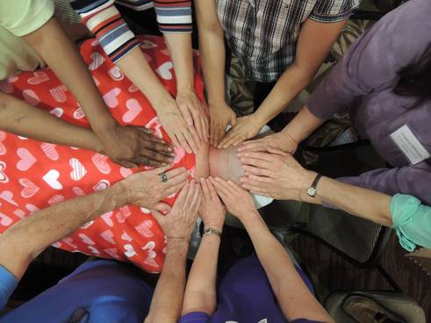
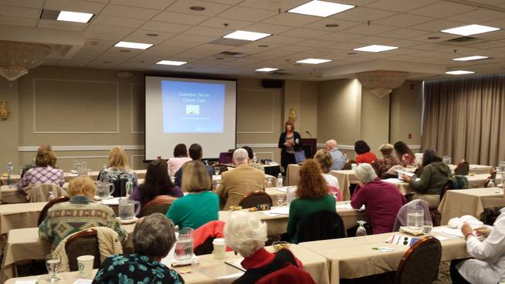
YOUR AMTA membership and support of the New Jersey Chapter make this exceptional service possible.
AMTA-NJ is your connection to communications.
- Assistance from AMTA massage therapist volunteers who are only a phone call or email away. You can find us 24/7 on our chapter website.
- Up-to-date information on state legislation and laws affecting you and your practice.
- The AMTA-NJ Touch Points newsletter 3 times per year with email blasts and phone calls to update you throughout the year.
AMTA-NJ is your connection to advocacy.
- Member-elected massage therapists in your state who understand and represent your concerns-who amplify your voice to AMTA's House of Delegates and to your state's policy makers.
- AMTA-NJ's chapter-funded lobbyist and legislative consultant protect your interests at the state level.
AMTA-NJ is your connection to community.
- Access to an existing network of ethical AMTA massage therapists who draw upon their wealth of knowledge and experience in the profession to provide you with guidance and support.
- Reduced-cost continuing education in your state, organized by your peers.
- The AMTA-NJ Community Service Massage Team that offers local charitable events that can help build your skills and massage therapist network.
- The AMTA-NJ Sports Massage Team, which has received national recognition for their commitment and unending hard work to promote the benefits of massage therapy within the sports community.
In looking at all of these MANY member benefits, you can easily see how valuable your AMTA membership is! Many of these benefits are chapter funded, so we ask that you continue to invest in and support your NJ Chapter with your donation.

