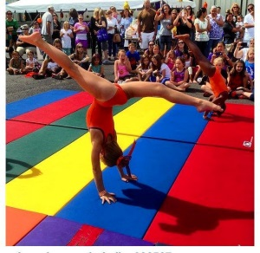

**No Membership fee for new members!**

**Buy 1 Leo get 1 Leo 10% off!**

Join us for a fun-filled day of Open Gym, Gymnastics Performances, DJ/Photo Booth, Food, Crafts, Bounce House, Raffles and Games!

Learn about the exciting new changes to our Progressive Program and take advantage of special offers that we will have on this day ONLY!

Come grow with us at J.A.Gymnastics!

2 Toelles Rd. Unit 5

Wallingford,CT 06492

(203)269-5244

JAGYMNASTICSLLC@AOL.COM

**Buy 1 apparel item get 50% off pair of shorts!**

**Existing Customers 15% off Session 1**

**Receive 20% off a Birthday Deposit!**

Sunday September 21, 2014 11:00am – 3:00pm