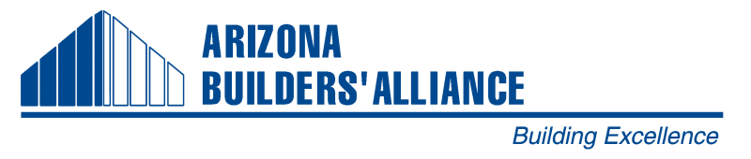
2014 Spring Phoenix Classes & Events
For Details & Registration Information Visit www.azbuilders.org or call 602.274.8222

January
3 Leadership Development Forum (LDF) – Phoenix
9 Joint Member Lunch “Economic Forecast” with CSI & CFMA @ Doubletree Resort – Phoenix
16 Webinar! Delay Claims - Phoenix
24 Board of Directors @ TDI office - Phoenix
February
7 Leadership Development Forum (LDF) – Phoenix
7 President’s Party/Auction – Phoenix
11-12 abc Biz/Con Meeting – Maui, Hawaii http://www.abc.org
13 Indemnity Roundtable, Lunch & Learn - Phoenix
19 Lunch & Learn - Networking for the Nervous – Practical Tips - Phoenix
19 Navigating Lien Notices Webinar - Phoenix
21 Board of Directors @ TDI office - Phoenix
March
4 Technology Seminar - Phoenix
5 CPC Prep Class 1 – Phoenix
3-6 National AGC Convention/CONEXPO-CON/AGG – Las Vegas, NV http://convention.agc.org
7 Leadership Development Forum (LDF) - Phoenix
12 Joint Member Mixer hosted by Minard-Ames - Phoenix
12 CPC Prep Class 2 - Phoenix
19 CPC Prep Class 3 - Phoenix
20 Joint Member Lunch, ABA, CFMA, ASA - Phoenix
April
2 CPC Prep Class 4 - Phoenix
4 Leadership Development Forum (LDF) – Phoenix
4 Annual Craft Training Golf Tournament - Phoenix
5 CPC TEST DATE – Phoenix
10 Member Mixer host LaborMax Staffing & AWIC – Phoenix ABA Office
11 Board of Directors – Tucson ABA Office
11 So. AZ Chairman’s Installation & Auction - Tucson
17 Lunch & Learn: Sullivan vs. Pulte Homes Legal Roundtable - Phoenix
24-27 IAC Conference, http://eepurl.com/u75OL - Scottsdale
May
2 Leadership Development Forum Class (LDF) – Phoenix
TBD Board of Director Strategic Planning – TBD
June
6 Leadership Development Forum (LDF) - Phoenix
18 Apprenticeship Completion Banquet - Phoenix
Major ABA Events
Feb. 7 ABA Pres. Parties & Auction - Phoenix
Feb. 11-12 Natl. ABC Biz/Con Meeting – Maui, Hawaii
March 3-6 National AGC Convention/CONEXPO-CON/AGG – Las Vegas, NV http://convention.agc.org
April 4 Annual Craft Training Golf Tournament - Phoenix
April 11 So. AZ Chairman’s Installation & Auction - Tucson
Oct. 16-18 ABA Convention – So. AZ
Dec. 12 ABA Member Lunch honoring LDF/SEP grads - Phoenix

