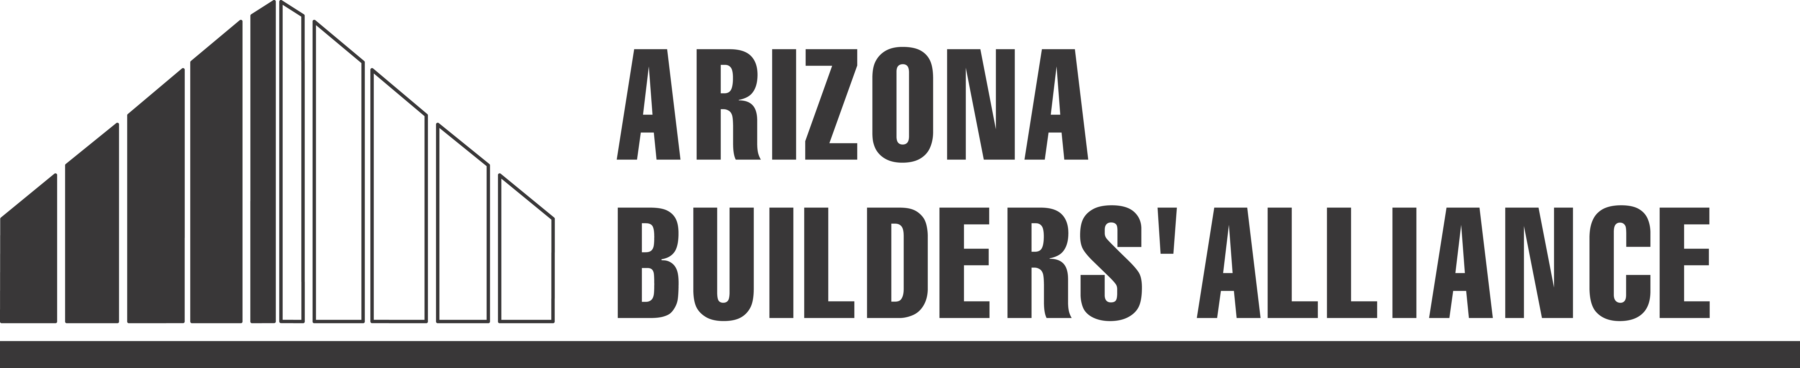
Community Service Board
“Assistance Application”

Our mission is to give back to the Phoenix metropolitan community through charitable projects and endeavors.If your organization is in need of construction orassistance, please e-mail this completed form by January 10, 2014 to elange@azbuilders.org.
Name of Organization:
Contact Person:
Contact Phone/Email:
Website:
Year Founded: *Is your organization a 501c3? Y / N
Number of volunteers per month? Number of paid employees?
Describe your organization and service(s) offered (max 100 words):

_________________________________________________________________
Describe your organization’s construction or maintenance need (max 100 words): ________________

_________________________________________________________________
Do you own the facility and have permission to make the repairs? Y / N
Please explain: _______________________________________
Is the estimated value of your project between $25,000 and $100,000? Y / N
If available, please provide the estimated cost of the need. $
**Is a permit required for this work? Y / N
Please attach your organization’s most recent consolidated balance sheet.
If you have questions, please contact Erica Lange at 602-274-8222 or elange@azbuilders.org
*Organization must be a 501c3 to qualify
**If permit is required, the permit must be secured to qualify
Note: Project must be located within the Phoenix metropolitan area to qualify

