Thank you for the Arizona Builders Alliance submission to the Chapter Best Practice Champion Program. On behalf of the Chapter Development Committee, I want to congratulate you and your chapter on your achievement, (“Explorer Post 811”) which has been recognized as a best practice. Your effort demonstrates a replicable format for other chapters around the country to adopt and improve their chapter’s business.

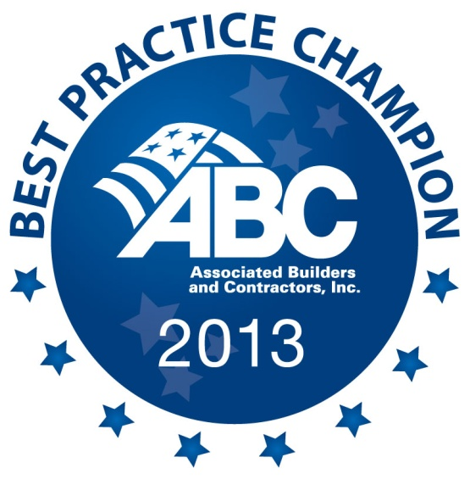

Your chapter’s achievement will be recognized in the following ways:
- A description of your best practice is currently featured on National Connections (http://nationalconnections.abc.org)
- Recognition inside the 2014 ABC Workforce Development Conference program guide and during the Opening Night Awards Celebration
- Eligibility to receive a Chapter Award of Excellence

Your chapter’s willingness to share best practices can immediately help other chapters to improve their management and services. In addition, your work will help us to create a robust knowledge base to benefit current and future chapter staff.

Congratulations on your accomplishment, and thank you again for your contribution to our members and chapters!

Cordially,
Lisa-Marie
Lisa-Marie Gardner
Senior Manager, Education and Conference Programming
Associated Builders and Contractors

