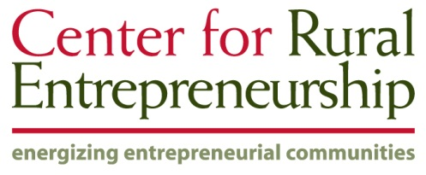

**Policy Education White Paper**

**Western North Dakota Regional Legacy Trust**

**Dick Gardner**

**Bootstrap Solutions & Senior Fellow, CRE**

**and**

**Don Macke**

**Center for Rural Entrepreneurship (CRE)**

**November 2013**

**Executive Summary**

This second white paper of the Western North Dakota Energy Project was written at the request of the VisionWest ND consortium. The purpose was to provide more detail for policy consideration about the recommendation in the first white paper, which was to develop a regional trust fund for the counties of Western North Dakota directly affected by the energy development of the Bakken shale formation.

This paper begins by summarizing the highlights of the first paper. It then outlines nine different ways that local and state government could pay for mitigating the short-term impacts of shale development in ways that set the region up for longer-term sustainability. Property taxes, existing state tax revenue sharing, impact fees, bond financing, and public/private partnerships are currently available to local governments. State legislation would be required to establish a state infrastructure bank, a state revolving loan fund, state impact fees per well, or state energy tax revenue sharing beyond current levels.

Three different examples, at the national, state, and regional levels, were then shared regarding the use of endowment funds from natural resource booms to ensure long-term sustainability. Norway’s Oil Fund is by far the most ambitious effort in the world to avoid the Dutch Disease of crowding out by deferring oil revenues into a sovereign oil fund for spreading equity across generations of its citizens. New Mexico is one of several states that have established permanent funds with severance tax revenues. Lastly, the Iron Range Resources Rehabilitation Board (IRRRB) has been using a portion of taconite severance taxes to sustain and improve a portion of Northern Minnesota for over 70 years. Its model of regional self-governance and its strategic use of trust funds inspire many of the recommendations in this paper.

North Dakota’s first effort to retain a portion of its energy revenues in the creation of the Legacy Fund is reviewed. Between the Legacy Fund and the much older Common Schools Trust, North Dakota saves more tax revenues per barrel of oil than any other state. However, that is less than a tenth of Norway’s savings rate, and in terms of savings per capita lags far behind Wyoming and Alaska.

Much of the paper describes some ways that a Western North Dakota Regional Legacy Trust might be established and govern itself. The ideas presented are not definitive, but are offered as a starting point for discussions. Spending guidelines for the Trust are based on the IRRRB example and the authors’ experience in rural development and with strategic investments in community philanthropy.

Last, an example is offered of how North Dakota might fund such a regional legacy trust, and how those funds would flow through the Trust to the various stakeholders to address strategic purposes for sustaining the region. In this example, the Trust would immediately pass on $1.25 billion to critical needs for improving regional systems during the energy boom. Yet it would also build a multi-billion dollar permanent fund over the course of several decades.

The questions posed by this paper are whether the region yielding its oil and gas deserves special treatment as a matter of fairness, and whether North Dakota is willing to save more of its energy revenues for this purpose.

**Background**

The Western North Dakota Energy Project (WNDEP) is an analysis and outreach effort of the Strom Center at Dickinson State University. It seeks to help the community leaders of the Bakken Region make more informed decisions by providing them with timely and useful information relevant to shale development. The project has chosen not to focus on the environmental aspects of shale development, feeling that this policy space is already filled with numerous players representing all perspectives including providers of objective information and analysis. Instead, the emphasis has been on community impacts flowing from the influx of new people and economic activity, and on the fiscal implications of this growth in both the short and long term.

To date, the WNDEP products have included two sets of webinars– a ***Boom or Bust Series*** on the lessons learned by leaders in other regions that have experienced natural resource booms, and a ***Shale Projection Series*** that provided county-level scenarios of future employment, housing, and population developed by North Dakota State University and the North Dakota Division of Mineral Resources.

While the authors have been partners in WNDEP for years, we recognize the danger of outsiders advancing specific recommendations for regional policy. We acknowledge that we do not have the same standing as residents experiencing the Bakken Boom on a daily basis. We are approaching this subject with the humility of people who have lived in and worked on behalf of rural people and places through both boom and bust periods. However, we judge it worth the risk to advance an idea if it stimulates a regional and statewide conversation about long-term public interest. This paper is intended to show how a set of ideas could be put into action. Please take these ideas as a starting point and modify them to fit the people and culture of North Dakota.

A third WNDEP product was a 2012 policy education white paper[1] that offered general insights about the predictability of natural resource booms and an overview of the issues embedded in fiscal policy for energy development. This white paper builds on the 2012 policy education paper. It begins with a review of the options for financing the mitigation of short-term impacts, though the focus is primarily on long-term effects. Three examples of boom regions that have created public trusts with energy tax revenues are then reviewed. North Dakota’s policy response to date is briefly described. The creation and operation of a hypothetical Western North Dakota Regional Legacy Trust is then advanced.

**Review of the 2012 White Paper**

The first white paper outlined the predictable phases of development and of community attitude. It focused on the following topics:

**Goals of Energy Fiscal Policy**. A framework[2] drawn by a WNDEP partner, Headwaters Economics, described both the short-term fiscal challenges and three goals for fiscal energy policy:

1. *Fossil fuel extraction pays its way through effective impact mitigation.*
2. *Fossil fuel extraction supports long-term economic diversification and resilience.*
3. *Fossil fuel extraction leaves a lasting legacy in the form of a permanent fund.*

**Challenges** **to Fiscal Planning**. Several obstacles stand in the way of community leaders trying to cope with the short-term impacts of rapid growth from energy development:

* **Revenue Timing:** Service demands are immediate; revenues lag with oil production. For example, property taxes are typically received 12-18 months after occupancy of a new building commences.
* **Jurisdictional Unevenness:** Location of production and revenue is often different from the location of service demands. Revenues may be determined by the location of well fields while workers who live elsewhere create costs through their demand on city services.
* **Revenue Volatility:** Revenues may vary with energy prices, and drilling may shift within the Bakken region according to geology, technology advances, and profitability, leaving communities with a pause in growth. One-time state appropriations are not predictable or dependable. All contribute to revenue volatility and greatly complicate infrastructure planning.
* **Revenue Amount:** Effective tax rates vary considerably from state to state. For instance, Headwaters Economics found the effective tax rate, considering all sources and incentives, ranged from 4.6% in Montana to 9.9% in North Dakota and 10.3% in Wyoming. Tax rates on natural gas varied more widely from 11.7% in Wyoming to 7.1% in Texas, and as low as 1.3% in Pennsylvania, which has no severance tax.

To address these challenges, the paper outlined a recommendation for predictable revenue-sharing streams to affected communities for mitigating community impacts. A coordinating mechanism was also recommended, such as the county shale task forces found in Pennsylvania that allow various service providers to communicate, collaborate, and meet needs as efficiently as possible.

**Long-term Impacts.** Lastly, the paper summarized short and long-term aspects of ***crowding out*** and the *Dutch Disease*, whereby energy economies grow so large that other economic sectors become less competitive and fade over time. The Iron Range Resources and Rehabilitation Board (IRRRB) was touted as a great U.S. regional example of a boom region that banked some of its taconite severance taxes into an endowment for sustaining the Iron Range. Consideration of a regional legacy fund, and an example of the income it could generate, was the final suggestion.

**Financing Short-Term Impact Mitigation**

It does not take long for a local jurisdiction to have its infrastructure and public service systems overpowered by rising demands fueled by an energy boom. This is especially true if that city or county is rural and located in a region with a previously stable or stagnating economy. Excess system capacity is quickly committed to demands caused by new residents, and expansions to infrastructure systems can be perceived by existing residents as extremely costly.[3] Yet impacts can be addressed in positive ways that position communities for the future.

Energy development represents a remarkable and unique opportunity for involved communities and regions. Since fossil fuel energy development is not sustainable long-term, how communities and regions embrace this opportunity is critically important. Predictable and effective provision of resources to affected communities can enable them to better support energy development short-term, while positioning their communities and regions for post-energy development prosperity. Such positioning is increasingly important when energy development and production phases are predicted to last decades not years. It is important to remember that short-term support needs to be used not just for the capital costs of infrastructure construction, but also to increase the capacity to implement projects through design and engineering, planning and accounting staff, code inspectors, etc.

As impacts accrue, Western North Dakota leaders have a number of funding mechanisms at their disposal. Each has different strengths and weaknesses.

**Current Options for Financing Short-Term Impacts.** The following options are readily available to local and regional leaders:

* **Property Taxes** – As residential, commercial, and industrial projects are constructed, the increase in assessed value is subject to property taxation. However, revenues typically lag the need for infrastructure services by 12-18 months. Residential developments are notorious for not generating enough tax revenue to cover costs, because they house children with education needs. In addition, there may be a jurisdictional disconnect between developments that occur out in the countryside, with taxes going to counties, and the need for public services occurring within city or town limits. Note also that North Dakota is projected to use $342 million of energy revenues for property tax relief in the 2013-15 biennium.
* **Sales Tax Revenue Sharing** – Many states share sales tax revenues with local jurisdictions or allow them local option sales tax authority. Again, there is a lag between tax collection and receipt by local governments, typically of 30-60 days. This time the jurisdictional disconnect flows in the opposite direction with larger cities and towns that serve as retail centers (hub cities) getting sales tax revenues from rural residents living and creating service needs in smaller places.
* **Impact Fees** – Impact fees have the timing advantage of being received before construction begins. Unfortunately, impact fees must be justified by data analysis, so that smaller towns can rarely afford the studies and impact fees often apply only to the largest needs, such as roads, schools or parks.
* **Bond Financing** – Public improvements can be funded by issuing bonds that pledge the stream of revenues from user fees in the case of water, wastewater or solid waste systems (revenue bonds), or by pledging tax revenues and the full faith and repayment capacity of the local government (general obligation bonds). In either case, existing residents are accepting a significant risk. Should the energy boom subside, or even pause due to price drops or better prospects elsewhere, revenues to meet bond payments may lapse. This situation occurred in a small town in Western North Dakota during the energy boom of the 1970s, causing the city to declare bankruptcy.
* **Voluntary Public/Private Partnerships** – A creative, but very common, option in energy boom regions is the fashioning of any number of private/public partnerships. They can be easy to create because the interests of energy companies and their contractors overlap substantially with the public interest of cities and counties. Both are interested in well-maintained and safe roads, adequate infrastructure systems to allow housing and commercial growth, quick and coordinated emergency response providers, etc. Examples include industry partnerships to build emergency response buildings closer to well fields or add four-wheel drive ambulances, to assist in road and well site signage, and to serve as unpaid contractors to help maintain heavily used roads.

**State Policy Options to Support Financing of Short-Term Impacts.** There are also four policy options requiring state authorization:

* **State Infrastructure Bank** – States with substantial permanent funds have an easy way to minimize bond financing costs of local government. They can dedicate a portion of a permanent fund as an infrastructure bank. This bank could make low interest loans directly to local governments for infrastructure projects backed by revenue streams, or more commonly they simply guarantee the bonds local governments issue. This allows the municipal bonds to be issued with the highest rating, which means the lowest interest rate. Small reductions in bond interest rates can mean large savings over the life of the bond. Bond defaults are extremely rare and might only follow unusual oil price declines. This appears to be a very low risk strategy to help local units of government deal with rapid growth.
* **State Revolving Loan Fund** – A more direct way to finance local infrastructure is for the state to establish a revolving loan fund for that purpose. It allows complete control of loan terms and processes, and money does return as principal and interest are repaid to the fund. A disadvantage is that the state must have sufficient energy revenues to cover the entire loan amount, whereas the infrastructure bank requires the state to only provide loan loss reserves. A secondary weakness happens when the funds are loaned at a low interest rate, which contributes to low returns to those energy funds and may limit endowment payouts.
* **Statewide Impact Fees per Well** – Pennsylvania has tried a creative approach to impact mitigation through the passage of statewide impact fees collected annually on a per well basis in 2012. The annual fees vary with the price of natural gas and decline over time as the impacts of the well are expected to decline. The first year fee is $40,000-60,000 per well depending on gas price, and it declines to $10,000-20,000 by Year 10 and expires after Year 15. Sixty per cent of the fee is distributed to host cities and counties, while the remaining 40% is distributed to various state service providers via the Marcellus Legacy Fund. This mechanism has a major advantage for industry in that they pay a known fee to a single state entity, rather than facing a fractured landscape of impact fees by local jurisdiction. Unlike normal impact fees, this statewide fee is first paid after a year of production, so the timing advantage of prompt upfront payment is lost. This mechanism could be an efficient way for a state to address impact mitigation of energy development, provided the fee is correctly calibrated to cover the average amount of impacts. It appears possible that this initial level of impact fees is low, given that cities and counties would share the $24,000-36,000 from each well in the first year under the revenue-sharing clause. Localities are only now receiving the first payments under this policy in Pennsylvania.
* **Severance Tax Revenue-Sharing** – A clearly-defined policy to automatically share severance or other energy tax revenues with local units of government is perhaps the best option to efficiently cover the short-term costs of mitigating the impacts of energy development. If revenue is predictable based on oil and gas production, returned to local governments in a reasonably timely manner, and shares are specified fairly to the correct units of government, severance tax revenue-sharing could be an excellent mechanism for all concerned. From an industry viewpoint, it is again a single tax that is clear and transparent and meets the needs of both state and local government, possibly for both short and long-term impacts. In the past, North Dakota shared state revenue with affected local governments only with one-time appropriations long after the need had arisen. These appropriations were neither timely, nor predictable, nor sufficient. The subsequent creation of the Legacy Fund and its revenue distributions was a significant improvement in public finance policy (more discussion in a later section).

**The Path Breakers in Building Natural Resource Endowments**

Fortunately for Western North Dakota leaders, other regions and countries have developed and tested models for addressing the long-term impacts of energy development. There are clearly lessons to be learned and potentially adapted to the realities of this region.

**Iron Range Resources & Rehabilitation Board (IRRRB)[4].** Of particular relevance for North Dakota is the ***Iron Range Resources & Rehabilitation Board*** (IRRRB). The IRRRB was created through policy enacted by the Minnesota Legislature in 1941 at the request of Governor Harold Stassen. For the past 72 years, the IRRRB has pursued a mission of ***“investing in business, community and workforce development for the betterment of northeastern Minnesota.”***

In 2010, mining in the five counties of the MN Iron Range generated nearly $110 million in mining taxes, approximately 21% of which was set aside for the IRRRB ($23.1 million). Between 1993 and 2011, nearly $200 million was invested by the IRRRB to achieve a three-pronged mission:

* Support for Ongoing Mining
* Community and Economic Diversification
* Environmental Reclamation and Stewardship

A key design feature of the IRRRB is its focus on ensuring the continued operation of mining in the Iron Range. The IRRRB has worked collaboratively with mining interests and miners to ensure the industry’s success. It has invested in research and development to develop new mining technology that has kept the Iron Range alive; for example, the development of both the original and an improved taconite pellet is tied to IRRRB investments with industry. It has also invested in the development of non-ferrous minerals and in mine reclamation projects. This element of the IRRRB provides an appropriate model for creating a constructive partnership with energy interests in western North Dakota.

In addition, the IRRRB made an early loan to Chun King Chinese foods that created a new business in the region. More recently, IRRRB developed the Giant’s Ridge Golf & Ski Resort, and built a cross-region snowmobile trail. Investments in workforce training help keep the region competitive and resilient. Grants for community betterment projects allow rural communities to leverage those funds with other state and federal programs.

Despite legislative attempts to redirect IRRRB dedicated funds and funding to state budget purposes, this policy has been protected and today has approximately $125 million in its trust fund. Annual contributions to IRRRB from taconite taxes have ranged from $10-20 million in recent years. The IRRRB has become a predictable and robust partner in this region, ensuring its communities long-term economic success and prosperity.

**Norway Sovereign Oil Fund.** In 1963, Norway claimed its oil rights in the North Sea, but it was not until 1969 that Ekofisk oilfield started a major boom. Leaders in Norway had, in the 1970s, watched the Netherlands experience a natural gas boom increase the price of labor and its currency so that it lost competitive position in international markets, a phenomenon now called *Dutch Disease*. Norway realized it was counterproductive to spend its tax revenues in an overheated economy. It decided to adopt a far more rational and longer term approach, as it anticipated the eventual decline of oil production and also wanted to moderate effects of volatile oil prices. Norway had an explicit goal of providing fairness across generations of its citizens. It became a minority owner of every oil development license it issued, accepting both risk and reward. The Petroleum Fund Act established the Government Petroleum Fund in 1990 to invest its revenues from taxes on oil companies, payments for exploration licenses, returns from its direct ownership shares, and dividends from the partly state-owned energy company, Statoil.

Over the years, the Oil Fund (now called by the somewhat misleading name, *Government Pension Fund-Global*) slowly evolved its investment policies as it sought to spread risk through diversification. It allowed equity investments in 1998, emerging markets in 2000, ethical guidelines in 2004, small-cap equities in 2007, and real estate in 2008. Norway correctly sees the Fund as a large investor with a long time horizon and a limited liquidity need. Currently, the investment targets are 60% equities, 35-40% bonds, and up to 5% real estate. The fixed income benchmark is 70% government bonds and 30% corporate bonds. The equity component also had geographic targets of 50% Europe, 35% Americas and Africa, and 15% Asia and Oceania, though that policy has been recently refined. Its first real estate purchases involved office and retail properties in Paris and London. The Fund re-balances its portfolio annually. The ethical focus areas are currently equal treatment of shareholders and shareholder influence, efficient markets, climate change risk management, water management, and children’s rights.

The net rate of return above inflation from 1997-2012 has been 3.2%.[5] The Fund is now worth over $729 billion as of March 31, 2013 and is projected to hit $1 trillion by 2019. It is one of the largest sovereign oil funds in the world. The $729 billion amounts to some $146,000 per capita. Spending from the Fund is targeted to a real return goal of 4% annually, but its policy has a counter-cyclical feature that increases spending in economic downturns and reduces it as unemployment and other metrics improve. The country faces pressure from some political groups to increase spending and to alter its spending targets, as might be expected with the existence of such a large pool of wealth. Spending up to 4% of fund balance is determined annually through Norway’s budget process and amounted to some $21 billion in 2013.

In 2005, Norway created a small *Oil for Development* program which uses oil revenues to provide technical assistance to developing countries experiencing oil booms and to transfer the lessons it has learned. It is currently helping 36 countries.

**New Mexico Permanent Funds.** The State of New Mexico is a good example among the several Western states that place energy tax revenues into long-term endowments. It has directed revenues from its severance tax into its Severance Tax Permanent Fund since 1976. The balance in FY2012 was $3.7 billion and it earned $183 million for state funding priorities via the New Mexico General Fund. In addition, a portion of the severance tax revenues is used for a Severance Tax Bonding Fund, which helps pay for projects proposed by local governments in the state and nominated by a legislator or the Governor. The State views these capital investments as providing long term benefits to citizens and aiding the attractiveness for economic enterprises. Fund earnings averaged 5.3% from 1995-2011.[6]

A second Land Grant Permanent Fund contains all the energy royalty payments, lease bonuses, and other rents that accrue from state lands, e.g. grazing fees. Its FY2012 balance was $10.7 billion, and it generated $462 million to the General Fund and $92 million to other beneficiaries.

An important stabilizing feature of both permanent funds is that they direct 5% to be spent annually from their balances. This means that earnings in excess of 5% are banked into the endowments, while the balances are drawn down when earnings fall short. This feature adds budgeting predictability for planners and decision makers, which is important given the volatility of oil prices and energy taxes.

The table below shows the trust fund balances of major energy states and provinces. North Dakota ranks fifth in total savings behind Alaska, Texas, New Mexico and Wyoming.

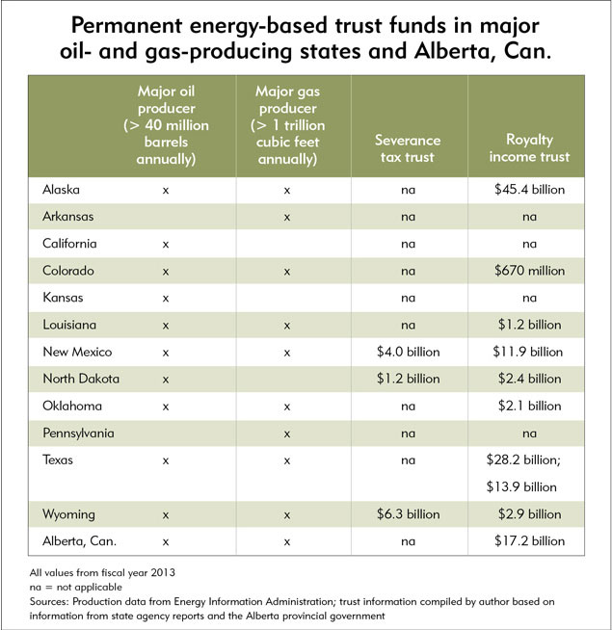

Source: Wirtz, Ronald A., [Saving for a Rainy](http://www.minneapolisfed.org/publications_papers/pub_display.cfm?id=5158), Oil-free Day, fedgazette, Minneapolis Federal Reserve, September 3, 2013.

**North Dakota Response: Creation of the Legacy Fund**

North Dakota’s response to the increased flow of oil and gas production was the creation of the Legacy Fund in 2010 by the passage of a constitutional amendment (Article X, Section 26) that provides 30% of oil and gas gross production and extraction taxes be placed into this fund. It is worth noting that an earlier constitutional amendment vote to place 50% of energy taxes into a permanent fund failed in 2009.

The State Investment Board (SIB) invests the principal, and interest earnings accruing after June 30, 2017 will be transferred to the General Fund at the end of each biennium. This means that the only way for the Legacy Fund to grow is through additional oil and gas revenues. This policy contrasts with ones used in New Mexico and Norway that cap the annual payout somewhere near the long-term average real (inflation-corrected) return on investment, say 3-5%. This allows the principal to rise at roughly the rate of inflation and remain constant in real terms. The predictable payout introduces some stability into budget planning.

However, North Dakota energy tax revenues are now accruing at more than $80 million per month and drilling now exceeds depletion rates by a factor of 1.5.[7] The Legacy Fund had a balance of $1.3 billion as of June 30, 2013 and it is projected to hit $3 billion in two more years. The Legacy Fund was originally invested in a very conservative way (all fixed income) that did not reflect the constitutional and Legislative intent for a long-term permanent fund. That policy was changed in May 2013. The new asset allocation is 35% global fixed income, 30% domestic equity, 20% international equity, 10% diversified fixed income and 5% real estate.

It is worth noting that North Dakota has a second fund, the Common Schools Trust, that dates to 1889 when the state received title to several million acres of federal land, most of which had oil and gas beneath it. It received $350 million in royalty income and another $192 million in severance tax revenues from a 20% provision in the oil extraction tax distribution. The Common Schools Trust now has a balance of $2.4 billion and is projected by North Dakota to nearly reach $4 billion by the end of FY2015. School districts received $66 million in the last biennium, double the 2001 level. Clearly, the key priority for its children, K-12 public education, has been cared for by North Dakota. There are no comparable written vision, mission, goals, or purposes statements for the Legacy Fund, such as the mission that guides Minnesota’s IRRRB.

The graphs below show that while North Dakota still ranks below New Mexico , Wyoming and Alaska in terms of trust funds per capita, it leads the way in the amount of trust funds per barrel of oil equivalent. However, it is still less than a tenth of Norway’s saving rate. The question is whether North Dakota is willing to save more, and/or to trust the region of origin with some of that savings.

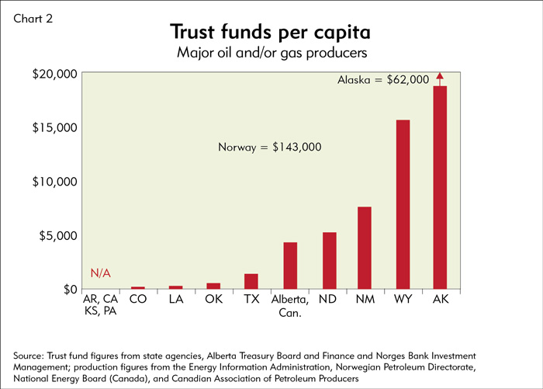

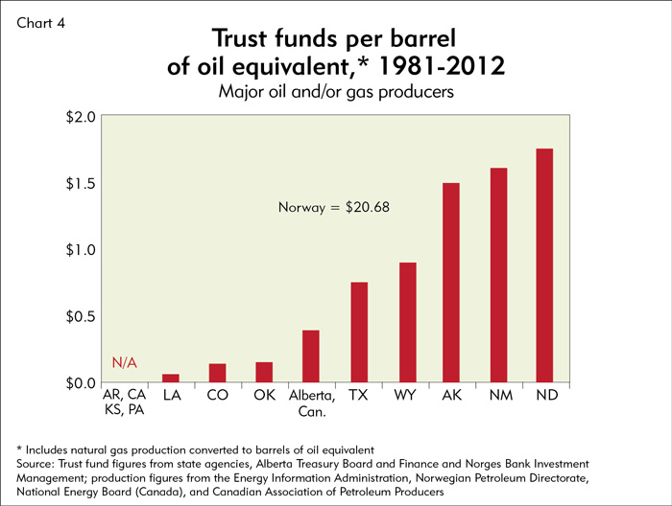

Source: Wirtz, Ronald A., Saving for a Rainy, Oil-free Day, fedgazette, Minneapolis Federal Reserve, September 3, 2013, <http://www.minneapolisfed.org/publications_papers/pub_display.cfm?id=5158>

**An Idea Worth Considering – Western North Dakota Regional Legacy Trust**

North Dakota has already embraced the idea of setting aside some oil revenues via the Legacy Fund for the future. An idea worth considering is the creation of a Regional Legacy Trust that recognizes that western North Dakota is the source of these oil tax revenues and also the region most impacted, both positively and negatively, by this development. Natural resource economic theory suggests that every barrel of oil, a non-renewable resource, extracted from the region today is unavailable for future extraction. The present value of those lost future opportunities represents the opportunity cost to the region. Severance taxes are one way to account for those lost opportunities with a contribution to public coffers. They are, in essence, the region’s savings account for a post-energy future.

How might a Western North Dakota Regional Legacy Trust be structured? As a conversation starter, this section shares one scenario for such a trust.

**Funding Source and Use.** North Dakota has already set aside 30% of its energy revenues for the statewide Legacy Fund. The Regional Legacy Trust could be established with an additional portion of the severance tax. If the State can save 30% for its needs, what portion is it reasonable to dedicate to the region where the nonrenewable resources were extracted? These revenues would provide a more permanent return from energy development than has been true of past booms in the state. The proposed Regional Legacy Trust represents a chance for Western North Dakota to develop a nest egg that can benefit it for all time.

Energy revenue distribution in the state has been compared to filling a cascading series of fund buckets. As one program bucket is filled, the revenues spill down to the next. Given the complex nature of current energy tax distribution formulas, we leave it to North Dakota policymakers, who better understand the intricacies of that distribution, to determine exactly from what source the Regional Legacy Trust should be drawn. It could be an additional percentage of energy taxes as suggested above. It might be drawn from revenues over and above other obligations. It might be linked to revenues derived above certain oil and gas price points, e.g. $90 oil and $4 natural gas. It may be possible to embed a regional trust within the Legacy Fund when its mission and purposes are clarified. For instance, a portion of the Legacy Fund revenues come from the 5% gross production tax levied in lieu of property tax and originally intended for local use. We simplify this example by assuming a set amount of money is distributed to the Regional Legacy Trust each year, and leaving the revenue source for a later discussion.

The Regional Legacy Trust would use up to half of its stream of annual contributions from energy taxes in the first decade to mitigate the many short-term impacts that are affecting the region. In this way, the region creates the capacity to respond, in both the short and long term, to the demands and opportunities associated with energy development.

**Fiscal Agent.** The key characteristics of a fiscal agent are integrity, public credibility, competence as both administrator and investor, and transparency. An additional, highly desirable attribute would be an institution that is separate from state government and the appropriations process. Such independence provides protection for the fund if the state’s fiscal condition declines and legislators are looking for funds to balance the state budget. While such a scenario is unlikely at present, there is no predicting the future. One credible candidate for fiscal agent of a Regional Legacy Trust is the Bank of North Dakota. Unique to North Dakota, this state bank has sufficient autonomy that together with a strict authorizing statute prohibiting use of the trust balance for any purpose not expressly stated, the regional legacy trust should be secure. In addition, the Bank of North Dakota meets the key desired characteristics of a fiscal agent listed here.

**Governing Board.** There are numerous ways to construct an effective governing board of a regional legacy trust. The overriding principle should be regional empowerment, providing leaders from the affected region with majority representation on the board. Here’s a sample governing board structure with 13 voting members and one ex officio non-voting member. We believe this size is large enough to be inclusive, while small enough to be manageable:

1. Office of the Governor of North Dakota
2. North Dakota House of Representatives – appointed by the Speaker of the House
3. North Dakota Senate – appointed by the Senate Majority Leader
4. Bank of North Dakota – non-voting *ex officio* as fiscal agent
5. County Commissioner – from core Bakken counties of Williams, McKenzie, Mountrail, Dunn and Billings
6. County Commissioner – from other 14 counties in region
7. City Representative – Mayor or city council from Hub City as defined in Legacy Fund
8. City Representative – Mayor or city council from non-Hub City
9. Tribal Representatives (2) – tribal chair or tribal council member from MHA Nation and Trenton Indian Service Area (TISA)
10. Regional Organization Representative – from 3 councils of government, VisionWestND, or Association of Oil Producing Counties, elected from nominations by county and city members
11. Education Sector Representative – School Board superintendent, school principal, or school board chair, elected from nominations by county, city, & regional members
12. Higher Education Representative – President or Dean of a unit of higher education in North Dakota, including community colleges and tribal colleges, elected from nominations by county, city, & regional members
13. Health Care Sector Representative – hospital executive director or Board chair, public health district director, or primary care clinic director, elected from nominations by county, city and regional members

**Spending Guidelines for State Contributions to Western North Dakota Regional Legacy Trust.** The Regional Legacy Trust would make mission-driven investments in the region, in a manner similar to the IRRRB. Two sets of guidelines are proposed – one for spending the trust earnings and a second for spending a portion of the direct state contributions in the first ten years for mitigating short-term impacts. The next decade should accommodate most of the boom period infrastructure adjustments. A suggested set of temporary guidelines for impact mitigation in the first decade includes:

* **Community Infrastructure Investments** – 10% of the annual contribution to the Trust from severance taxes would be targeted to cities and counties within the region according to permanent population for infrastructure systems including roads, bridges, water and wastewater systems, solid waste facilities, public heath care facilities, schools, and community betterment facilities like community centers, libraries, wellness or recreation centers, sports facilities, theaters or auditoriums, park acquisition and development, trail or bike path acquisition and development. Perhaps the most important use of these predictable funds is for staffing and building capacity to accomplish improvements. A tenth of the annual contributions to the Trust seems a reasonable amount to dedicate to a predictable funding formula that local jurisdictions can use in their capital improvement and staffing plans during this initial decade.
* **Energy-related Infrastructure Expansions** – During the first 10 years of operation, up to an additional 30% of the annual contribution to the Trust from energy taxes would be targeted to cities, counties, and taxing districts, based on competitive need, for infrastructure expansions related to energy development.
* **Workforce Training Investments** – During the first 10 years of operation, up to an additional 5% of the annual contribution to the Trust from severance taxes would be targeted for workforce training and education of the region’s permanent and temporary residen*ts.*
  + **Affordable Housing and Childcare Investments** – During the first 10 years of operation, up to an additional 5% of the annual contribution to the Trust from severance taxes would be targeted for the provision of affordable housing or child care through eligible housing authorities and non-profit organizations. This provision is an attempt to find ways to keep those on fixed incomes, and most vulnerable to crowding out, from having to leave the state. Child care is included to address pressing needs to have safe, quality facilities that facilitate a learning environment to foster curiosity and creativity in our youngest citizens.
* **Permanent Endowment** – A minimum of 50% of the annual contribution to the Trust from severance taxes would be used to create the permanent endowment of the Trust.

**Spending Guidelines for Earnings of the Western North Dakota Regional Legacy Trust.** Over time, the trust itself will generate earnings that can be used for the betterment of the region, though we recommend retaining earnings in the first decade. Here is a set of guidelines related to those earnings:

* A minimum of 10% to a maximum of 40% of the annual earnings from the Trust would be targeted to support of capital investments in ***new infrastructure to aid economic development*** within the affected communities. Preference would be given to projects which leverage the Trust investment with federal, state, or private funds. Planning would be a fundable purpose within this section.

Expansions to infrastructure to accommodate energy development can be funded directly from severance tax contributions to the Trust over the next decade. Good public finance dictates that where possible user fees should maintain existing infrastructure systems. This program would fund roads with local jurisdiction, water & wastewater systems, solid waste disposal, expansion of utility services, emergency response services, even health facilities where there are documented needs that would support diversification of the regional economy. Note that planning grants would be eligible; this type of funding is hard to obtain from other sources for projects like broadband deployment or downtown revitalization.

* + A minimum of 10% to a maximum of 40% of the annual earnings from the Trust would be targeted for ***community betterment projects*** within the affected communities. Preference would be given to projects which leverage the Trust investment with federal, state, or private funds. Planning and public participation would be fundable purposes within this section. There is a growing body of research that shows that younger and creative people, as well as retirees, look for natural and built amenities when choosing where to live. This program would fund quality of life improvements like community centers, libraries, wellness or recreation centers, sports facilities, theaters or auditoriums, park acquisition and development, trail or bike path acquisition and development, etc. The Trust would fund capital costs, so preference would be given to plans that demonstrate support for facilities after construction.
* A minimum of 1% to a maximum of 3% of the annual earnings from the Trust would be targeted for **arts and culture projects and programs**within the affected communities, with funds going to cities or local arts, humanities, or history councils.Preference would be given to projects which leverage the Trust investment with federal, state, or private funds. Planning and public participation would be fundable purposes within this section. The arts reflect mankind’s highest aspirations and honor our cultural traditions. They enrich communities and are a special form of amenity. In many communities, the arts become an industry itself with economic value. The applications can be for projects like public art installations, or for programs like performing arts or arts education, or for arts events like art fairs or concerts.
* A minimum of 1% to a maximum of 5% of the annual earnings from the Trust would be targeted *for* ***business development***grants to local or regional governments, nonprofit organizations, or units of higher education in North Dakota for entrepreneurship training, feasibility studies, trainings, applied research, or the support of collaborative networks relating to the economic development and economic diversification of the region.

State and local governments are active players in community economic development. State and local funding are commonly used to support targeted business development. In this case such funds could be used to help support existing industries and businesses impacted by energy development. Additionally, the vast majority of developed nations embracing international trade provide assistance to industries impacted by expanded international competition. These policies are often referred to as “trade adjustment” programs. Typically these programs provide technical assistance, financing and transition protection to help industries transition. We recommend adaptation of trade adjustment programs to impacted industries in the energy patch. In geographies where massive energy development is crowding out (e.g., labor shortages, higher business costs, etc.) existing industries like manufacturing, agriculture or tourism similar assistance can be provided to first help existing businesses weather the boom phase of energy development and second reposition for long-term success.

Minnesota Initiative Foundations

We recommend consideration of employing a regional “community development finance institution” or CDFI for short. CDFIs are public-private business development organizations that specialize in business financing. CDFIs are common throughout the United States. Sometimes CDFI’s are aligned with regional or local development organizations. A great model worth exploring is the Minnesota Initiative Foundations. The Initiative Foundations were created 25 years ago by the McKnight Foundation in response to drastic declines in the late 1980’s in farming, logging and mining industries in rural Minnesota. The Foundation enabled six regional initiative foundations. Over two and on-half decade long period the Initiative Foundations have provided over 23,000 community development grants valued at $140 million, issued 3,600 business loans worth $193 million and secured 40,000 quality jobs for rural areas in Minnesota.

There may also be new opportunities as the resources of Western North Dakota are used for things we cannot now conceive. Networks are deliberately included because mechanisms that lead to communication tend to result in positive accomplishments. There is a high need for a limited amount of analysis and outreach that supports local decision making. [8]

* Up to 20% of the annual earnings of the Trust would be targeted for a revolving loan fundmaking ***loans or equity investments in new or existing businesses*** within the region. A committee of business and financial experts would advise the Trust on selection of investment opportunities. Preference would be given to opportunities that add value within the energy, agriculture, manufacturing, or technology sectors.
* Up to 10% of the annual earnings from the Trust would be targeted for ***capacity-building activities*** for the residents of the region. Eligible purposes include community leadership training, adult community education classes and trainings, and scholarships for higher education. Scholarships for professional degrees in health care, engineering, or business are encouraged to include a provision for residency and work within the region upon graduation, and preference shall be given for such scholarships. Local leadership is essential to making progress on all community and economic development issues. A cadre of trained local leaders creates a common language for building public processes for participation and project implementation. The scholarships create ways for youth to come back to the region for productive careers.

Capacity can be defined as the “ability to do work.” Community capacity building relates to increasing the ability of communities to effectively engage in their own development. In the United States, unlike most other mature economies, community economic development is a local responsibility. Increasing the capacity of communities in energy development areas is paramount, and will serve two important purposes. First, such capacity building will enable communities to better support and manage energy development, ranging from providing necessary development infrastructure to health care services. Second, expanding community capacity building beyond energy-related needs and opportunities will position impacted communities for post-energy development futures.

Two Leadership Successes

|  |  |
| --- | --- |
| The Ford Family Foundation in Oregon has funded leadership training in rural Oregon communities for over a decade, spending over $1 million per year. Under the Ford Institute for Leadership Program (FILP), they engage with each community for 5-7 years, using a statewide non-profit organization as the trainer. The main course is a 48 hour leadership training course conducted over 4 weekends that covers topics like team-building, personality styles, conflict resolution, facilitation, and project planning. Classes are purposely diverse and intergenerational. A Spanish language version is offered where appropriate. Their goal is to issue all Ford community grants to groups led by graduates of their program. This means grants have a higher likelihood of wide community buy-in and successful completion. | Another national community capacity building model is HomeTown Competitiveness or HTC (in other places the name HomeTown Prosperity is used). HTC was developed in Nebraska with support from the W.K. Kellogg Foundation and continues to be used throughout rural America (from Arizona to Maine and Indiana to Oregon). HTC focuses on increasing a community’s capacity in four critical areas leadership and development organizations, youth engagement and attraction, entrepreneur-focused economic development and financial resource mobilization. HTC received the International Community Development Society *Innovative Program Award* in 2004. |

**Purpose and Range of Distributions from State**

**Contributions to WNDRLT and from Earnings of WNDRLT**

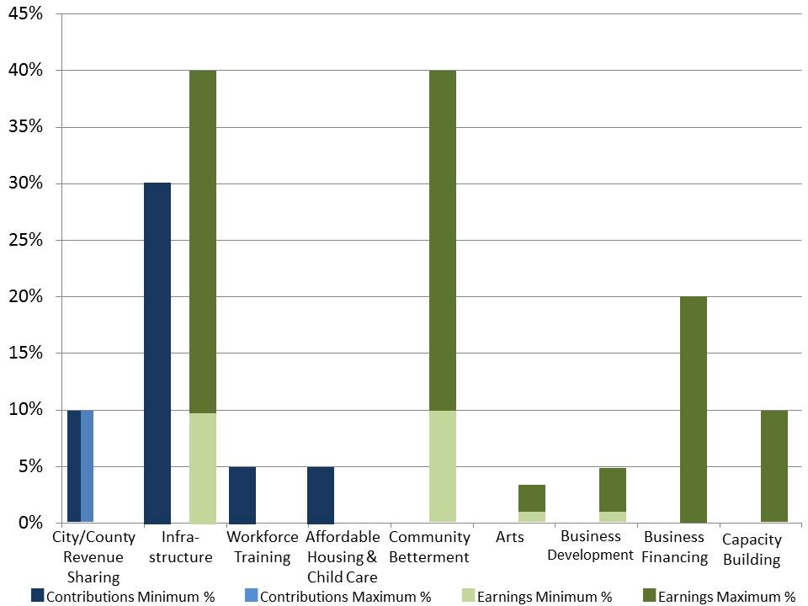

The graph above summarizes the distributions to various purposes of funds that come from contributions to the WNDRLT during the first 10 years in blue, and then the distributions from trust earnings in green. The light green shows the minimum distribution and the darker green the maximum. Note that maximum potential earnings distributions total 118%. Actual distributions would be at the discretion of the WNDRLT governing board.

**Other regional trusts.** An interesting idea to improve the political support for authorizing legislation is to allow for the creation of regional trusts in other parts of the state, perhaps even blanketing North Dakota. These trusts would follow the same guidelines, though there may be less need for mitigating short-term impacts of the energy boom. As the region of origin of the oil resource and tax revenue, the Western North Dakota Regional Legacy Trust deserves a much larger share of severance tax revenues than the other trusts. The state might consider deploying smaller amounts to other regional trusts. An option would be to provide energy tax revenues to regional trusts on a 2-to-1 or 3-to-1 basis against funds raised privately for the trust, up to the state contribution limit. This implies an active community philanthropy program has been established, and it gets some local skin in the game for unaffected regions. Another option would be to allow existing community foundations within a region to apply to house and administer a regional trust.

**Private Contributions and Community Philanthropy.** The regional legacy trusts also become excellent vehicles for philanthropic interests, provided the broad purposes of the trusts are acceptable to the donor. Given the large number of landowners receiving mineral lease bonuses and oil and gas royalties, there is considerable potential for contributions to a donor’s home region. In fact, many community foundations conduct giving campaigns aimed at receiving something during estate planning (see CRE website for details and support). Community trainings on philanthropy would be eligible Trust activities under capacity-building. Providing the regional trusts with the capacity to receive private contributions would provide a broader base of fundraising beyond the energy sector.

Under U.S. Internal Revenue Service law “community foundations” enjoy a powerful range of powers that are highly suited to rural regions like western North Dakota. Consideration should be given to working with the North Dakota Community Foundation ([www.ndcf.net](http://www.ndcf.net)) and other community foundations serving western North Dakota. Community foundations have the ability to create local foundations (such as a regional trust) within the host foundation, minimizing cost and increasing management effectiveness while ensuring maximum local control. Community foundations can support a wide range of community economic development activities and are proven partners with local governments. Community foundations could provide a vehicle for supporting long-term community economic development initiatives in western North Dakota, including community capacity building work. Community foundations are certified by the Council on Foundations, ensuring strict adherence to the highest standards of financial management and performance. Should North Dakota elect to partner with community foundations as one option to deploy trust funding, we recommend that partnering foundations have Council on Foundation certification. Such certification ensures prudent trust management resulting in long-term protection of endowed funds (corpus) and the prudent annual distribution of earnings from the trust’s investments.

**Infrastructure Bank.** An infrastructure bank to guarantee local bond issues to increase system capacities could be created using a portion of the trust funds. However, this might be more appropriately created within the state Legacy Fund, so that it might guarantee bonds issued throughout the state.

**Retained Earnings.** It is appropriate to retain a portion of earnings in order to grow the endowment. This is especially important in early years when the economy is still strong as a hedge against overheating the regional economy. Note that many foundations and permanent funds limit disbursements to 4-5%, with any additional returns retained as a hedge against inflation. Again, IRS laws and community foundation certifications speak to this issue.

**Process.** There remains the need for debate and decisions around the grant or loan making process. What funds are disbursed as competitive grants to taxing districts? Which nonprofits or private businesses are eligible? Which individuals? We have suggested that 10% of state contributions go to all communities based on population, but this is subject to debate. Does the governing board have to individually approve all grants, or can some programs, such as individual scholarships, be decided by management or a subcommittee? We suggested a committee to review business financing application. There are many details that need to be addressed during the legislative and regulations development processes.

**Testing the Idea: A Regional Legacy Trust Example**

How might these ideas play out in North Dakota? This section uses a hypothetical example to test the concepts. This example assumes that oil production will remain at or above its current level of roughly a million barrels per month for the next decade or so and then begin to slowly decline. The example also assumes a set amount of funds moving from state energy revenues to the regional trust, but does not specify the source. We make no assertions that the amounts are correct or that our assumptions about oil production from the Bakken are correct.

Let us assume that $250 million per year is placed into the Western North Dakota Regional Legacy Trust (WNDRLT) for the first 12 years. If the Legacy Fund is now accumulating revenues at about $1 billion per year, then this amounts to a quarter of the Legacy Fund contributions, or about 7.5% of state energy revenues. These revenues are assumed to be over and above the current revenue-sharing policies from the extraction tax.

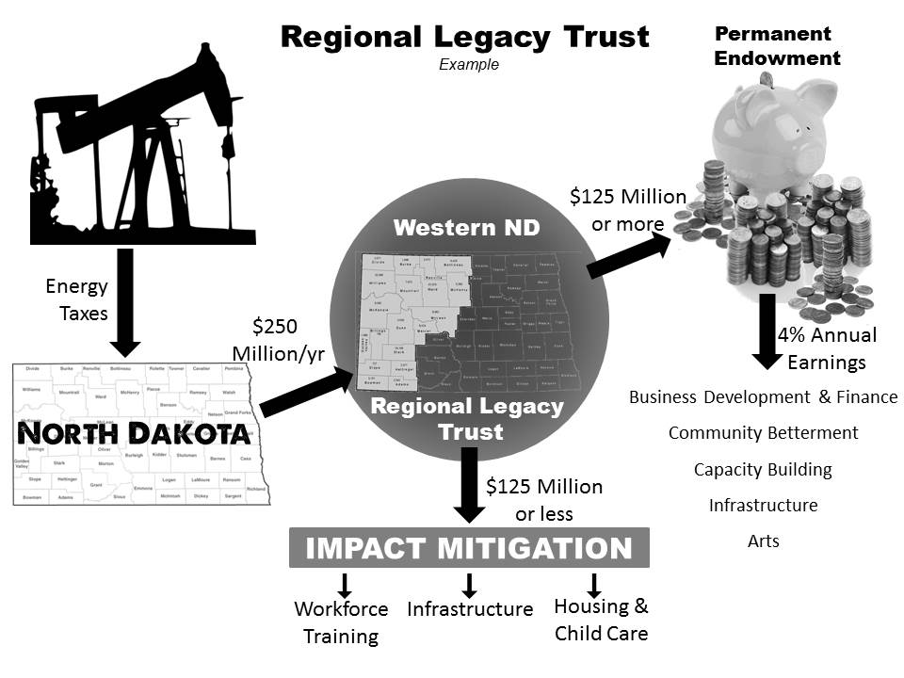

During the first decade of the Trust’s existence, the governing board may distribute up to $125 million directly to eligible entities within the region (above current ND revenue-sharing). $25 million is distributed to cities and counties automatically in proportion to population. Up to $75 million may be distributed for infrastructure expansions according to competitive need. Up to $12.5 million each may be allocated to workforce development and to affordable housing and child care. At least half of each year’s contribution in the first decade is invested into the permanent fund of the WNDRLT.

Beginning in Year 11, all contributions to the WNDRLT are invested in the permanent fund, and it begins to distribute up to 4% of the balance as earnings. Earnings are distributed to projects and programs in infrastructure, community betterment, arts, business development, business finance, and capacity building according to the spending guidelines described earlier.

This example assumes that $250 million is contributed to the WNDRLT in Years 11 and 12, but that the distribution is then reduced to $125 million annually for Years 13-22, then to $50 million annually for Years 23-42, and to $10 million annually thereafter.

The balance in the WNDRLT endowment increases to $1.25 billion at the end of year 10, to $1.75 billion at the end of Year 12, to $3.0 billion by Year 22, and to $4 billion by the end of Year 42. Distributions of earnings from this trust balance amount to $50 million at the end of Year 10, $70 million by the end of Year 12, $120 million by Year 22, and $160 million per year by Year 42.

These estimates are summarized in the table below. (All numbers are in 2013 $, because earnings in excess of 4% are assumed to be left in the trusts to offset inflation.) We have not added any earnings on the trust balance, making these estimates conservative. Note that this example also assumes that as a matter of fairness, regional legacy trusts are formed in other regions of the state. This example assumes up to five other regional trusts are formed, and each receives $50 million per year as the initial contribution. Though this is one-fifth of the amount given to the region that produced the oil revenues, these other regions need not pay out impact mitigation funds in the first decade, so that their balance accrues more rapidly.



Perhaps the most important point to make here is that by the end of Year 42, North Dakota has created a Western North Dakota Regional Legacy Trust with a permanent fund of $4.0 billion dollars. In addition, up to five other regional trusts contain over $1 billion each. Any private foundation with an endowment of $1 billion would be considered a major asset in community philanthropy. North Dakota would have six organizations serving only a multi-county region each. And each of these regional trusts can be counted on to serve the most pressing regional needs because they are governed by regional leaders. To cap it off, the Legacy Fund at this point should have a balance exceeding $20 billion to serve statewide needs.

Again, this is just one example of how regional trusts might work in North Dakota, if the state were able to save an additional half billion per year from its energy revenues. It is based on conservative estimates of future oil production, at a time when estimates seem to be regularly exceeding projections. It will be up to North Dakotans to decide exactly how to establish and govern regional trusts, and to what purposes their earnings should be dedicated.

**Summary**

This paper is offered in the spirit of public brainstorming. Its purpose is to seed a public policy dialogue in North Dakota about the use of a significant portion of oil and gas severance tax revenues to sustain Western North Dakota and the entire state in future generations. The creation of the state’s Legacy Fund represented a public consensus that revenues earned during today’s energy boom should be saved for the future. The idea shared here is based on an equity consideration – that the region generating this statewide wealth, and bearing the bulk of the short and long term impacts of energy development, ought to receive and control the management of a sizeable portion of that wealth within reasonable guidelines. It seems only fair during this energy boom to endow the region with resources that can keep it vibrant for generations to come.

The Center for Rural Entrepreneurship’s vision for rural America is one of vibrant communities and regions that embrace entrepreneurship, that find new sources of competitive advantage in their inherent assets, and that invest in a new more sustainable future for both present and future generations. The Center’s mission is to help our local, regional and state partners achieve this future. We are committed to connecting economic development practitioners and policy makers to the resources needed to energize entrepreneurs and implement en­trepreneurship as a core economic development strategy. We value collaboration and work with partners to bring the latest research, practice and policy innovations to leaders across rural America.

To learn more about the Center’s history and program areas, go to [www.energizingentrepreneurs.org](http://www.energizingentrepreneurs.org).

1. Macke, Don, and Dick Gardner, Policy Education White Paper: Western North Dakota Energy Project, Center for Rural Entrepreneurship, August 27, 2012.
2. Haggerty, Mark, Headwaters Economics, Western Energy Development & Taxation, Boomtown Energy Series, [webinar](http://www.visionwestnd.com/webinars.php). December 9, 2011.
3. A listing of the many types of short-term impacts can be found in the CRE presentation to a shale development workshop at the National Association of Counties Annual Conference in Fort Worth, Texas on July 21, 2013.
4. To learn more, a recorded briefing is available at [IRRRB Webinar](http://energizingentrepreneurs.adobeconnect.com/p9dhrkwtqvt/). This briefing, led by IRRRB Commissioner Tony Sertich on February 28, 2012, provides an overview of the IRRRB including its formation, history and current role and [mission](http://energizingentrepreneurs.net/site/index.php?option=com_content&view=article&id=123&Itemid=4).
5. Norway Ministry of Finance, The Management of the Government Pension Fund in 2012, [www.regjeringen.no/dep/fin/document-and-publications](http://www.regjeringen.no/dep/fin/document-and-publications), accessed 9/23/13
6. Clark, Stephanie Schardin, State Board of Finance, State of New Mexico, Presentation to Revenue Stabilization and Tax Policy Committee, Santa Fe, August 19, 2013
7. Source: Wirtz, Ronald A., Saving for a Rainy, Oil-free Day, fedgazette, Minneapolis Federal Reserve, September 3, 2013, <http://www.minneapolisfed.org/publications_papers/pub_display.cfm?id=5158>
8. A specific shortcoming in North Dakota is its failure to support socio-economic research, analysis, and outreach by North Dakota higher education institutions. This work provides valuable information to community leaders, such as county-specific projections of energy impacts.