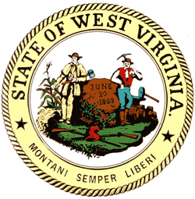

STATE OF WEST VIRGINIA
WEST VIRGINIA ETHICS COMMISSION
210 Brooks Street, Suite 300
Charleston WV 25301-1804
(304) 558-0664 / FAX (304) 558-2169
ethics@wv.gov / www.wvethicscommission.org

MEDIA ADVISORY

FOR IMMEDIATE RELEASE Contact: Diane Holley-Brown
November 7, 2013 (304) 558-0661

WEST VIRGINIA ETHICS COMMISSION TO CONDUCT TRAINING ON GOVERNMENTAL ETHICS ACT ON NOVEMBER 19 IN MOOREFIELD

CHARLESTON, W.Va. – The West Virginia Ethics Commission announced today that it will offer a one-hour ethics training session on the West Virginia Governmental Ethics Act on Tuesday, November 19, beginning at 6 p.m. at the Hardy County Division of Highways Headquarters, located at 39 Second Lane, 2104 SR 55, in Moorefield, W.Va.

The session is free and open to state and local public employees, government lawyers, media and the general public. The West Virginia State Bar has approved the course for 1.2 hours of Continuing Legal Education (CLE) credit, which includes 1.2 hours of Ethics credit.

The topics covered from the Ethics Act will include the prohibition against use of public office for private gain (including nepotism); the prohibition against having a financial interest in a public contract; gift limitations for public servants; the prohibition against improperly using or divulging confidential information; employment limitations for public servants; prohibited representation; limitation on practice before board/agency/department; employment by regulated persons/vendor; voting rules for public servant; and limitations on compensation/expenses.

Registration is only required for attorneys who wish to receive CLE credits. The meeting room will open at 5 p.m.; the meeting capacity for the meeting space is 50.

#30

