Wolf Pack Theatre Company in conjunction with

Community Crisis Services and St. John Evangelical Lutheran Church

Proudly Presents the Second Annual:

[](http://www.google.com/url?sa=i&rct=j&q=&esrc=s&frm=1&source=images&cd=&cad=rja&uact=8&docid=5S7HrwFrAncgnM&tbnid=JtYHYrO5ctDh3M:&ved=0CAUQjRw&url=http://christmas-wallpaper2012.blogspot.com/2012/12/christmas-flower.html&ei=WMIAVJr4OM_pggS6uILgAQ&bvm=bv.74115972,d.eXY&psig=AFQjCNGdVyYI7hH6xJH6BytbIbjb0xG3Iw&ust=1409422095036192)

[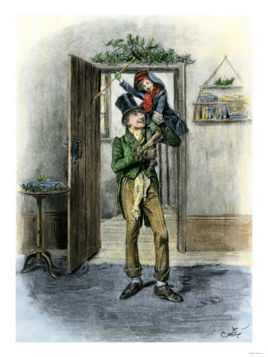](http://www.google.com/url?sa=i&rct=j&q=&esrc=s&frm=1&source=images&cd=&cad=rja&docid=NO2dJrLcNpssjM&tbnid=5OgpD6jY7eeJ2M:&ved=0CAUQjRw&url=http://keepingthechristmasspiritalive365.blogspot.com/2010/11/sunday-song-god-bless-us-everyone.html&ei=T9RvUo_XEs3C4APY8YD4Bw&bvm=bv.55123115,d.dmg&psig=AFQjCNGTJnECy4mM_drHOgcKrGgJfE4E6Q&ust=1383146420968718) [](http://www.google.com/url?sa=i&rct=j&q=&esrc=s&frm=1&source=images&cd=&cad=rja&uact=8&docid=EV7e3RyvvSpvBM&tbnid=unCXhUdMYnYJzM:&ved=0CAUQjRw&url=http://www.gabriellahewitt.com/2011/08/20/out-of-the-shadows-first-review/&ei=n-HPU5XmF8uzigLZzoGgDA&bvm=bv.71667212,d.aWw&psig=AFQjCNH9UPtiUUfQc2rsQv4WTFedhIFCYA&ust=1406219034056967)

**DC Metro Theatre Arts 2013**

[](https://www.google.com/url?sa=i&rct=j&q=&esrc=s&frm=1&source=images&cd=&cad=rja&uact=8&docid=nfkPDj4FmdQ0JM&tbnid=gpulLlMcQyI2iM:&ved=0CAUQjRw&url=https://sites.google.com/a/su.edu/virtual-tour/home&ei=_NXPU6aAGNauyATniIKgAQ&bvm=bv.71667212,d.aWw&psig=AFQjCNGCsDhJmQYZAJAFvw7GuCPgR-i6iw&ust=1406214830351969)

Charles Dickens Classic

Adaptation by William Leary

**Five Shows Only!!**

**December 5th and 6th**

**December 11th, 12th and 13th 2014**

**8pm Nightly**

**St. John Evangelical Lutheran Church**

**5820 Riverdale Rd.**

**Riverdale MD 20737**

**$15.00 Adult $9.00 Kids 12 and Under**

**For Reservations Call Bill Leary**

**301-864-7095**

**Email** [**billl@ccsimd.org**](mailto:billl@ccsimd.org)

[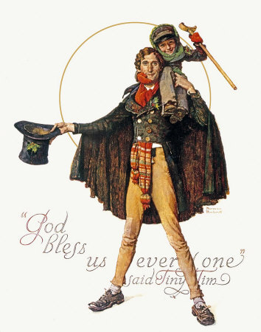](http://www.google.com/url?sa=i&rct=j&q=&esrc=s&frm=1&source=images&cd=&cad=rja&uact=8&docid=kxpwfmA-BeeHvM&tbnid=YUgoJ_4U4a1X1M:&ved=0CAUQjRw&url=http://www.best-norman-rockwell-art.com/1937-christmas-gramps-in-snow.html&ei=6OTPU8PWAsW5igLLuIHwDg&bvm=bv.71667212,d.aWw&psig=AFQjCNHUf9LVHtysxj7kwPLpYfn8HZH2Hw&ust=1406219861093979)