P.O. Box 425 Rochester, Illinois 62563 Phone: 217.381.6006 Website: www.inhishandsorphans.org

Dear Manager,

In His Hands Orphans Outreach is a 501 (c)3 non-profit ministry that provides adoption and orphan awareness, financial assistance for adoption, and helps children residing in orphanages worldwide as well as those in the United States foster care system. In His Hands is organizing the 4th Annual Heart and Sole Run for Orphans, which will be held on June 7th in the Rochester Community Park. We are excited to announce our project goal of $20,000 for this year’s race, which will be used to help purchase 6.3 acres of land in Haiti on which to build several orphan homes. In addition to raising funds, the race will create awareness of the need to help children in the U.S. foster system and orphans around the world.

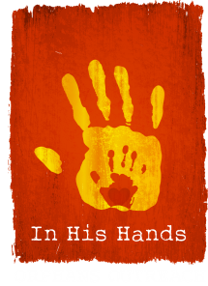
We are in need of sponsors for the event, and are asking you to partner with us to change the lives of orphans. Please see the attached flyer for the different levels available. Items or gift certificates for prizes are also appreciated. If you wish to sponsor the event or donate an item, please contact me at (217)899-6634 or by email at jerry@inhishandsorphans.org.
In His Hands Orphans Outreach

Your donation is tax deductible. For tax purposes, please use In His Hands Orphans Outreach Employer Identification Number: 90-0346849.

If you have any questions, feel free to contact us. We hope to see you at the Heart and Sole Run for Orphans to learn more about our organization and the work we do. We appreciate your consideration in joining In His Hands to give these little ones hope for a bright future.

For the children,

Gerald E. Willman
Race Director, Board Member
In His Hands Orphans Outreach

