Nis family fun night voucher
Date: 1/14/14
Time: 4-9 PM
Place: Friendly’s Restaurant
700-80 Route 101
Medford, NY 11763
631-924-4530
Submit this voucher to your server to ensure NIS receives 20% of your total bill.
Call Susan Cali at (631) 924-5583, ext. 128 for more information.
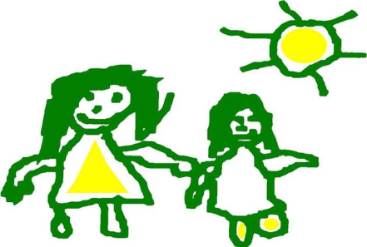
NIS is a non-profit school serving students with and without disabilities from birth to age 5.
New Interdisciplinary School * 430 Sills Road * Yaphank, NY 11980 * (631) 924 – 5583 * www.niskids.org

