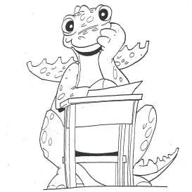Incredible Years
Parent Newsletter
Hello families!
Here at NIS, we are proud to use the Incredible Years program in our classrooms to help the children learn how to do their best in school, make friends, solve problems, and learn all about feelings. Every week, puppets named Wally, Dina, and their friends, visit the children in class to learn and practice new skills, with help from two members of our Children and Family Services department, Samantha and Tara.
This newsletter will keep you updated about the different lessons and skills being taught in the Incredible Years program. Ideas for activities you can try with your children at home will also be included. You will receive a new newsletter periodically, as the children progress through the program.
If you have any questions about the Incredible Years program, please feel free to contact Samantha Boutis, Psy.D. at 631-924-5583 x504, or Tara Buonagura, L.C.S.W. at 631-924-5583 x506.
We’re looking forward to an Incredible Year!!

Incredible Years
Parent Newsletter

Unit 1: How to do your best in school

In this unit, the children are taught the skills needed to succeed in school. Topics such as listening to the teacher, the importance of rules, waiting and being patient, being a good listener, and raising a quiet hand are all taught in this unit.
Home activities:
Here are some fun activities to try at home to help build on your child’s school-readiness skills
- Play Simon Says – this helps build listening skills and direction-following skills
- Play I-Spy – this helps build attention and observation skills, as well as direction-following skills.
- Make a list of “house rules” for the family to follow. Talk about them together, write them down, and hang them up. This will help your child learn more about rules and why they are important

