SJA Dinner Out Night
Thursday January 22, 2015
Take a break and enjoy lunch or dinner at HUB’S

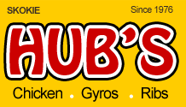
Hubs will donate 20% of sales to SJA! Print this flyer or mention SJA Night Out when ordering!
Hub's Restaurant
(eat in, carry out or delivery)
3727 W. Dempster, Skokie, IL 60076
Email: hubsrestaurant@aol.com
Phone: 847.677.7695 847.673.9409
Fax: 847.677.7701

Donations will benefit SJA School and eighth grade fundraising.

