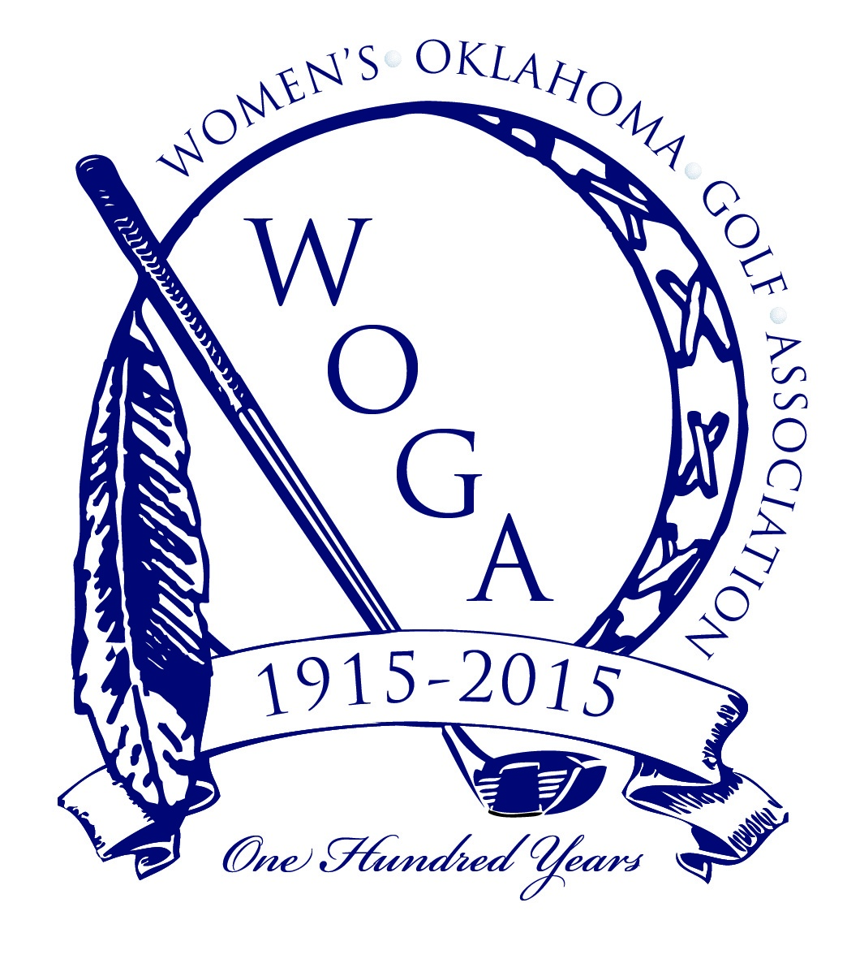
2015 WOGA CENTENNIAL SCHEDULE
May 18-19
WOGA Cup, Hillcrest CC, Bartlesville

June 16-17
WOGA Stroke Play/Mid Am Championship
Golf Club of Oklahoma, Broken Arrow

July 13
3rd WOGA Fundraiser benefitting WOGA Junior Programs
Southern Hills Country Club, Tulsa

July 14-15
64th WOGA Girls’ Junior Championship
Southern Hills Country Club, Tulsa

July 26
Once in a Lifetime
WOGA Centennial Celebration Gala Celebrating 100 Years
Oklahoma City Golf & Country Club, Oklahoma City

July 26-29
97th Women’s Oklahoma State Amateur Championship
Oklahoma City Golf & Country Club, Oklahoma City

August 2-4
Fore State Championship
Shadow Valley Country Club, Rogers Arkansas

August 25-26
WOGA Partnership, Shangri-la GC, Grand Lake

September 10-12
USGA State Team Championship
Dalhousie GC, Cape Girardeau, Missouri

September 21-22
39th WOGA Senior State Championship
Shawnee Country Club, Shawnee

