Victoria Park Recycling program
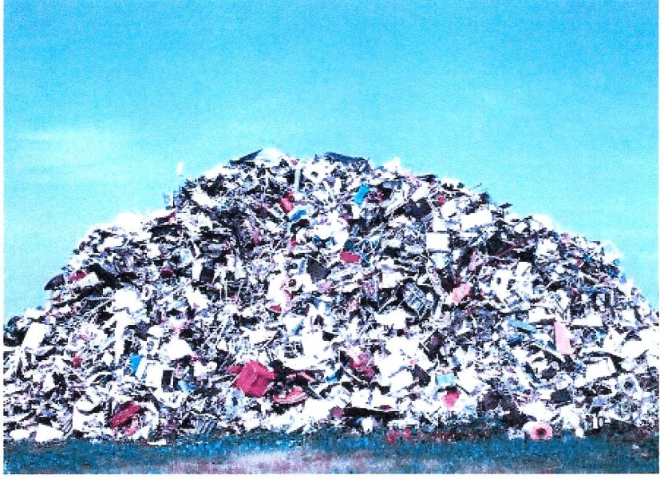
Recycle Today for a Cleaner & Safer Tomorrow
The Victoria Park HOA is implementing a program for residents to recycle batteries and fluorescent light bulbs which are not part of the current weekly recycling. Both of these items contain carcinogenic material which if deposited in dumps will leak into the ground and eventually the water we drink. The goal of the program is to encourage residents to recycle by providing convenient drop off spots within Victoria Park. Details on drop off locations and items on the list for recycling follows:
Drop off items (in plastic bags)
1. All fluorescent light bulbs 2. Batteries (all sizes except car) All types except Alkaline which can be put in regular garbage
Drop off location
1. Victoria Gardens Club House- turn in to the person at the reception desk or in the office 2. Commons, Hills and the Trails - turn in at the Park HOA to the person at the reception desk

