Lunch & Learn

Date: 3rd or 4th Wednesdays Quarterly (July, Oct. 2014; Jan., April, July, Oct. 2015)
Time: 11:30 AM – 1:30 PM
Description: Designed to meet specific needs of our members and their employees, Lunch & Learn educational seminars are offered in conjunction with Coastal Pines Technical College. Typically held from 11:30-1:30, these beneficial courses will include quality instruction, relevant training, class materials, and lunch for a nominal charge of $20 per person. Space is limited. Once the class title and date are announced, attendees will contact the Chamber to register.
Class Fee: $20 first employee/$15 each additional

Lunch & Learn Registration Form

Class Name: _______________________________________________Class Date:____________________________________

Chamber Member Name: _________________________________________________________________________________

Name & Email Address of Attendees:
__________________________________________________________________________________________________________
__________________________________________________________________________________________________________
__________________________________________________________________________________________________________
__________________________________________________________________________________________________________
__________________________________________________________________________________________________________
Please, list any dietary or seating accommodations beside the attendee’s name.

Amount Enclosed:

$20 for first participant = $20
$15 additional participants (________ x $15) = _______

Total: = _______ (checks made payable to PC Chamber of Commerce)
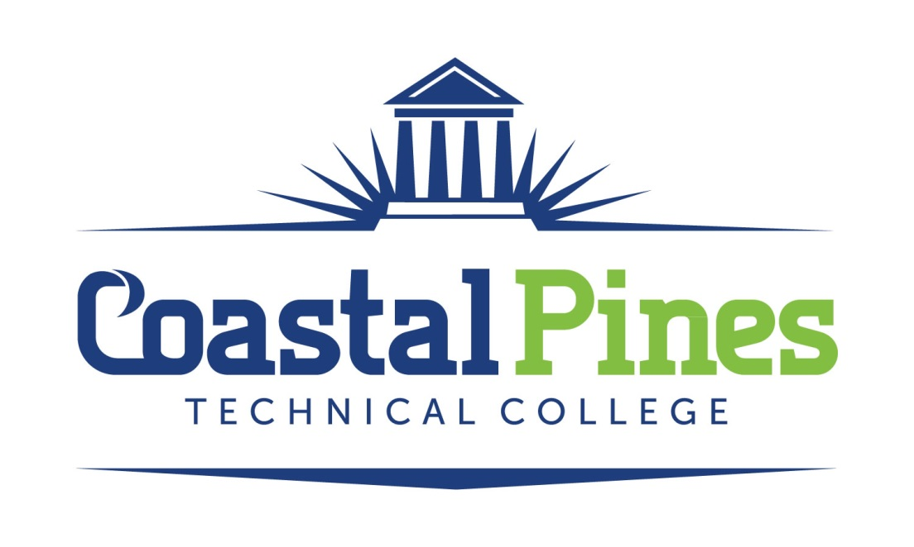
Wednesday, Oct. 22, 2014 – Board Room-PC Board of Ed.– 11:30-1:30
Class Title: EXCELLENT CUSTOMER SERVICE
Course Description: How you handle your customers can directly impact your individual and organizational goals. This interactive and informative session will give you the tools you need to communicate effectively and enhance customer relationships. After all, customers today demand world-class service!
Instructor: Markisha Butler’s expertise is in workforce development, community organization, mentoring, and group training. She couples her professionalism, creativity, flexibility, and enthusiasm to the relevant subject matter. She is the Director of Business and Community Services at Coastal Pines Technical College and brings over 14 years of work experience with federal and state education and training programs. Markisha has a Bachelor of Science degree in Sociology, a Master’s degree in Public Administration, and is currently pursuing a dual doctorate degree in Organizational Leadership and Higher Education Leadership.

Angela Manders, Executive Director
Pierce County Chamber of Commerce
P.O. Box 47, 200 SW Central Ave., Blackshear, GA (912) 449-7044
piercechamberofcommerce@gmail.com

