1207 Seminole Highway

Madison, WI 53711-3726

(608) 263-7888

Fax (608) 262-5209 www.wisc.edu/arboretum

Clothing to Wear for a Work Party
During our volunteer projects, volunteers spend approximately 2-4 hours outdoors, sometimes in brushy vegetation. Mosquitoes and ticks are present in the summer, snow likely in the winter. It is very important to dress properly in order to have a comfortable and safe Arboretum volunteer experience. Wear clothes that you don’t mind getting dirty. We provide tools and gloves.
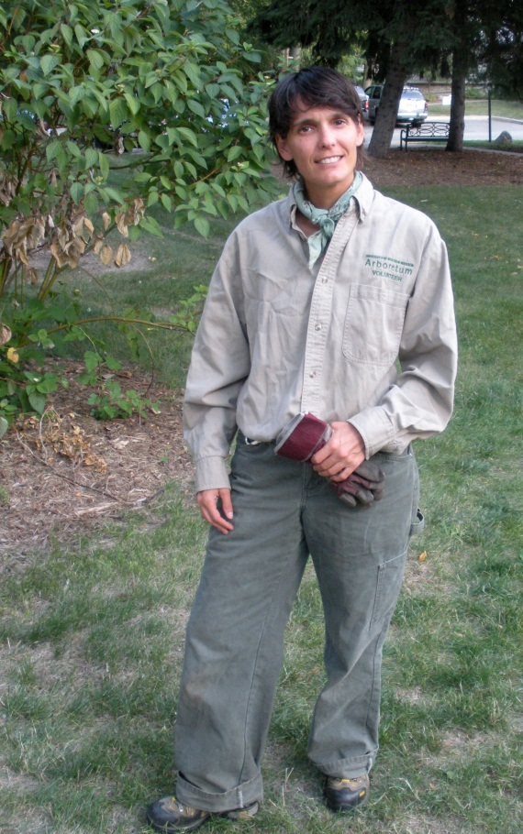
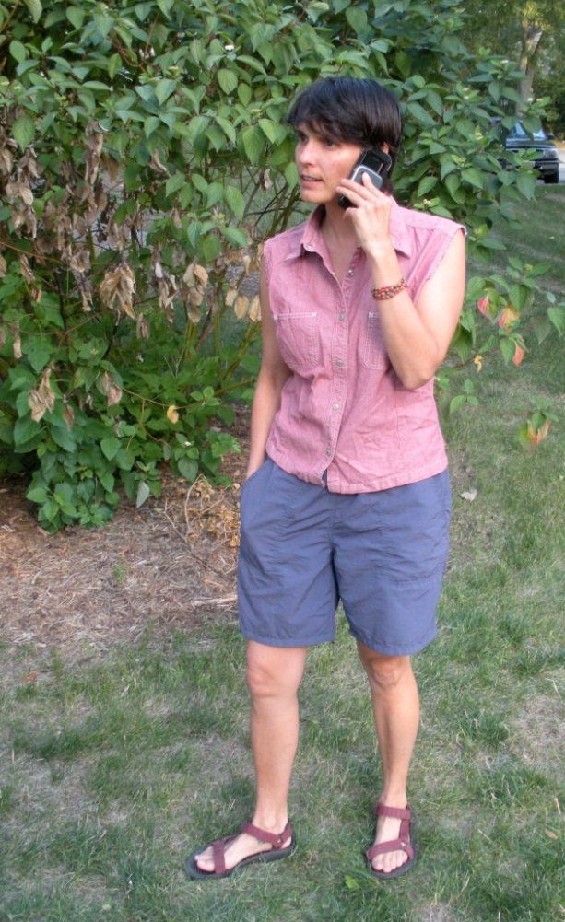
NO!
YES!

Do Wear:
Sturdy closed-toed shoes or boots
Long pants

Optional to wear or bring:
Long-sleeved shirt
Heavy socks
Hat
Jacket (no flannel or fleece)
Long underwear in the winter
Favorite garden gloves, sunscreen, or insect repellent
Water bottle
Do Not Wear:
Sandals or flipflops
Dress shoes
Shorts
No cell phones or i Pods
Flannel or fleece shirts or jackets (burrs get attached)
Dress clothes

