Gear Tip- Choosing Dry Fly Rods
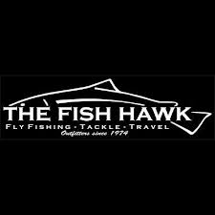
By: Gary Merriman
Few choices are as important in fly fishing as which fly rod you choose. The fly rod is the delivery system for your fly line, it controls how your fly lands on the water surface, it maintains the dead drift, and it is the shock absorber that protects your tippets when fighting fish. To many, the number of fly rods on the market is daunting and the choices can be overwhelming but we will try to clear the air and make give you some great tips for how to pick the perfect fly rod. In this article, we will focus on what makes a quality dry fly rod and how to choose one.

When fishing dry flies, nothing matters more than your presentation. A dry fly should land delicately and disturb the surface of the water very little. This is only accomplished by a long, well constructed leader which is delivered with the correct amount of power. The perfect dry fly rod is one with enough action that will give just enough power to the leader to turn over the length of the leader. This is a delicate balance and is best accomplished with a slower action rod. The perfect dry fly rod will not have the same action as your nymphing rod which is intended to turn over indicators, lead, and multiple flies. When fishing a dry fly on this type of rod, your presentations will often have the too much power and will splash the fly into the water, often times at the expense of scaring off the fish. The stiffer action rods will also not guard your delicate tippets. A dry fly rod with a softer action will act much like a shock absorber when fighting a fish. It will flex, bend, and bounce and take much of the force into the rod rather than strictly on the tippet. A stiff rod will not flex enough and all the force that a fish generates will go straight into your tippet often resulting in break offs.

A dry fly rod will also need to be long enough to mend the line and ensure a dead drift. A nine foot rod is normally the best bet. It will be long enough to lift the line off the water or to throw aerial mends but its length won't be cumbersome to cast. Ensuring a dead drift is paramount in dry fly success and a nine foot rod will give you the most versatility between being able to mend your line and cast accurately.

