Display Panels

99” w X 87.5” h

Table Top

48” w X 51.5” h

Table Cloth

Convertible 6’ or 8’

TERT accessories are available for TERT related conferences. If possible, please send item reservation at least 8 days in advance. Shipping to your location will be free. NJTI-TERT has a limited budget for outgoing shipping. If you need shipping reimbursement please scan the receipt with reimbursement information (name/address, etc.) to sdecker@nctcog.org. Choose the cheapest shipping method available. Once the items are shipped to the requested location, included will be instructions on how/where to return the panels and/or items. Requesting members are responsible for ensuring that they arrive at the new location by the date given. If for some reason, the items do not arrive at the requested location or arrive damaged please email sdecker@nctcog.org or give call 817-695-9199. A calendar dedicated for TERT items is available on the NJTI website. If you have any questions or concerns please contact Sherry Decker.

Name: Organization: Contact number: Shipping address: Item(s) to reserve: Dates needed:

FAQ

I’m having trouble retracting the table top. What should I do?

When retracting the table top, you will get to a point when it no longer wants to retract. This requires a very simple solution. You simply have to remove the two chrome pieces at each end of the table top. To remove the chrome pieces you do not need any tools, simply pop them right off. You then press and hold the button on the right side of the table top while pressing the button on the left side of the table top. The frame should automatically retract. You should hold the frame upright in order for it to retract appropriately.

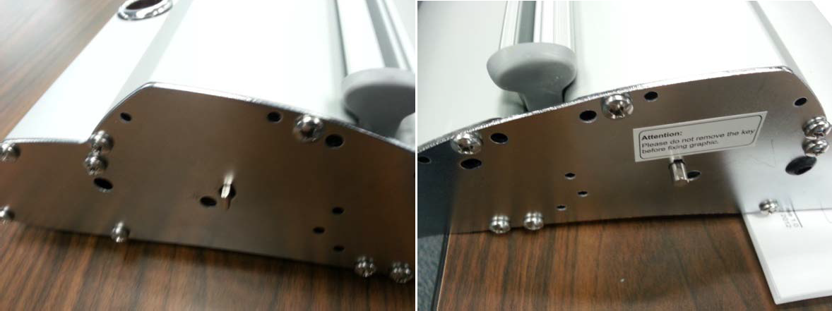

(Left) Chrome piece has been removed. (Right) Chrome piece has been removed. button is located in the middle, on the Button is located below white Attention label. top right of the hole.

I don’t think I’m setting up the panels correctly. I think I might be missing some pieces. Are there any directions for setting up the panels?

Setting up the panels should be fairly straight forward. Check the bag to make sure you have all the pieces for the display panels. The table top and display panels each come with 2 poles and each pole comes in two pieces. Make sure you have all of the pieces available when constructing the panel. The top piece of each pole extends, so make sure it is extended far enough to display the entire panel.

The panels seem to have arrived damaged. What should I do?

If the panels arrive damaged or have not arrived please send Alejandro Moreno an email or give him a call.
ccabrera@nctcog.org 817-695-9155.

