NCBI Seaside Community Dialogue
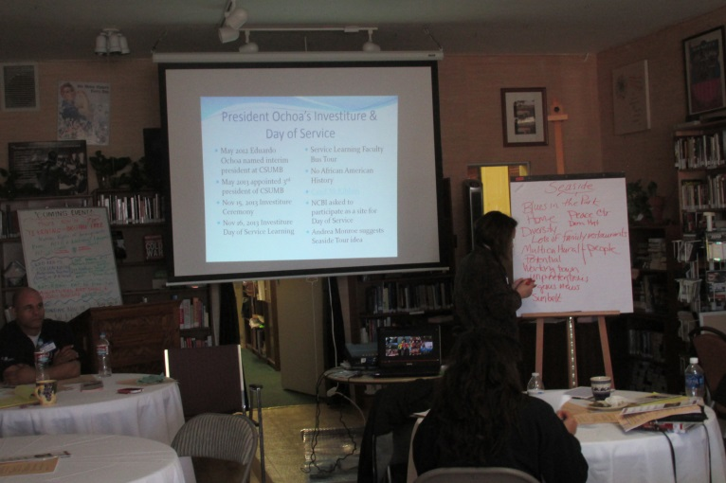

In celebration of the investiture of Dr. Eduardo Ochoa as CSU Monterey Bay’s third president, NCBI Monterey County was one of over two dozen agencies that hosted CSUMB students, staff and faculty for a Day of Service coordinated by the CSUMB’s Service Learning Institute (SLI) on Sat November 16th, 2013.

The previous year while working as an AmeriCorps VIP at the SLI, Steven Goings (now an AmeriCorps VIP for NCBI) had noticed that there was no mention of African American history on the CSUMB faculty bus tour hosted by the SLI that begins on campus on the former Ft. Ord (now part of Seaside) and goes through the Salinas Valley.

Having just read historian Carol Mckibben’s book, Racial Beachhead; Diversity and Democracy in a Military Town, which explored the central role African Americans played in the development of Seaside, Steven was on the lookout for an opportunity to correct the oversight. Yet it was Andrea Monroe, associate director of the SLI, who first came up with the idea of hosting a community dialogue designed to bring together stakeholders to drum up interest in the development of a walking historical and social justice tour of Seaside.

Simultaneously and serendipitously, CSUMB student Lucia Giroux who had volunteered with NCBI at this year’s Training of Trainers contacted Chapter Director Sue Parris with the hopes that she could perform her 30 hours of Service Learning with NCBI and voila! we had a project and a volunteer/service learner. Now we only needed a place.

As a former president of the Monterey Peace and Justice Center, Steven Goings was able to arrange to have the community dialogue, at the Peace Resource Center. Long time Seaside residents like Helen Rucker and Be Swartley attended along with a handful of CSUMB community members including Dean Brian Simmons. NCBI Chapter Director Sue Parris and Elena Loomis facilitated portions of the dialogue using NCBI diversity training techniques.

Also in attendance was Seaside Arts and History Committee Chair Michael Wildgoose. NCBI is happy to report that the Service Learning Institute and the Seaside Arts History Committee are now in follow up meetings about creating service learning projects that will honor the diverse history of Seaside and educate students about its historic importance in terms of American civil rights and the integration of African Americans into the US military at Ft. Ord.

