ALL WOMEN WELCOME!
Synergy Success Networking Summit
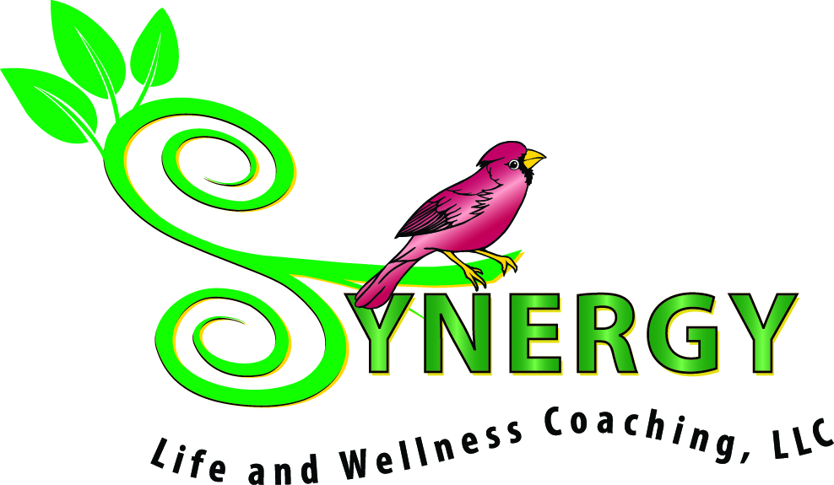
Bring Your Business to the Ballroom!

Thursday, November 6th at Spotswood Country Club, Harrisonburg

5:00-5:30 p.m. Early-bird Specials, Light refreshments, & Happy ½ Hour

5:30-7:00 p.m. Open House with 35 Networking Tables! An Exciting opportunity for Members and Friends of our “Synergy Success Circle” to Network, Showcase Products, Share Business Cards, Highlight Services, Be Inspired and get a Jump-Start on Holiday gift-giving!

7:00 -7:45 p.m. Heart-Centered Speakers: Meet 3 amazing women who are sharing their gifts with the world through their work. These women inspire me with their creativity, heart, and tenacity. I want you to know them too!

Cathy Jackson Leitner
Estate Planning Attorney
“Tips to Create & Sustain Balanced Success”

Jill McLaughlin
Classic Kitchens and Bath
“Leverage your Professional Platform
to Raise Awareness for Causes you Care About”

Sallye Trobaugh
Trobaugh Group
“Tap into Professional Prosperity by Honoring the Feminine Way”

Want a Networking table? Have Questions? Call Christina at 540-746-5206
or Email info@synergylifeandwellnesscoaching.com

*This Event is designed for high-value networking, low-cost table fees, and free admission*

