Synergy Success Networking Summit
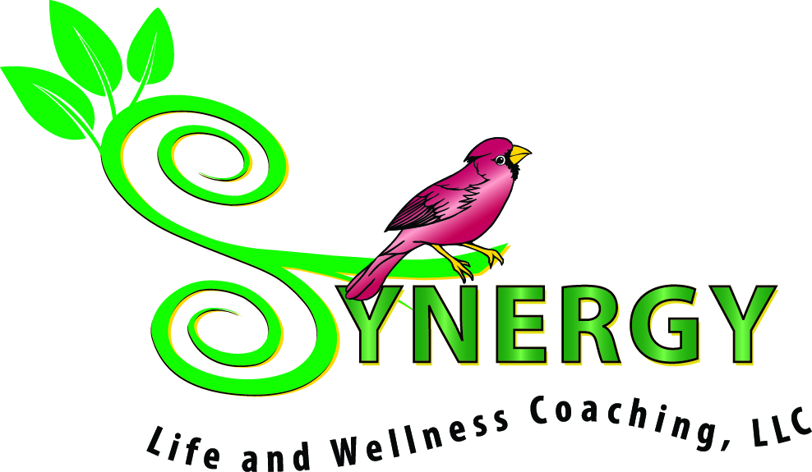

Thursday, November 6th 5-8 pm at Spotswood Country Club in Harrisonburg.

WOW!! We’re now filling up the BIG Ballroom! 35 tables/vendors
To ensure a great turn out and keep it "Easy-Breezy" for all of us:
- $20 per table (100% of this will go toward food/refreshments)
- 1 small raffle item to put into our drawing
- Invite 25 of your girlfriends with (a festive flyer will be provided)
If you want to join us and you are not already listed below, please reply "YES-I'm In”
By October 10th to reserve your table.

- Marsha Mays Bernard Dynamic Balance Consulting, LLC
- Kathy Armentrout Edward Jones
- Monica Johns Breaking Free/Counseling Services
- Jennifer Shirkey Lenhart Pettit PC/Dancing with the Stars of the 'Burg-Team Shirkey
- Mona Gil Unique Handmade Jewelry and Interior Design
- Atwell Family Chiropractic
- Jeanette Key Premier Jewelry
- June Martin Wildtree
- Jill McLaughlin Classic Kitchen and Bath
- Jennifer Matthai-Cottrell You’ve Got it Made /LOTUS Holistic lifestyle practices
- Cindy Noftsinger Mary Kay
- Kay Harrison Organizing
- Valerie Golladay Abundant Life Nutritional Therapy
- Christina Kunkle Synergy Life and Wellness Coaching/Harrisonburg Crossfit
- Cathy Beighe Valley Staging and Design
- Lauralea Spitler Hopkins Cabin Art Gallery treasures
- Judith Rocchioli Medical Thriller Novels
- Aimee George Shenandoah Magazine
- Anne McMahon Pink Papaya Inner Balance, Outer Beauty
- Kathleen Kelley Integrative Physician/Holistic Lifestyle practices
- Deirdre Staton Into Courage and Connection (from Brene’ Brown)
- Kim Landis-Hamner Skin and Zen
- Beverlee Juiced by Beverlee/Kendall Wondergem Hot Yoga Harrisonburg
- Becca Slye Isle of Candles (Soy Lotion Candles)
- Kelly Burkholder Ameriprise Financial
- Mary Mather Access Dermatology
- Elizabeth Scott Scentsy
- Whitney Lawson Thirty-One 31
- You?_____________________________________
- _________________________________________
- _________________________________________
- _________________________________________
- _________________________________________
- _________________________________________
- _________________________________________

Call Christina at 540-746-5206 or Email info@synergylifeandwellnesscoaching.com for more information
& to reserve your table!

It's sure to be a fun event filled with amazing women, new friends, great snacks, and much more.

