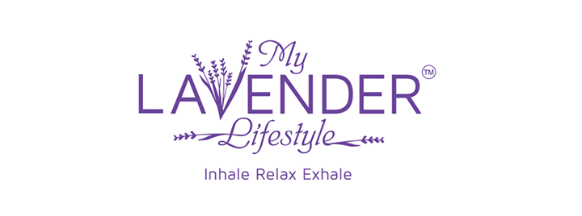

YOU ARE INVITED TO RELAX & UNWIND AT
OUR“MY LAVENDER LIFESTYLE” PARTY

PARTY HOSTESS: Christina Kunkle & Synergy Success Circle
CONSULTANT: Marsha Mays-Bernard
WHEN: Thursday, March 20, 2014
TIME: 6:00-7:30 p.m.
WHERE: The Gathering Place, 841 Mt Clinton Pike, H’burg

All of our My Lavender Lifestyle products contain lavender essential oil and flowers grown naturally at White Oak Lavender farm in the heart of Virginia’s beautiful Shenandoah Valley.

My Lavender Lifestyle is a holistic way of living that embraces healthy practices utilizing the relaxing properties of lavender. We believe lavender brings out the best in people. Lavender has something special that invites us to relax, share our stories and find clarity and courage in our lives.
Please RSVP by March 18th 540-746-5206 or info@synergylifeandwellnesscoaching.com

Our Raffles always Rock ~ So Tip the Tickets in Your Favor!
RSVP by March 18th = 1 extra raffle ticket
Bring a Friend = 1 extra raffle ticket for each guest you bring

