Oregon State University Craft Brewery Startup Workshop Scholarship Recipient Announced
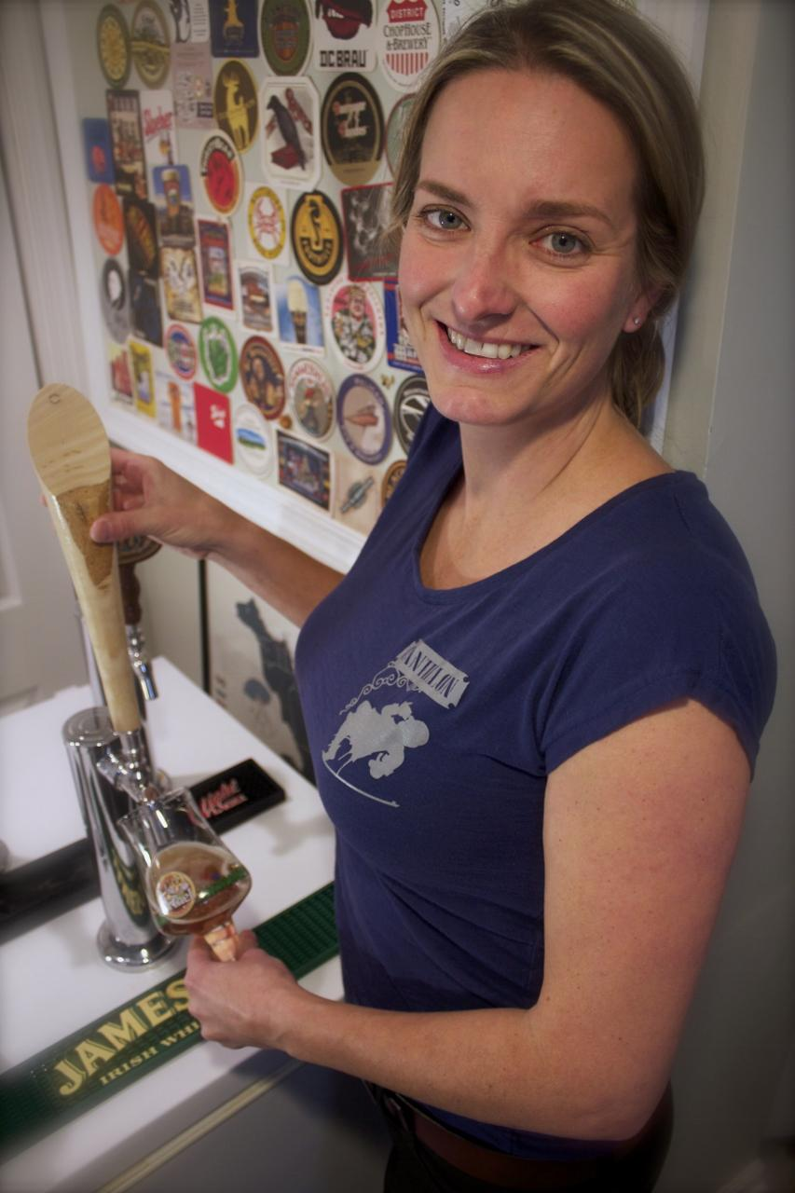
The Pink Boots Society is proud to announce that Judy Neff has been selected as the recipient of the 2014 OSU Craft Brewery Startup Workshop Scholarship. Judy is co-owner of Pints and Plates, a beer dinner catering company, in Baltimore, Maryland, who plans to begin construction on her Farmhouse Brewing Company in 2015.

The PBS Scholarship Selection Committee (SSC) is made up of five very experienced women beer professionals who hold positions as brewers, educators and writers. The committee was impressed with Judy’s craft beer path and believes with her enthusiasm, energy, passion and creativity the scholarship is a great match for helping her make that happen.

Judy, who holds a PhD in microbiology, brewed her first batch of beer in 2006 and since then has become imbedded in the craft beer scene in Baltimore. In addition to earning the opportunity to brew a batch of her English Special Bitter with tea at the Pratt Street Alehouse she has organized events during Baltimore Beer Week, co-founded the Baltimore Beer Babes (now a Barley’s Angels chapter) and regularly speaks at events to promote craft beer appreciation, specializing in food pairings.

Attending the Craft Brewery Startup Workshop will build on the education she has already pursued - she’s a Certified Cicerone and BJCP recognized beer judge - and further assist her in plans to open Farmhouse Brewing Company with three other individuals. Plans for the brewery include a flagship Saison/American Farmhouse style beer with yeast collected from a farm in Baltimore County, a juniper IPA, a clementine wit and the ability to produce small-scale specialty beers that incorporate ingredients such as ginkgo, ginseng and schizandra berries. Judy is excited to be attending the workshop, knowing it will, “be valuable to gain insights into the validity of our model, [provide] assistance with improving our business plan and… increase our chance for success.”

In addition to tuition for this course, Judy will receive a pair of pink steel-toe rubber boots when she fulfills the Pay It Forward requirement associated with the scholarship.

