Siebel Concise Course in Brewing Technology Scholarship Recipient Announced
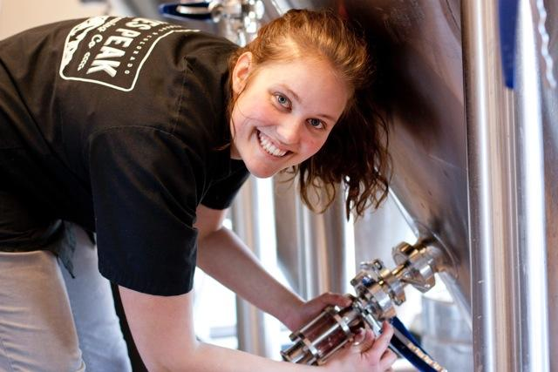
The Pink Boots Society is proud to announce that Aly Hartwig has been selected as the recipient of the 2014 Siebel Concise Course in Brewing Technology Online Scholarship. Aly is the assistant brewer at Pikes Peak Brewing Co. in Colorado and the only professional female brewer in Colorado Springs.

The PBS Scholarship Selection Committee (SSC) is made up of five very experienced women beer professionals who hold positions as brewers, educators and writers. The committee chose Aly from the pool of applicants agreeing that, “this course will allow Aly the start she needs to achieve her career goal as Head Brewer.” Her dedication to the craft comes through in her work as well as being the force behind Craft Beer Week in Colorado Springs and being the founder of the local women's homebrew club.

Aly is actively working to increase the knowledge and skills of those around her by inviting brewers and non-brewers including local beertenders, distributors and journalists, in on brew days. In March she hosted an International Women’s Collaboration Brew Day at Pikes Peak Brewing Co and in April was one of 30 women who participated in an all female tap takeover at Ernie’s Bar & Pizza in Denver, CO during the 2014 Craft Brewers Conference.

Pikes Peak Brewing Co. is a small, but rapidly growing and Aly knows that the growth will require a more educated brewer than she currently is. Through furthering her education she feels she will be able to gain the expertise to meet the increasing demands and grow with the brewery. Ultimately she hopes to become a head brewer and be in a position that will allow her to use her creativity to, “make wonderfully crafted beer that brings the community together and supports local philanthropic organizations.”

In addition to tuition for this course, Aly will receive a pair of pink steel-toe rubber boots when she fulfills the Pay It Forward requirement associated with the scholarship.

