we l ve our volunteers
Sale
April 15th - 26th, 2014
Just for Volunteers

Volunteer Polo’s 30% off
Volunteer Journey Guide Sets 10% off
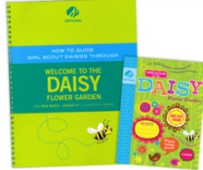

All Adult Clothing 30% off
Adult Cardigans, Sweatshirts, Dress shirts, T-Shirts & Pullovers

Thank you for ALL YOU DO!!!

Excludes clearance, excludes previous purchases and other offers

