Heritage DISTRICT

2014 PINEWOOD DERBY

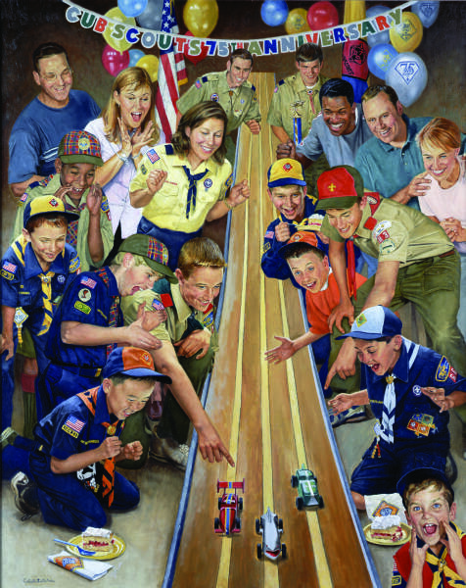

SCOUTS, START YOUR ENGINES!

PACK 915 is Proud to sponsor the 2014 heritage District Pinewood Derby!

This year’s Derby is scheduled to be held:

Saturday, February 22nd

Bethany United Methodist

1509 Todds Lane, Hampton.

All participating packs are asked to pre-register no later than February 14, 2014.

**District Pinewood Derby Chair:**

**Jim Mershon**

[Pack915cubmaster@gmail.com](mailto:Pack915@gmail.com)

(757) 813-7890

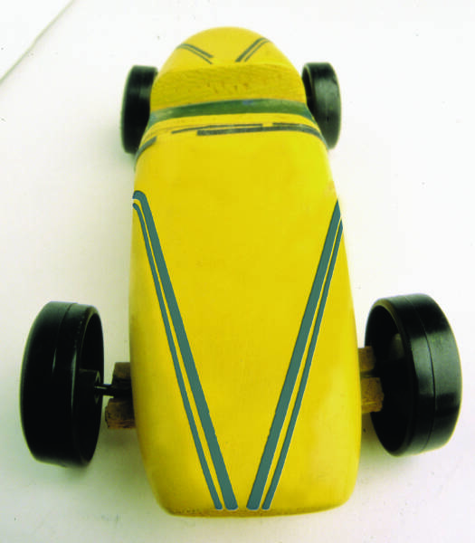**HERITAGE DISTRICT 2014 PINEWOOD DERBY**

**GENERAL RULES**

1. Pack 915 will sponsor the district competition with registration and race track officiating. Our volunteers will attend the pre-race briefing 30 minutes prior to check-in time on the day of the derby.
2. Tigers, Wolves, Bears, Webelos I’s, and Webelos II’s from Heritage District Packs will be allowed to compete at the district competition provided the boy is a registered Scout at the time of the District Pinewood Derby.
3. **In fostering an atmosphere of fair play and sportsmanship, participating scouts must be present to win in any category.** Therefore, the unit leader and all participating scouts from the pack are to check in together.
4. Each pack is encouraged to register their 1st, 2nd, and 3rd place winners in each rank, for a total of 15 entrants. No scout will be permitted to register more than one car, and cars will only compete in one category at the district level.
5. Your 4th place car also should be prepared to go to the district derby, in the event that one of your top 3 is not able to attend district competition or is disqualified at check-in.
6. Some Packs do impound their cars after the pack race. It is not required by the District. If you do impound, your pack-designated leader would be responsible for the cars until they arrive at district competition. The District will not store, nor be responsible for these impounded vehicles.
7. Cars constructed and/or used in previous year’s derby races are prohibited from competition in any subsequent year.
8. Late check-ins will not be permitted. Ensure your scouts have enough time to make those final adjustments, arrive early!
9. Axle guards are prohibited in District races. No solid/fixed axle that connects the same two wheels (both front wheels or both rear wheels) will be allowed.

**February 23th SCHEDULE OF EVENTS:**

(We will make every effort to keep on track with our times but be prepared for some modifications as needed. This will be an all-day event so come prepared to have fun for the whole day.)

|  |  |  |  |  |
| --- | --- | --- | --- | --- |
|  | Register  Start Finish | | Race  Start Finish | |
| Webelos IIs | 8:15 | 8:45 | 9:00 | 9:45 |
| Webelos Is | 9:00 | 9:30 | 9:45 | 10:30 |
| Bears | 9:45 | 10:15 | 10:30 | 11:15 |
| Wolves | 10:30 | 11:00 | 11:15 | 12:00 |
| Tigers | 11:15 | 11:45 | 12:00 | 12:45 |
| Grand Final | No Later Than | | 1:00 | 2:00 |

Note: Scouts can register earlier than their scheduled race time but no later than what is scheduled.

**Food & Drink Concessions will be available**

**CAR CONSTRUCTION RULES**

**(Applies to all cars, in all competition categories!)**

1. All cars are to be constructed using the materials provided in BSA’s Official Grand Prix Pinewood Derby Car Kit, to include official accessories also offered through BSA.

* Scouts may use any variety of accessories! This includes the BSA Pinewood Derby Car Add On Sheet, Red Dome Alert Light, Siren and/or Rocket Sound Wheel, Rocket Booster with Flashing Light, as well as any of the widely used weights and decals. When in doubt, if BSA sells it, and it’s used as intended, the scout can use it!
* Use of the aforementioned accessories, or those the scout creates, are not to interfere with nor negate any other construction rule, and are to be included in determining length, width and weight of the car.

1. The car length will not exceed 7 inches. Width will not exceed 2 ¾ inches.
2. The car shall weigh no more than 5 oz. Weight adjustments may be accomplished at weigh-in to ensure all entrants are in compliance. All weights must be firmly secured to the car with no moving parts/components. Mercury may not be used.
3. WHEELS AND AXLES:
4. The car will not ride on any type of springs and must be free-wheeling without any starting devices.
5. Loose materials, wheel bearings, hubs, washers, and bushings are not permitted. Axles may not be ground, filed, cut or otherwise turned so as to alter the original shape or size as provided.

**Note:** Axle guards are not permitted in District races. No solid/fixed axle that connects the same two wheels (both front wheels and both rear wheels) will be allowed.

* Officials must be able to see the axle at check-in!
* Only those axles provided may be used.
* Please note, the Sound Wheels offered through BSA are intended to be attached as a “spare tire”. They are not intended to replace the wheels and axles provided in the Official Grand Prix Pinewood Derby Car Kit.
* Only BSA approved wheels (no matter color) will be used for racing.

1. The distance between the front and rear wheels will not be altered from that of an official BSA kit, 4-3/8 inches. Nor shall the location of the axle grooves be altered to change the distance between the grooves and the front/rear ends of the car.
2. If the car design has a narrow body, make sure the area where the axles are inserted into the body remains 1-3/4" wide, or wheels will not fit over the guide strips of the track.
3. The car must have 3/8” clearance underneath the body for it to clear the track.
4. Wheels can be lightly sanded, as indicated in the instruction sheet that comes with the car kit, just enough to remove the seam created at fabrication. They may not be beveled, turned, thinned, drilled, or otherwise altered from the original manufactured shape which would otherwise create an unfair advantage by reducing friction or resistance.
5. The only approved axle lubricant is the Pinewood Derby Axle Lube (available through BSA) or powdered graphite. Any other lubricant is unauthorized. If used, lubricant may only be applied: 1) prior to check-in, and, 2) during the race after any necessary wheel repairs.
6. Once checked-in, cars will not be altered or modified in any way.
7. Strict adherence to these rules is essential. Any car found to be out of compliance will be disqualified.

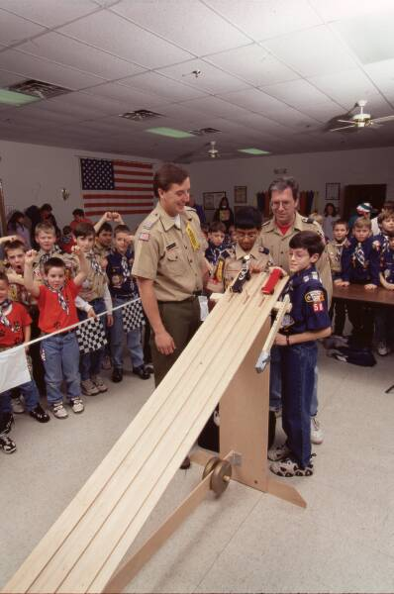**CONDUCT OF THE DERBY**

1. Once checked-in:

No one except the race officials will be permitted to handle the cars.

Specifically, Scouts will not handle their car during the race, except to make

approved in-race repairs. A limit of two in-race repairs will be allowed, if

more is required, the car will be disqualified.

1. Cars will race once in each lane, the order of which will be selected at random by computer. Each car’s average time, calculated by dividing the added race times from all race lanes by the number of lanes, will determine the finishing order.

* Times are calculated to the ten thousandths of a second (.0001). In the unlikely event of a tie, the car with the single fastest time, in any lane, will be used to determine ranking order.

1. If any part of the car breaks during the race, the scout shall be afforded the chance to repair the problem in the pit area, but no more than twice, under the supervision of an official, and the car rechecked to ensure it meets construction rules. The repair time will not exceed five (5) minutes. If after 5 minutes the car is not ready to race, it will be withdrawn from further competition. Accessories which are nothing more than cosmetic, which fall off during the race, are excluded from this rule and the scout will not be given time to re-attach the accessory. However, the heat may be re-run if, in the opinion of the Senior Race Official, the accessory interfered with an otherwise clean race.
2. If a car jumps the track, runs out of its lane, interferes with another car, loses an axle, etc., the race will be Red Flagged, the car(s) in question and entire length of the track inspected for defects, followed by a Green Flag to re-run the heat. If the same car gets into trouble on the second run, every reasonable attempt will be made to identify and correct potential problems. Only after reasonable efforts have been exhausted, will the car then be disqualified from the heat.



**Awards**

Award presentations will be made after each rank race.

Top 3 finishers per rank will receive trophies.

The final race will be for the Heritage District Grand Championship Cup.

This race will be comprised of the top finisher from each rank.

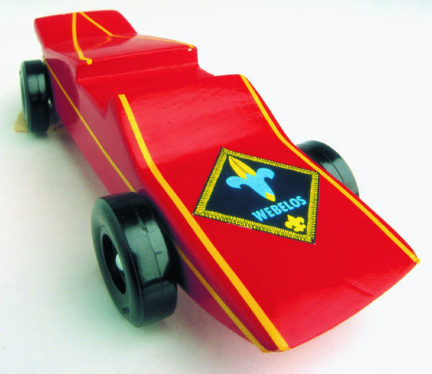**2014 HERITAGE DISTRICT PINEWOOD DERBY**

**PACK REGISTRATION FORM**

**Registration Deadline: Friday, February 14th, 2014**

**PACK Number: _________**

**CUBMASTER/ADULT LEADER: ___________________________________________**

**Phone _______________________ E-mail ___________________________________**

**TIGER-1: _____________________________ TIGER-2: ________________________________**

**TIGER-3: _____________________________ TIGER-ALT: _____________________________**

**WOLF-1: _____________________________ WOLF-2: _________________________________**

**WOLF-3: _____________________________ WOLF-ALT: ______________________________**

**BEAR-1: _____________________________ BEAR-2: __________________________________**

**BEAR-3: _____________________________ BEAR-ALT: _______________________________**

**WEB I-1: _____________________________ WEB I-2: _________________________________**

**WEB I-3: _____________________________ WEB I-ALT: _______________________________**

**WEB II-1: _____________________________ WEB II-2: _________________________________**

**WEB II-3: _____________________________ WEB II-ALT: ______________________________**

**Registration Fees:**

Total Entries ………….. ____________ X $5.00_ _ = $____________

Additional Patches Requested ________ X $2.00___ = $____________

(Additional patches would be for your #4 speed racer, adult volunteers, etc.)

**TOTAL REGISTRATION FEE ……………………………. $____________**

=115

**Completed registrations are due at the CVC Scout Office no later than Friday, February 14th, 2014!**