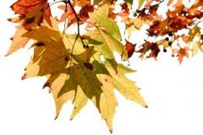
Fall 2014 Classes

September
9/6/14 10-11:30am Solar Light Study Group
9/23/14 6:30- 8pm The Sacred Bonds in our Lives
9/27/14 1-2:30pm Introduction to Essential Oils

October
10/4/14 10-11:30am Solar Light Study Group
10/11/14 1-2:30pm Rekindle Your Light
10/18/14 1-4pm How Light Unlocks the Higher Purpose Hidden in our DNA
10/30/14 6-8:30pm Halloween Body-Mind-Spirit Crawl (joint event with Mosaic Wellness)

November
11/1/14 10-11:30am Solar Light Study Group
11/15/14 1-3pm Documentary Film: Samsara

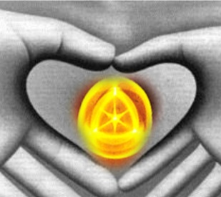
The Healing Place, W161N11629 Church Street, Germantown, WI 53022. www.thehealingplace1.com

