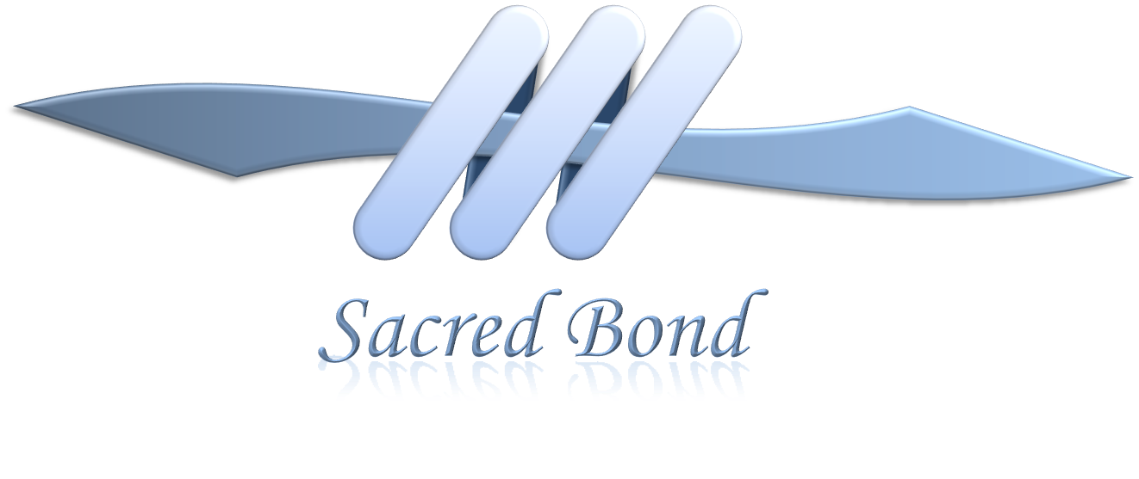
The Sacred Bonds in Our Lives

A Special Presentation at the Healing Place
6:30 to 8:00 PM, Sept. 23
Facilitator Rich Hanhardt

We all have been given the great gift of being able to enter into extraordinary relationships called here ~ Sacred Bonds. The depth and diversity and number of these healing relationships we have determine to a large extent the emotional health of our lives. I have dedicated my life to finding the pathway leading to the worlds in which these bonds can come alive for each of us.

This presentation will describe the five levels of Sacred Bonds that are available to us as human beings and how to access and deepen them. New techniques for discovering paths through difficult life experiences will be discussed. These healing paths, already worn smooth by the ancients, are much closer than we usually consider them to be.

Cost: $18

Please RSVP by Sept.15 at 262-719-0030 or pmyota@sbcglobal.net

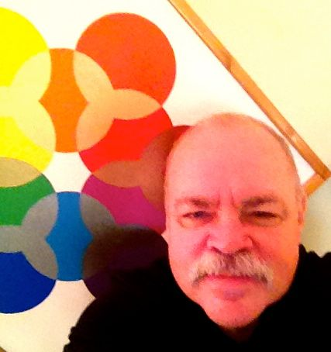
Rich Hanhardt, MS, MBA, BCSLC has studied and practiced in a number of traditions including Tibetan Buddhism, Zen, Taoism, Native American spirituality, the symbolic in healing, the work of Carl G. Jung, and the study of mythology, fairy tales and stories from multiple cultures. Most recently he has spent many years in the study of Christian theology and is now especially focused on the gifts from the Christian mystics. He is the author of the book “Sacred Bonds”.

The Healing Place, W161N11629 Church Street
Germantown, WI 53022
www.thehealingplace1.com

