Mayor’s Innovation Award
2014

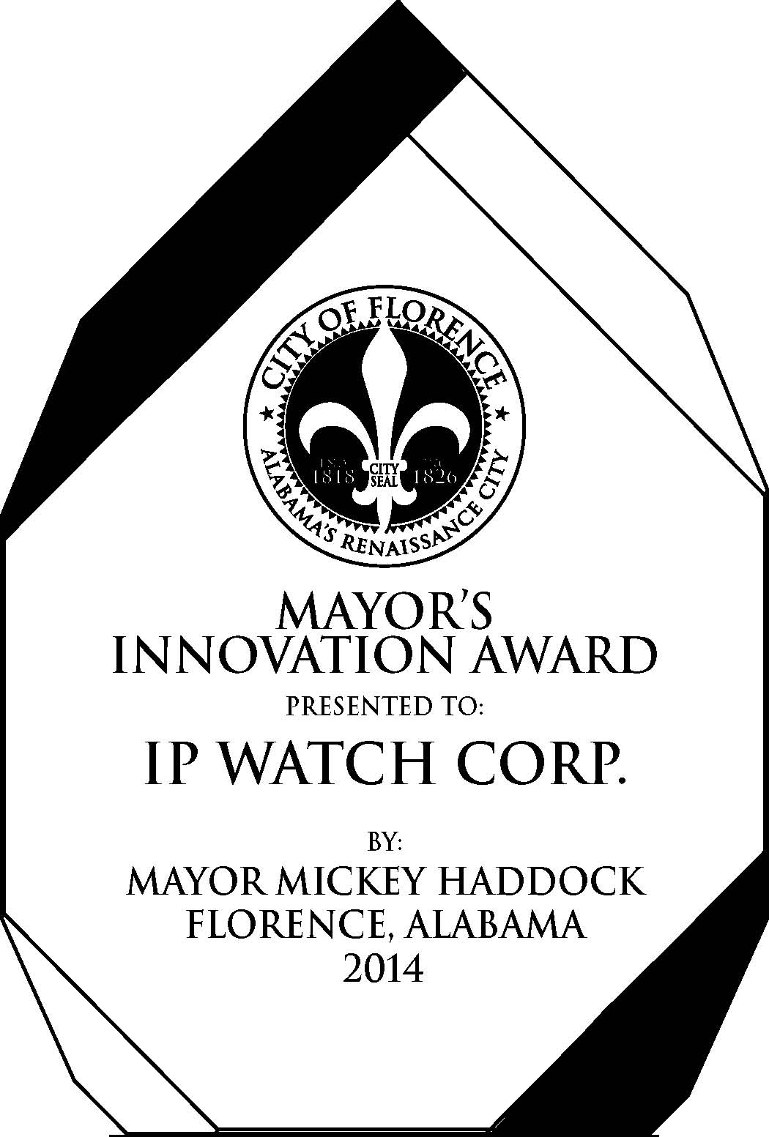

Along with the State of the City presentation on Wednesday, Mayor Haddock selected three companies to be recipients of the Mayor’s Innovation Award for 2014. This award is intended to encourage and recognize innovative ideas which make significant and lasting contributions in our community.

Innovation creates competitive advantage and is a powerful engine which can drive the economy of Florence and the Shoals.

Working cooperatively with UNA, corporate leaders, entrepreneurs, and concerned citizens, we believe Florence is positioned to transition into a community which will encourage and foster innovation, creativity, ideas, and solutions needed to address the pressing social and economic issues of the day and meet the challenges of tomorrow.

Bold, ambitious, and inspiring ideas not only enrich the innovator, but by igniting a new narrative for our region, can strengthen our economic future and build a spirit of innovation throughout Florence and the Shoals.

To this end and to recognize those who have made a positive contribution to the quality of life in Florence and the Shoals, the Mayor’s Innovation Award was created. The 2014 recipients are:

Billy Reid, Inc. –

Ms. Katy McNeill accepted the award on behalf of Billy Reid, Inc.

With an aesthetic that embraces classic Americana and modern luxury, fashion designer Billy Reid’s clothes appeal to men and women who understand quality and have a deep appreciation for craftsmanship and unique detailing.

In 2004, Billy Reid, the company, was started by four business partners including Billy Reid, KP and Katy McNeill, and Jake Szczepanski. The company would highlight the designer’s unique lifestyle and very personal point of view while growing a stable of stores equipped to house a full range of collections, foster community through special events, and serve as platforms for growth.

The company has won many awards Best New Menswear Designer in America; in 2010 as well as the CFDA/Vogue Fashion Fund. In 2012, Billy Reid received CFDA’s prestigious Menswear Designer of the Year award.
Billy Reid offers a full range of men’s and women’s clothing, accessories, shoes, and denim.

Billy Reid has showrooms and a retail shop in New York City and the flagship store and design studio in Florence, AL, where the company is a vital part of The Shoals.

There are eight additional Billy Reid locations in the United States, including Atlanta, GA; Austin, TX; Charleston, SC; Dallas, TX; Houston, TX; Nashville, TN; New Orleans, LA; and Washington, DC. Two additional stores will open in late 2014.

Billy Reid’s e-commerce shop offers a full range of men’s and women’s apparel and accessories, and the company also sells about 75 different retail stores across the country, including Nordstrom, Neiman Marcus, Sak’s Fifth Avenue and many others.

Alabama Chanin –

Natalie Chanin, founder and owner, accepted the award.

Alabama Chanin is a lifestyle company producing well-designed and thoughtfully-made goods for the person and the home. They use 100% organic cotton jersey fabric in their design, sourced sustainably from seed to fabric.
The company that has become what Alabama Chanin is today began early in 2000 with the creation of hand-sewn garments made from cotton jersey fabric. Alabama Chanin retains the same intention and integrity today. Heirloom pieces are made from 100% organic cotton, sewn by hand through a group of talented artisans who each run their own business, in their own time, and in their own way. The company strives to maintain sustainable practices—across its disciplines— and create sustainable products, holding themselves to the highest standards for quality. They are makers and educators, working to elevate and merge design, craft, and fashion.
Made in the USA, Alabama Chanin strives to celebrate and preserve our unique traditions and crafting techniques, with a strong commitment to community. The company is rooted in the tenets of the Slow Design movement: good, clean, fair— which encourages designers, artists, and consumers to create and utilize thoughtful products in a socially and environmentally responsible way.

IP Watch Corporation –

Dr. Sean Collin, founder and owner, accepted the award.

IP Watch was founded in Florence, Alabama with the goal of ensuring intellectual property protection for innovative companies nationally and globally. IP Watch technology assists corporations and law firms to more efficiently and effectively clear and manage their intellectual property assets. The company is profitable, and all of its technology development is self-funded through providing services and software to global multi-national companies, entrepreneurs, and public companies (including Fortune 100 companies). All of its technology was developed completely here in Florence Alabama and is currently deployed around the country and in a number of other countries.

IP Watch originally worked with third party software companies to provide services to its Clients. From there, the company began to develop and test different systems and technologies for intellectual property management with substantial companies across the United States, with the assistance of local UNA students and graduates. By 2012, IP Watch had arrived at the disruptive software and system architecture that would achieve their goals of lowering response time and costs materially for companies using IP Watch services. Soon after, the company began to run many beta tests on different aspects of the system with current clients, breaking seven figures in revenue in the process in 2013.

The company currently utilizes over 20 UNA students and graduates in full-time, part-time and paid internship positions. Dr. Sean Collin, its Founder, is a full-time faculty member at UNA, co-executive director of the UNA Institute of Export Research and Technology Transfer, and Advisory Board member for the UNA College of Business Executive Advisory Council. In 2013, Collin received the Jerry Davis Entrepreneurship Award from UNA in part for his technology and media work with IP Watch and students.

Dr. Collin describes the Florence Research and Innovation Center office, as "Silicon Valley meets the South". By collaborating with UNA and utilizing students, IP Watch promises jobs for graduates, attracting and keeping more young people in the area so that they don’t move away from Florence to launch their technology careers.

Many of the UNA students come to IP Watch as referrals from Dr. Vince Brewton of the Honors Program as well as Greg Carnes, Dean of the UNA College of Business, and other of Dr. Collin’s colleagues in the College of Business. The company continues to look forward to a strong mix of students coming to work for IP Watch full-time after graduation and students taking the skills acquired while working with IP Watch to cultivate the local economy by using all that they have learned participating in this partnership.

