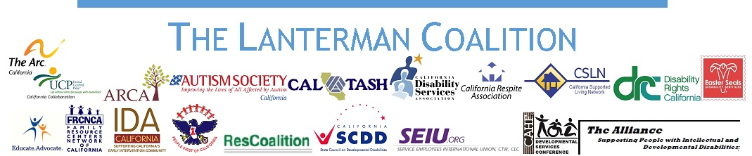

Honorable Governor Jerry Brown
Capitol Building
Sacramento, CA 95814

Re: The California Developmental Disabilities System

On behalf of the Lanterman Coalition, a coalition of the 19 statewide organizations of the California Developmental Services system, we urge you to stop the current state of collapse of our system before the harm to people with intellectual and developmental disabilities (IDD) and their families becomes irreparable. Our coalition represents every facet of our community and in our analysis the single most important action needed this year is a 10% increase to stop the current crisis from continuing to escalate and to begin to stabilize the community system.

People with IDD and their families have been supported by the Lanterman Act for the past 55 years. The promise of the act is still considered by many as an example of empowering and compassionate public policy, but realizing this promise has become increasingly impossible every year. During the past ten years alone we have seen a myriad of over 50 changes to the Lanterman Act, cuts to services, and frozen rates representing a major divestment from a once robust and comprehensive community system of coordinated care, supports, and services. Where larger community providers, some with histories longer than the Lanterman Act itself, once absorbed the closures of smaller programs now they are showing signs of collapse as well, shutting down programs or managing waiting lists from new referrals leaving people with disabilities with unmet needs and goals.

Families report they no longer have ready access to a stable and experienced team of regional center case managers, community direct support professionals, and others who used to make up the essential teams for realizing person centered and family centered plans.

There are countless problems in our community system today that have in the root cause the many years of divestments and neglect in its infrastructure and the 10% increase will not fix them, but we believe a 10% increase this year with 5% next year would make a serious impact on stopping the collapse. While there are also may other factors threatening to further deteriorate our community system that must be addressed such as a series of local, state and federal policy initiatives that add significant costs to providing services, those resolutions must be seen as separate from the 10% as they at best achieve only a status quo position for the IDD system.

Sincerely

Tony Anderson
Chair
Lanterman Coalition

