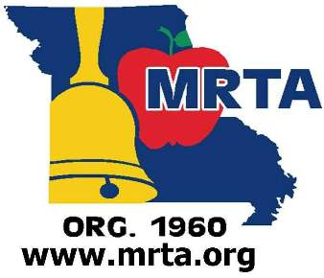

MRTA
Missouri Retired Teachers Association
and Public School Personnel
877-366-MRTA
3030 Dupont Circle
Jefferson City, MO 65109
www.mrta.org
News Release

For Immediate Release Contact
September 4, 2014 Jim Kreider – 417-849-5185
mrtadirectorkreider@mrta.org

MISSOURI RETIRED TEACHERS ASSOCIATION JOINS COALITION OPPOSING AMENDMENT 3

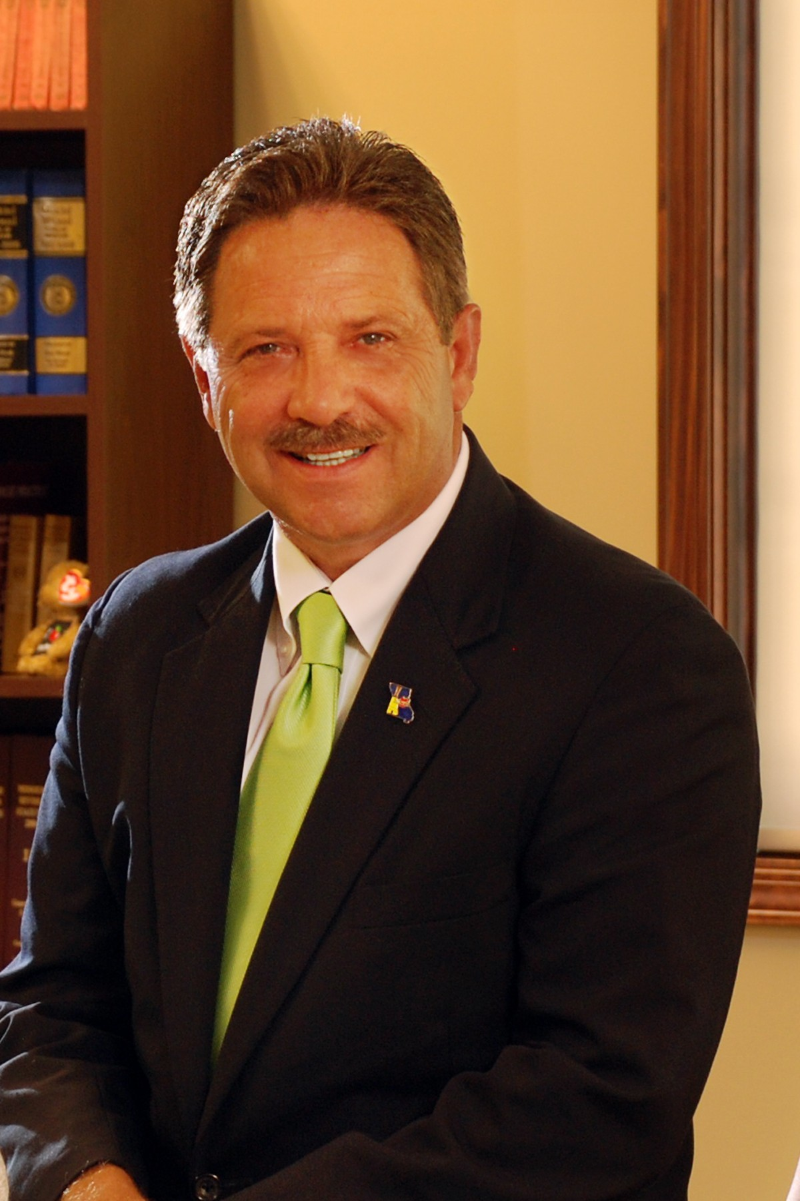
Jefferson City, MO – The Missouri Retired Teachers Association (MRTA), an independent association of over 23,000 members, joined the Coalition to Protect Our Local Schools campaign in an effort to defeat Amendment 3, which would take away local control of schools and implement a one-size-fits-all approach to education. The Protect Our Local Schools campaign is a coalition of teachers, parents, principals, superintendents, school boards and now, education retirees to defeat Amendment 3.

“I was a teacher for 25 years, and the standardized testing model that this amendment would implement is the wrong way to educate our children,” said Barbara Self retired teacher from Republic R-3. “Standardized testing does not work because it removes the individual needs of each child from the equation and forces a one-size-fits-all method of teaching. I encourage all Missourians to vote NO for the sake of our students.”
MRTA Executive Director Jim Kreider

“As a teacher of 30 years, I can speak to how awful standardized testing is for students,” said Linda Greeson, retired teacher from Eldon R-1. “I had many students who were very bright but were not the best test takers, and there is nothing more heartbreaking than seeing a child who is smart and who had studied hard do poorly on one of these tests. I know these are good students who know the material, but, unfortunately, the test score is all that matters. That’s the wrong approach. Please vote NO.”

MRTA is working with the Protect Our Public Schools Coalition to defeat the proposed unfunded mandates from the “Top Down” and what equates to a political takeover of our local schools in Missouri by Amendment 3. Amendment 3 is a Constitutional question funded by the Saint Louis billionaire Rex Sinquefield and his organizations. “Missouri School Districts do not need an outsider telling local school boards and taxpayers how to conduct school business,” stated MRTA Executive Director Jim Kreider. “We have the best and most experienced educators in the nation here in Missouri. Our education statistics prove Missouri children are getting a quality education at a very reasonable cost to the taxpayer compared to other states. We do not need Amendment 3. Please vote NO.”

###

