CLC Mondays at 360 Valencia in November

Open Lab and Tutoring in November
November 3 – 9:00 am to 1:00 pm, CLOSING EARLY
November 10 – 9:00 am to 3:00 pm
November 17 – 9:00 am to 3:00 pm
November 24 – 9:00 am to 3:00 pm

November Classes
Exploring Pinterest – November 3, 10:00 to 12:00
Overview of a blog from beginning to present: how to get started, what it takes to keep it up, where it takes you as you grow, financial opportunities. Ben Cohn has created a blog that started about seven years ago - it grew from an interest in music and has expanded to reviewing artists from all over the world. Check out the power of blogging!
Online Shopping - November 10, 1:00 to 3:00
Learn what you need for successful, accessible shopping online. Explore and using Amazon, Yelp, Etsy, Ebay, Craigslist and other sites. This isn’t ONLY an overview of sites; we’ll guide you on internet shopping and how to safely make a purchase online.
Holiday Cards - November 24, 1:00-3:00
eCards are those created by companies for individuals to send greetings electronically – they are well designed for all tastes and run from free to subscription - we explore mostly free ones and the easy to use. You can also create party invitations and keep party lists online.

Technology Swap Meet #3
Monday, November 17, 9:30-12:30 at 1187 Geary Street
Join us and many others to swap offers and requests for computer assistance; learn more about free and low cost computer resources; get hands-on training on computers, Skype, and email; see a presentation on accessible technology, and lots more! Call Community Living Campaign at 415.821.1003 or register online at: bit.ly/TechSwapMeet-3
See reverse side for other sites where CLC is teaching special “On The Road” classes and hosting weekly open computer labs
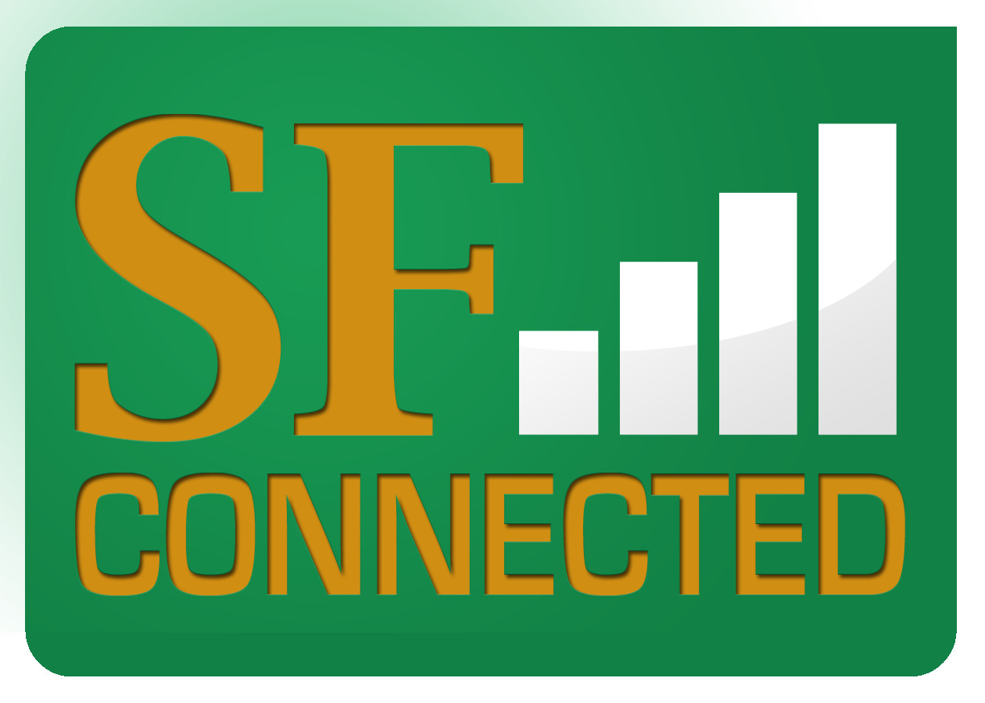
As part of the San Francisco Department of Aging and Adult Services’ SF Connected Program, Community Technology Network, Self-Help for the Elderly and Conard House also have basic computer training and specialty classes. To see a calendar of all free classes or for more information, go to www.sfconnected.org or call (415) 355-3555.

CLC’s Free Weekly Computer Classes & Tutoring
We teach people how technology and social media are new tools to help individuals and groups reduce isolation and reweave community. You can find the Community Living Campaign’s Community Connectors and Trainers in computer labs and senior centers across the city:
30th Street Senior Center* | Wed., 1 to 3 | 1 to 1 Tutoring, Classes | 225 30th St.
360 Valencia St. | Mon., 9 to 3 | 1 to 1 Tutoring, Classes | 360 Valencia St.
Aquatic Park | Wed., 1 to 3 | 1 to 1 Tutoring, Classes | 890 Beach St
Bethany Center | Thurs., (call to schedule) | 1 to 1 Tutoring | 580 Capp St.
Centro Latino* | Tues. & Wed., 10 to 12 | 1 to 1 Tutoring, Classes | 1656 15th St.
IT Bookman Center | Fri., 12 to 2 | 1 to 1 Tutoring | 446 Randolph St.
Laguna Honda Hospital | 1st & 3rd Wed., 1 to 3 | 1 to 1 Tutoring | 375 Laguna Honda
Mission Neighborhood Center* | Mon., 10 to 12 | 1 to 1 Tutoring,  Classes | 362 Capp St.
Telegraph Hill Neighborhood Center | Tue. 9:30 to 12:30 | 1 to 1 Tutoring | 660 Lombard St.
Richmond Senior Center# | Tues. & Thurs., 1 to 3 | 1 to 1 Tutoring | 6221 Geary Blvd.
* Training in Spanish # Bilingual training available in English and Chinese (Cantonese and Mandarin)

CLC’s “On the Road” Free Technology Presentations in November
￼Times and dates are subject to change. To confirm, or for more information about these and other hands-on presentations, contact Judy Auda at (415) 826-3194 or judyauda@yahoo.com:

Laguna Honda  Computer Club | Nov. 5 & 19 | 1 to 3 | Laguna Honda Hospital | 375 Laguna Honda – 1st Floor near Library
Video Post-Production | Nov. 6 & 13 | 11 to 1 | Bay Area Video Coalition | 410 Townsend St.
Creating and Emailing Holiday Greeting Cards | Nov. 13 | 1 to 3 | Stonestown YMCA Annex | 3150 20th Ave.
Sharing & Evaluating Your Collectibles – Bring a Favorite! | Nov. 20 | 1 to 3 | City College Program – 7th Avenue Presbyterian Church | 1329 Seventh Ave.
We’re always adding new classes – visit our online calendar at www.sfcommunityliving.org

