Annual Giving Workshops
The Gift of Generosity: Embracing the Way of Christ in your Annual Giving Campaign
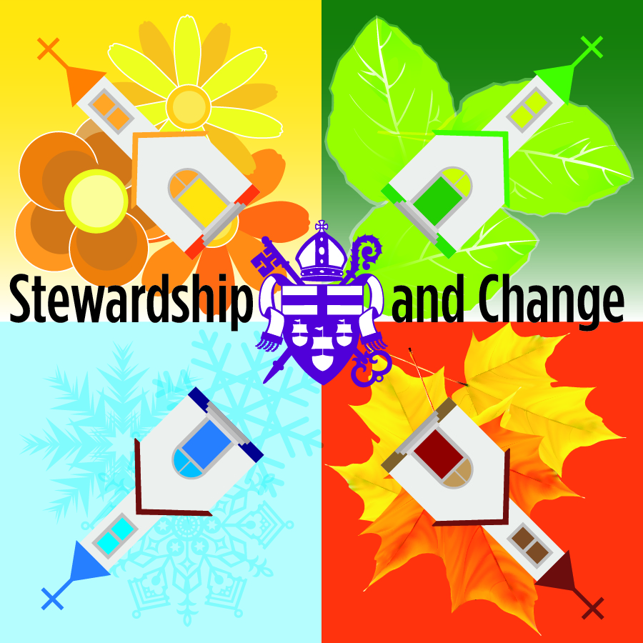
Saturday, June 21 9:30a-noon St. James’, Warrenton
Tuesday, August 5 7p-9:30p St. Andrew’s, Arlington
Wednesday, August 13 7p-9:30p Calvary, Front Royal
Saturday, August 16 9:30a-noon Emmanuel, Greenwood
Wednesday, August 20 6:30p-9p Grace, Goochland
Tuesday, August 26 7p-9:30pm Christ Church, Winchester
Tuesday, September 9 5:30p-8p St. Mary's, Whitechapel
Saturday, September 13 9:30a-noon All Saints, Richmond

Members of the Diocesan Committee on Stewardship will facilitate workshops on annual giving using The Episcopal Network for Stewardship’s 2014 materials, “Walking the Way”. These workshops are designed to complement your annual campaign through principles and practices that inspire faithful generosity.
This workshop will explore year-round stewardship and discuss what you need for a successful annual campaign. Registration is $25/person or $50/parish for up to four attendees. Scholarships are available. Contact Stephanie Higgins at shiggins@thediocese.net.

