Planned Giving Workshop: “What Any Church Can Do”
July 12, 2014
9:30 a.m. – 12 p.m.
Grace Episcopal Church, Kilmarnock

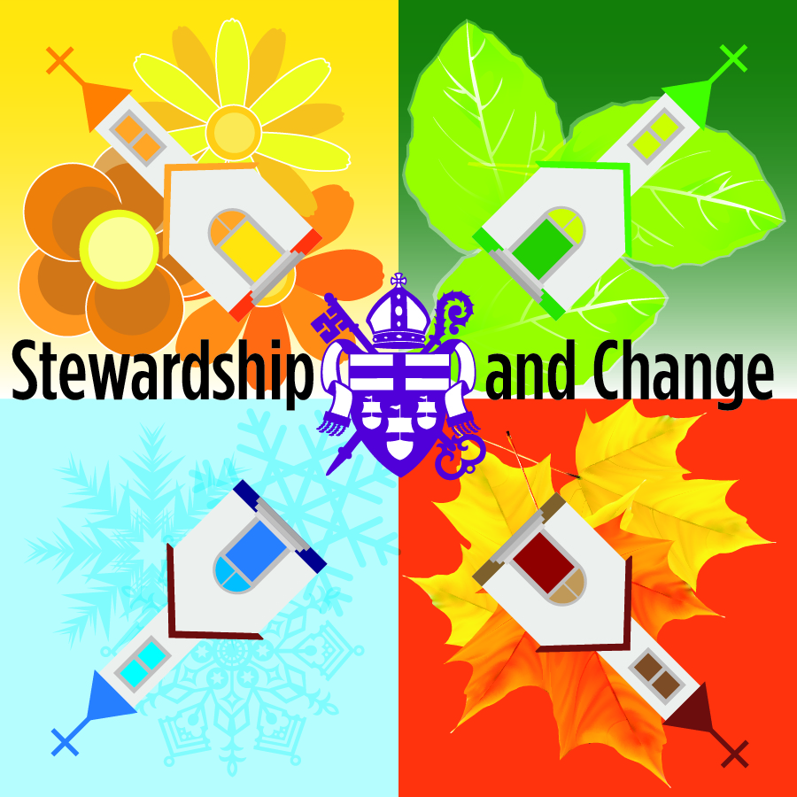

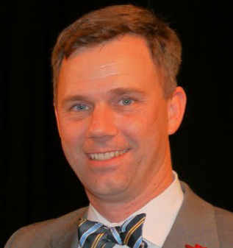
All the ministries our churches provide in service of God’s mission depend upon the availability of financial resources – now and in the future. This workshop will discuss how planned gifts to the church help ensure a future that will help serve as a testament of your values for generations. It will provide an overview on Planned Giving in the Church, what you must have in place and proven tools that any Church can use.
This workshop will be facilitated by Karl Mattison, the Executive Director of The Presbyterian Endowment Education & Resource Network - the PEER Network. As the first Executive Director in PEER’s 25 year history, PEER’s primary innovation is developing planned giving tools that are high-quality, yet efficient and affordable – tools that can be used at churches of all sizes by volunteers and staff alike, tools that enable churches to bring their planned giving efforts into the twenty-first century. Karl spent the first 10 years of his work-life working as a diplomatic banking specialist. In 2005 Karl felt a call to serve the Presbyterian Church, in the footsteps of his Father and Grandmother, both ordained clergy.
Registration is $25/person or $50/parish for up to four attendees. Scholarships are available. Contact Stephanie Higgins at shiggins@thediocese.net.

