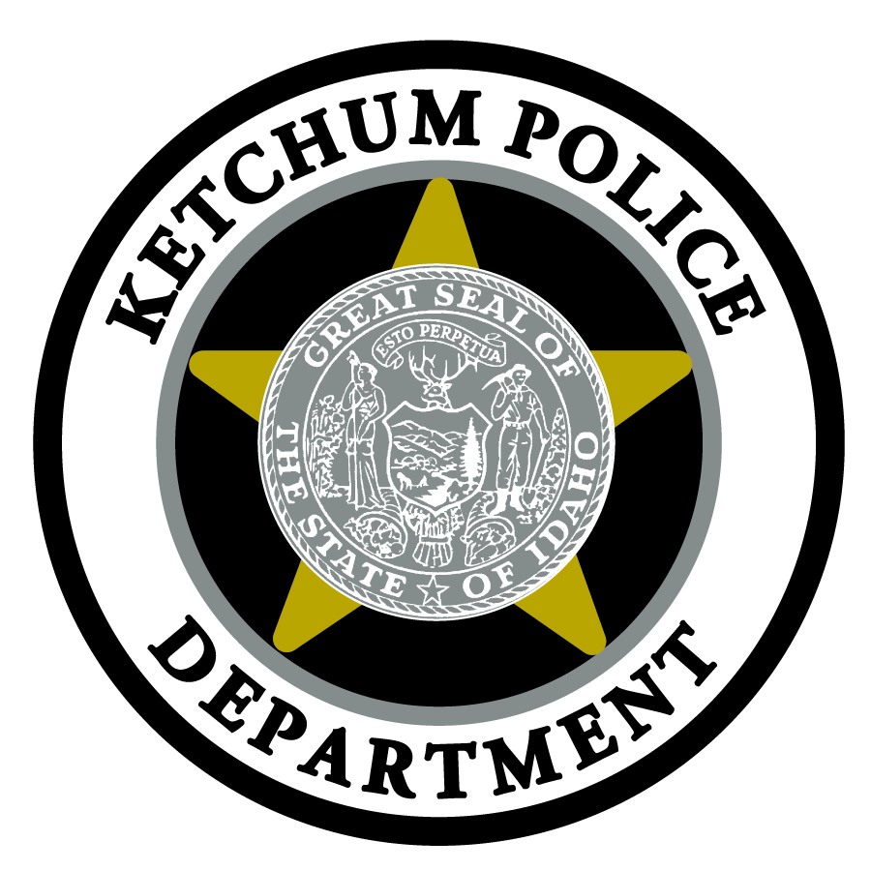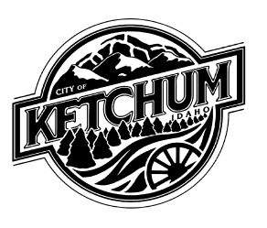MEDIA ADVISORY

Chief Steve Harkins

(208) 726-7819

sharkins@ketchumpolice.org

Ketchum Police Department Offers Training for Intervention Procedures (TIPS) Class
The Ketchum Police Department invites local establishments and retailers selling and serving alcohol

Who: The Ketchum Police Department

What: Training for Intervention Procedures (TIPS) Class
- Advance registration is required
- Cost: $15 per person
- Limited to 25 participants

When: Friday, March 14, 2014

10 am - 3 pm

Where: Ketchum City Hall
480 East Ave N
Ketchum, ID 83340

Why: This class is offered to all local establishments and retailers that sell and serve alcohol. The training will address the laws and dangers of over-service of alcohol, selling to minors and drinking and driving.

###

About the City of Ketchum:
The City of Ketchum is located in the Wood River Valley in south central Idaho. Founded in 1880 during the mining boom, Ketchum is now regarded as one of the most popular destinations for winter and summer visitors due to its world-class skiing, mountain biking, fishing, hiking, restaurants, art galleries and shopping. The City of Ketchum hosts the famous annual Wagon Days Parade, held on Labor Day weekend, and numerous other year-round attractions. Ketchum is home to more than 3,000 full- and part-time residents. For more information about the City of Ketchum, visit www.ketchumidaho.org.

