Exciting Developments for Living With Fire in 2014
2014 has brought with it a lot of promise for the Living With Fire program. The year has only just begun, and is already greeting us with new opportunities to inform Nevadans about how they can make their homes and communities safer from the threat of wildfire.
What better way to mark the new beginnings of 2014 than with a new tradition? We’re excited to bring you The Network Pulse, a newsletter with the goal of delivering the information that brings Fire Adapted Communities together.
The Network Pulse is one of the tools of the Nevada Network of Fire Adapted Communities, also known as The Network. A new organization that will operate with assistance from community members and fire service representatives, The Network will work hand in hand with the Living With Fire Program to support communities and other stakeholders in their efforts to become FACs.
Stay tuned for more news on The Network. If you’re interested in joining and helping your community work toward becoming a FAC and part of The Network, please contact Taryn Holland, at 775-336-0261 or hollandt@unce.unr.edu.
With the goal of helping Nevada’s communities to become fire adapted, we’re extending the wildfire awareness campaign during the month of May. May 2014 will mark Nevada’s first Wildfire Awareness Month (NWAM). That’s right: month.
Nevada Wildfire Awareness Week has shown great success since its first year in 2006. With continual positive turn out at past events and an increasing number of communities wanting to host their own events and take part, the wildfire awareness planning group has voted to extend what was formerly done in a week to a month-long campaign.
With three extra weeks to educate our families, friends, neighbors and communities, Nevadans can get an even better jump on the fire season, with more knowledge to perform the work that will make our communities safer from the threat of wildfire.
This year’s theme, hot off the press and right out of the ballot box, is:
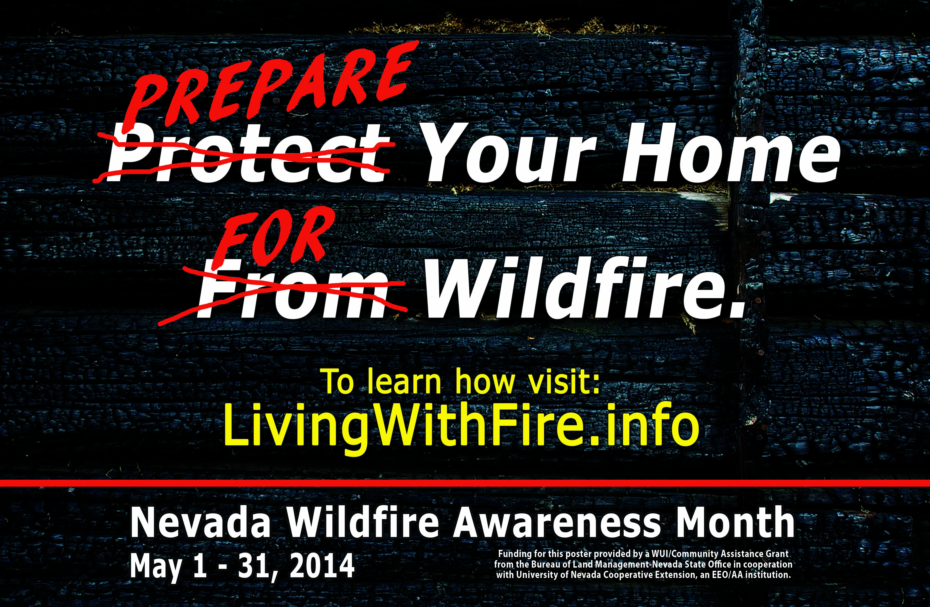
With this theme we hope to change our traditional thinking about the wildfire threat from being reactionary to being proactive. By preparing our homes ahead of time, we can greatly improve the odds of their survival in a wildfire. Preparation includes screening house vents to prevent ember entry, managing landscapes to serve as effective defensible space and replacing wood shake roofs with fire-rated types.
Join in on this important month and in sharing this critical message. Host an event in your community, or attend one in your area! An event calendar is forthcoming. For questions on NWAM or ideas for an event you can host in your community, contact Sonya Sistare, at 775-336-0271 or sistares@unce.unr.edu.
We’re excited for all these opportunities and more this coming year. Here’s to making 2014 a year when many Nevada communities become safer from the threat of wildfire!

Cheers!
The Living With Fire Team

