Presenter’s Bios

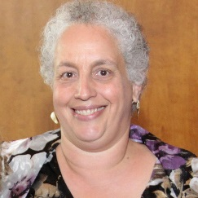
Susan G. Izeman, PhD, BCBA-D – Susan obtained her PhD from the University of Massachusetts. She has been working in the field of ABA for over 30 years. During her tenure in behavior analysis she held director positions for notable organizations in the industry. Her extensive experience has included developing various programs for children with autism of all ages (under 3 years old through young adulthood). She has provided supervision and training for parents, teachers, and paraprofessionals for over a decade. Her vast knowledge and experience have been instrumental in training aspiring BCBAs and continues to bring the quality therapy to centers and homes across New York that the autism community deserves.

Jennifer Kourassanis-Velasquez, M.A., B.C.B.A. – Jennifer is a Board Certified Behavior Analyst pursuing her Doctorate at CUNY, Queens College, where she obtained her Masters in Applied Behavior Analysis and her Bachelor of Arts in Psychology (with an emphasis on learning and behavior). Jennifer has been providing in home ABA therapy and parent training since 2009. She serves as a Behavior Consultant for several Nassau school districts where she restructures classrooms, provides staff training, conducts functional behavior analyses, and designs behavior intervention plans. She is also an adjunct professor at CUNY, Queens College and The Chicago School of Psychology. In addition to being devoted to assisting special needs children and their families, Jennifer loves educating students in the classroom and providing supervision to students pursuing their BCBA. When Jennifer is not running her center or teaching, she is focused on her research. Jennifer conducted a study involving peer video modeling in teaching social group games to children with autism. She hopes to submit the findings of her research for publication in the next few months. To date, she is proposing a pre-dissertation that will involve the use of video modeling to train typically developed children to facilitate joint attention in children with autism.
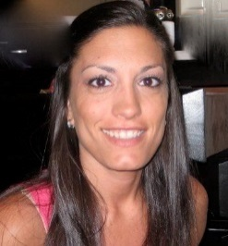
Christine Saulnier, M.A.T., B.C.B.A.– Christine is a NYS certified teacher and a Board Certified Behavior Analyst. She holds her Masters in Elementary Education from CUNY, Queens College and currently pursuing her post masters certification in special education. Christine has been providing ABA behavior therapy in home based, clinical, and classroom settings to a broad range of children on the spectrum for several years. She is knowledgeable in various aspects relating to autism and developmental disabilities and has a passion for providing intervention to assist children in achieving their full potential. Christine has experience in parent training, as well as, teaching language/functional communication skills, academic skills, social skills, self-help skills, and increasing positive behaviors.

