Riley Area Development Corporation 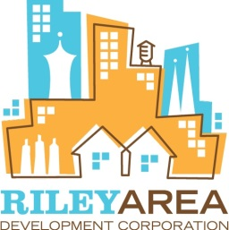

|  |
| --- |
|  |

**Riley Area Development Corporation** (RADC) is a non-profit Community Development Corporation working within the City of Indianapolis. Its mission is to develop and support a sustainable community environment in and around downtown Indianapolis through affordable housing, economic development, healthy public space and community development. Since 1995 RADC has invested over $5.5 million in 69 affordable new homeownership units. RADC is looking to develop up to five affordable home ownership opportunities in 2014 and 2015.

**Willard Park Neighborhood:** Willard Park is a 102 acre neighborhood developed in the late 19th and early 20th centuries. The area includes 362 mainly residential properties and a large park, Willard Park. Willard Park is adjacent to several successful urban redevelopment neighborhood projects including St. Clair Place that was a key focus of the 2012 Indianapolis Super Bowl Legacy Project. Willard Park’s proximity to the heart of Downtown Indianapolis means that it has exceptional bikability, walkability, and potential.

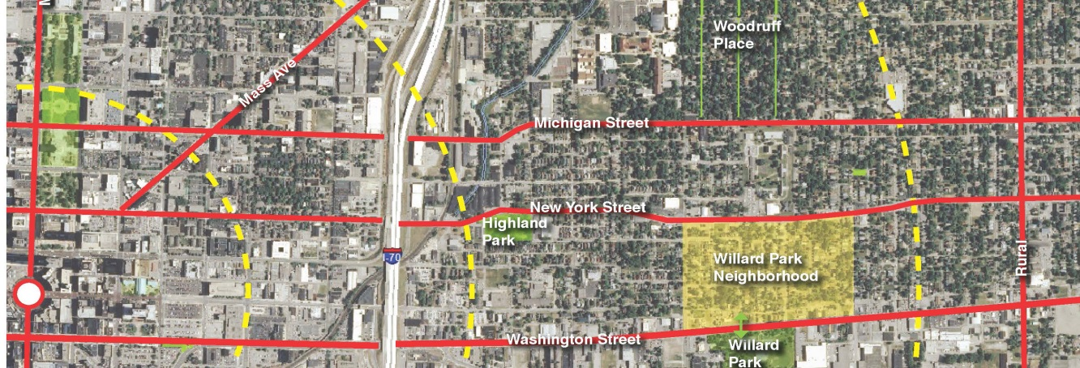

**Innovative New Home Ownership in Willard Park** RADC seeks to develop up to five affordable home ownership opportunities in 2014 and 2015 in the up-and-coming Willard Park Neighborhood.

* **5 new affordable homeownership opportunities include:**
  + **3 units that are new home construction.**
  + **2 units that area Rehabilitation/Restoration of historic homes.**
* **All homes will be energy efficient and include eco-friendly design, green infrastructure and garden beds that will tie into the community garden programs in Willard Park.**
* **New construction homes include innovative and modern design. RADC implemented a design contest to generate ideas for these homes.**
* **Houses are projected to sell between $90,000 and $107,500 to eligible applicants.**

# Other Willard Park Projects in 2014…

## Home Ownership Through Homesteading

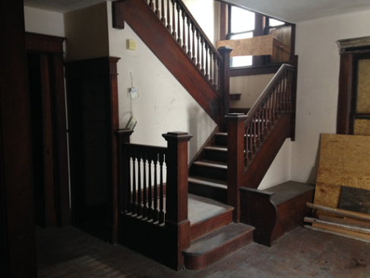Riley provides you with a forgivable loan, part of a Community Block Development Grant Award for this program, of up to ($12,500) towards the exterior rehabilitation and stabilization of the house. You have 18 months to complete the remaining necessary renovations and occupy the house. Once you have lived in the house for five years the loan will be forgiven. RADC will provide technical assistance on construction needs.

### GREEN PICKET FENCES: Green Picket Fences is a group of initiatives developed to grow Willard Park into a vibrant, self-sufficient community. Each “picket” represents one or more programs which address site-specific needs within WP that when properly addressed will eradicate our quality of life issues. A few of these are:

* Green Energy- Garden lots enhanced with wind turbines.
* Green Shepherd Project- Heritage breed sheep mowing neighborhood owned plus vacant and abandoned properties
* Green Streets- Stakeholders growing nutrient dense, non-GMO, chemical-free produce and selling it within Willard Park boundaries at affordable pricing

Multi-Use Green Space 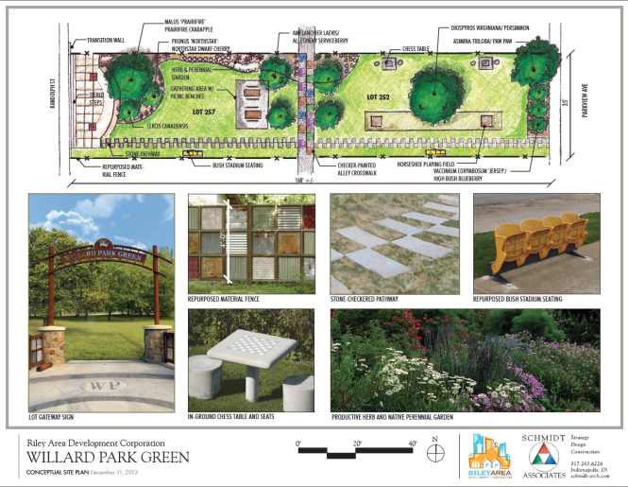Soon Willard Park residents will have a gathering space designed by local residents with community and “green” sustainability in mind. The lots are adjacent to the new home ownership unit at 246 N. Randolph St. The combined lots allows for the continuation of Marlowe Ave with an east-west pedestrian connection. A new 6ft wide multi-use trail, fruit trees, native prairie grasses, horseshoe pits, artistic fencing and signage will be constructed on the lot.