Naeem Tai

Software Developer Intern – IUPUI CyberLab

4/15/14

**Live Desktop Streaming for the ClassCast tool**

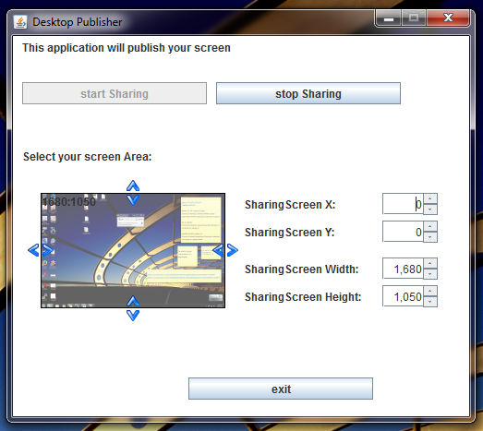

Desktop Application

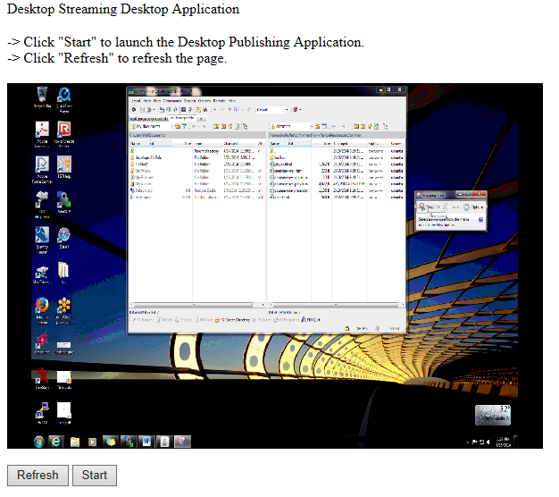

Web Page to launch the desktop application and view live stream

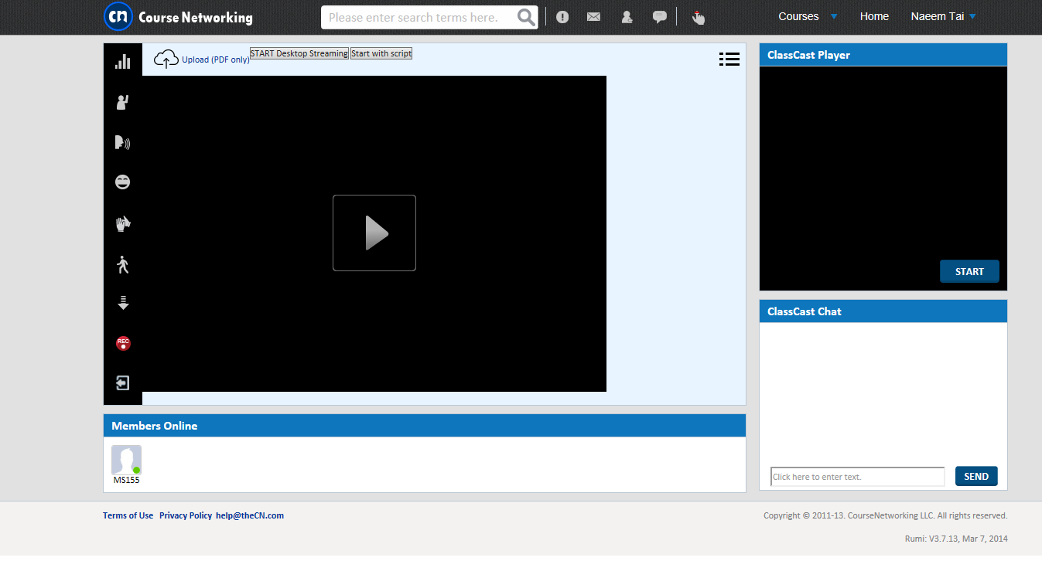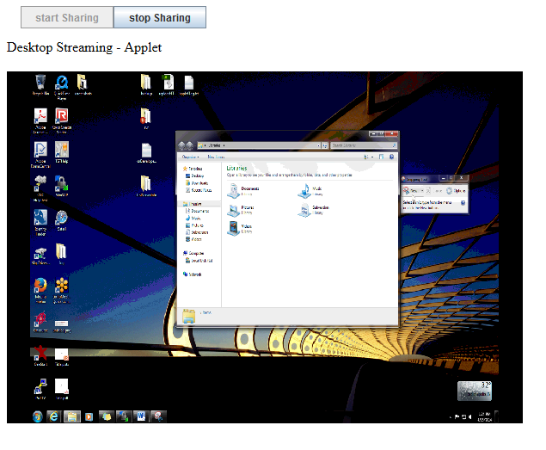

ClassCast page on CourseNetworking test site with desktop application and live stream player implemented

Web Page with an applet to view and start/stop live stream