2014 STC e-Newsletter Media Kit
About STC NewsLine
Now more than ever, professionals consume information on the go, STC NewsLine allows members to stay informed about timely industry topics and association news whether they are in the office or on the road.
Enjoy the benefits of advertising in a targeted e-Newsletter distributed quarterly to thousands of STC members and non-member athletic directors, athletic facility directors, architects and engineers, and other top decision-makers:
- In addition to STC members, opt-in subscription for non-members means that professionals in the market for your products and services see your message
- Frequently forwarded to others for additional exposure
- Cross-promoted in other STC publications and other communication pieces
- Directs visitors to the landing page of your choice to facilitate the purchasing process
- Archives are accessible for unlimited online viewing
- Limited available ad space makes each position exclusive
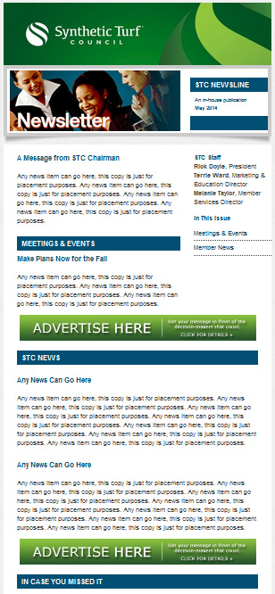
- Change artwork monthly at no additional cost to promote time-sensitive offers and events

Horizontal Banners (530 x 80 pixels)
4 issues | $900 2 issues | $475 1 issue | $250
- Only five spots available – NO ROTATION
- Located between article sections of the e-Newsletter
- Sections include:
  - Meetings & Events
  - STC News
  - In Case You Missed It
  - Industry News
  - Member News
e-Newsletter Branding Opportunities
To be included in the STC NewsLine, please select from the options below, and then return this completed form to the STC office headquarters.
Advertisements must be in JPG format at 530 x 80 pixels (animation and Flash/SWF files are not accepted) and the total file size must not exceed 100kb. Contract advertisers may change their ad artwork once a month at no additional cost.
Advertisers will receive campaign performance reports that details monthly ad impressions and click-throughs on an as-requested basis.
Horizontal Banner:
☐ 4 issues | $900 ☐ 2 issues | $475 ☐ 1 issue | $250
All advertisers will receive an invoice for the total amount, due upon activation.
When renewing e-Newsletter ads, all companies will be renewed on a first-come, first-serve basis.
Advertiser Information:

Company Name

Primary Contact/Position

Billing Address

City, State, Zip, Country

Phone/Fax

Email Address

Website

Cardholder Name

Credit Card Number | Exp. Date
I agree to all the terms of the rate sheet and this contract as applicable for my company.

Authorized signature

Date
All cancellations must be received in writing and all premium positions (banners) are NON-cancelable. Cancellations of online ads will be pro-rates to the next 30 days exposure.
Please sign and return to:
Melanie Taylor, Member Services Director
Synthetic Turf Council
Phone: 678-385-6720 | Fax: 678-385-6501
melanie@syntheticturfcouncil.org

