We sure picked the right year! Our first creek crossing (above) was at Mile #1! Get 'em wet! With each mile, this trail marathon turned in to more and more of an adventure race. Icy gravel service roads, melted snow that made at least a dozen creek crossings, and the trails were a sloppy, slippery, slope. Every loop presented new and different challenges, because 300 people just trampled through it!
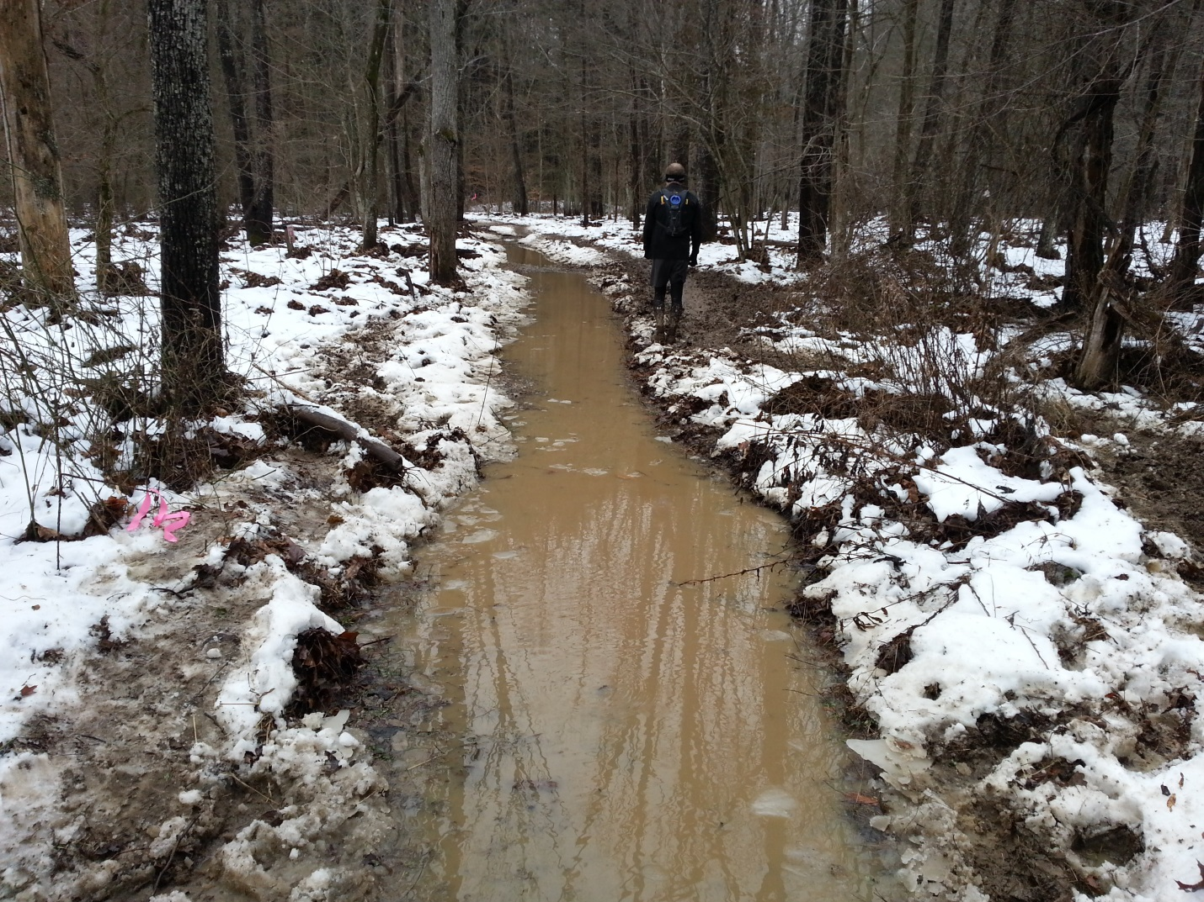
Sliding with every step, we made our way 26.2 miles through the muck! Up hills and down hills....it never got old! I never laughed so much during a marathon. Then, in mile #19, it happened...Left foot slid into the right foot and down I went. I rolled around in the mud like a kid laughing out loud at myself. The mud was soft. I assessed the body and nothing hurt....so, off I went. Running when I can and walking when I can't. Trying to stay on the side of the "mini" river, began to hurt my left ankle, so I ended up just splashing through the middle. Runners would approach and they wore the same muddy badge of honor down their backside that I now wore.
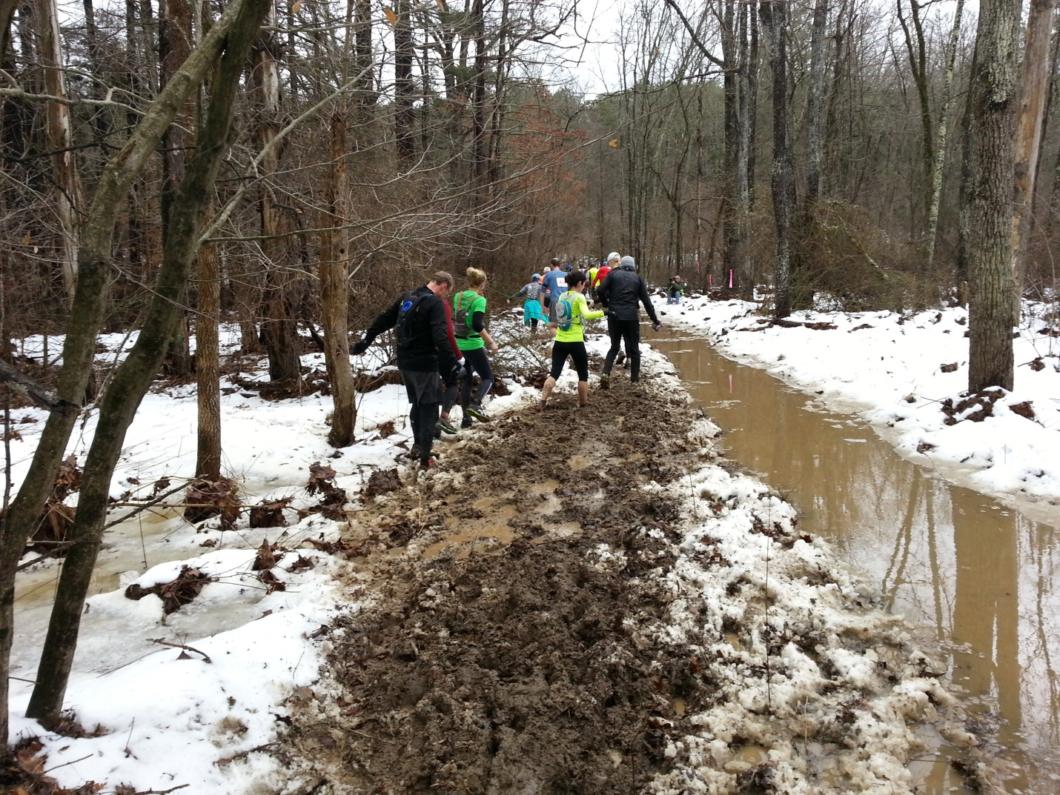

Ok - At mile #21, it happened again! A stick got stuck in the laces of my right foot. The stick was thick enough that it didn't break allowing me to get my right foot down. I'm hopping around on my left foot in the mud. You can guess what happened next, my left foot slid out from under me and my right foot can't come down because there is a damn stick stuck in the laces. I bit it hard and twisted my back. That wiped the smile off my face. Wet again! Covered in mud from my right shoulder all the way down, and both gloves went under the icy mud-water! Ok, that was less fun. We had to cross the deep creek again to get to the finish. It felt good and probably helped the sore ankles too! The finish chute took us around the camp ground and then across the finish line. We were so proud to have finished this tough, sloppy run! This was my second slowest marathon, ranking right under Pike's Peak Marathon. Thanks Tecumseh for kicking my ASS! ...and making this one of the most memorable marathons to date!
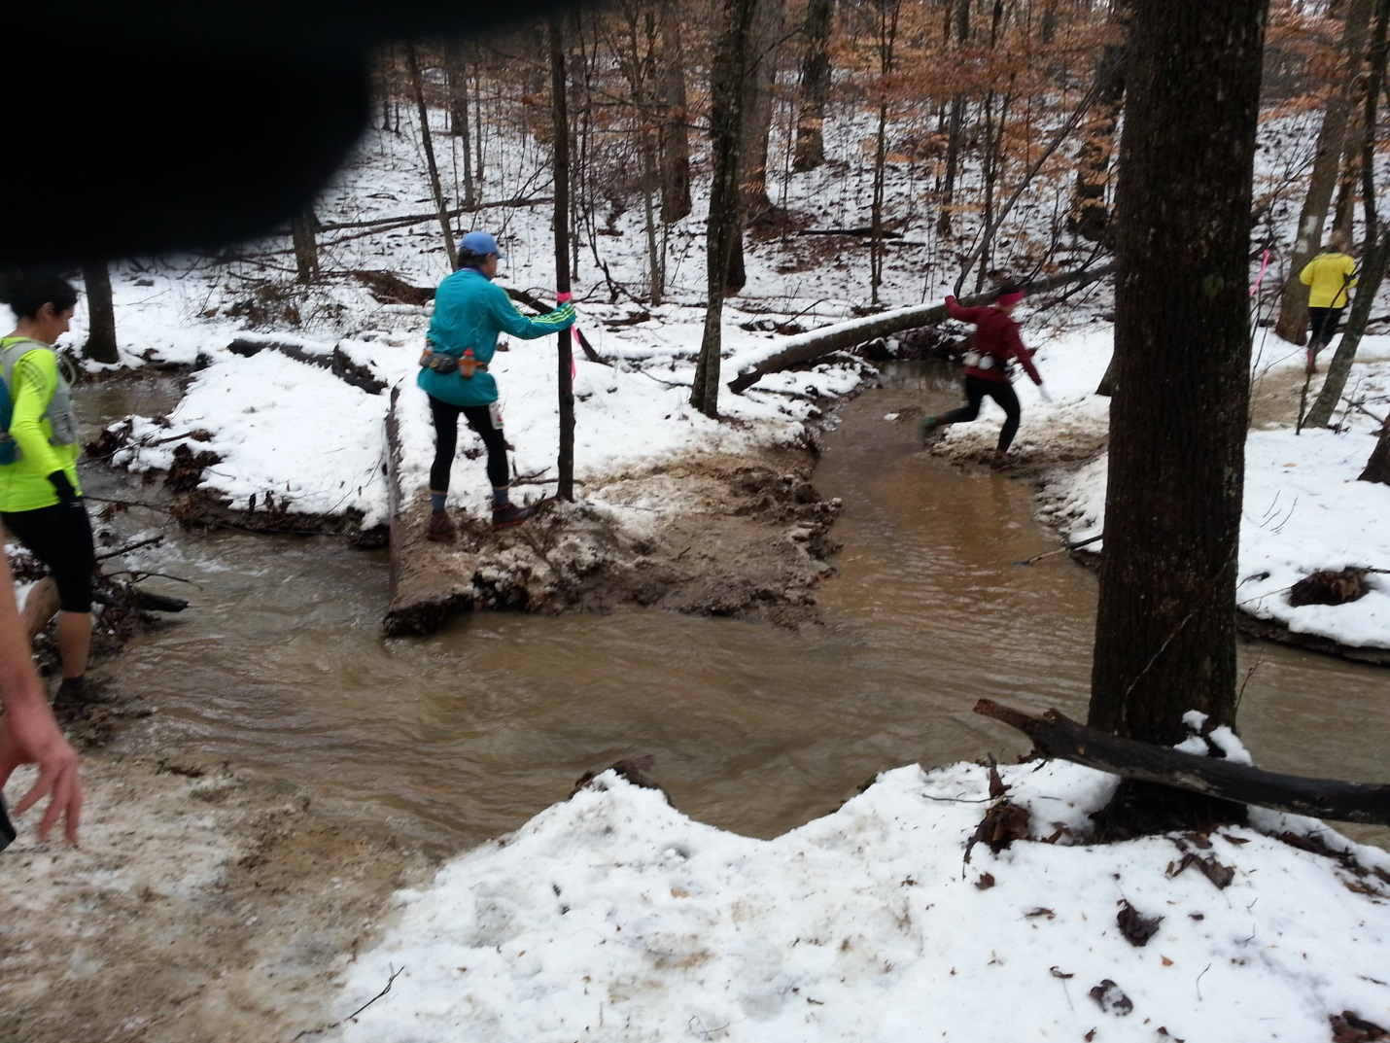

• COURSE: Hard! Hilly. Muddy. Technical
• SUPPORT: Awesome! Volunteers were amazing.
• RACE SWAG: Very different shirt - soft fabric. It had pockets in weird places?
• ORGANIZATION: Very well organized. This was the alternate date and they had to reroute the course, too. No complaints!
PRICE/VALUE: Price is reasonable. The race sells out every year!
Overall - I loved it. I'm always looking for new ways to HURT IT! This one did not disappoint!

