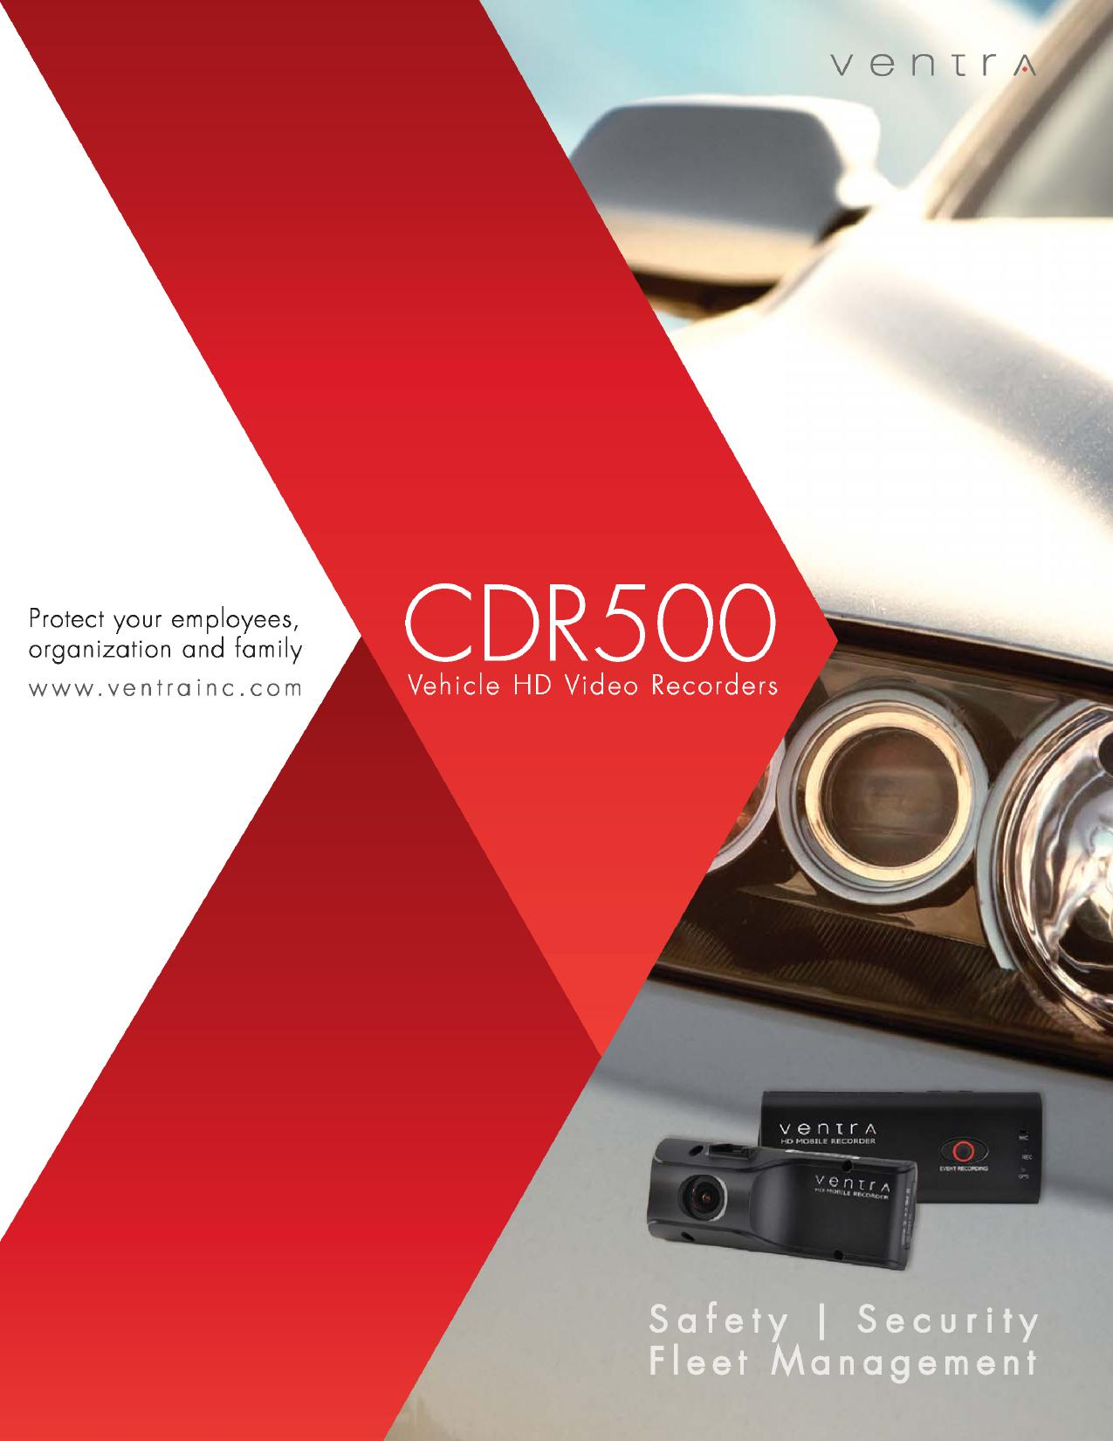
venir A
Safety I Security
Fleet Management
Protect your employees, organization and family
www.ventrainc.com
CDR500
venIIA
MO MOBILE REGOROBIL

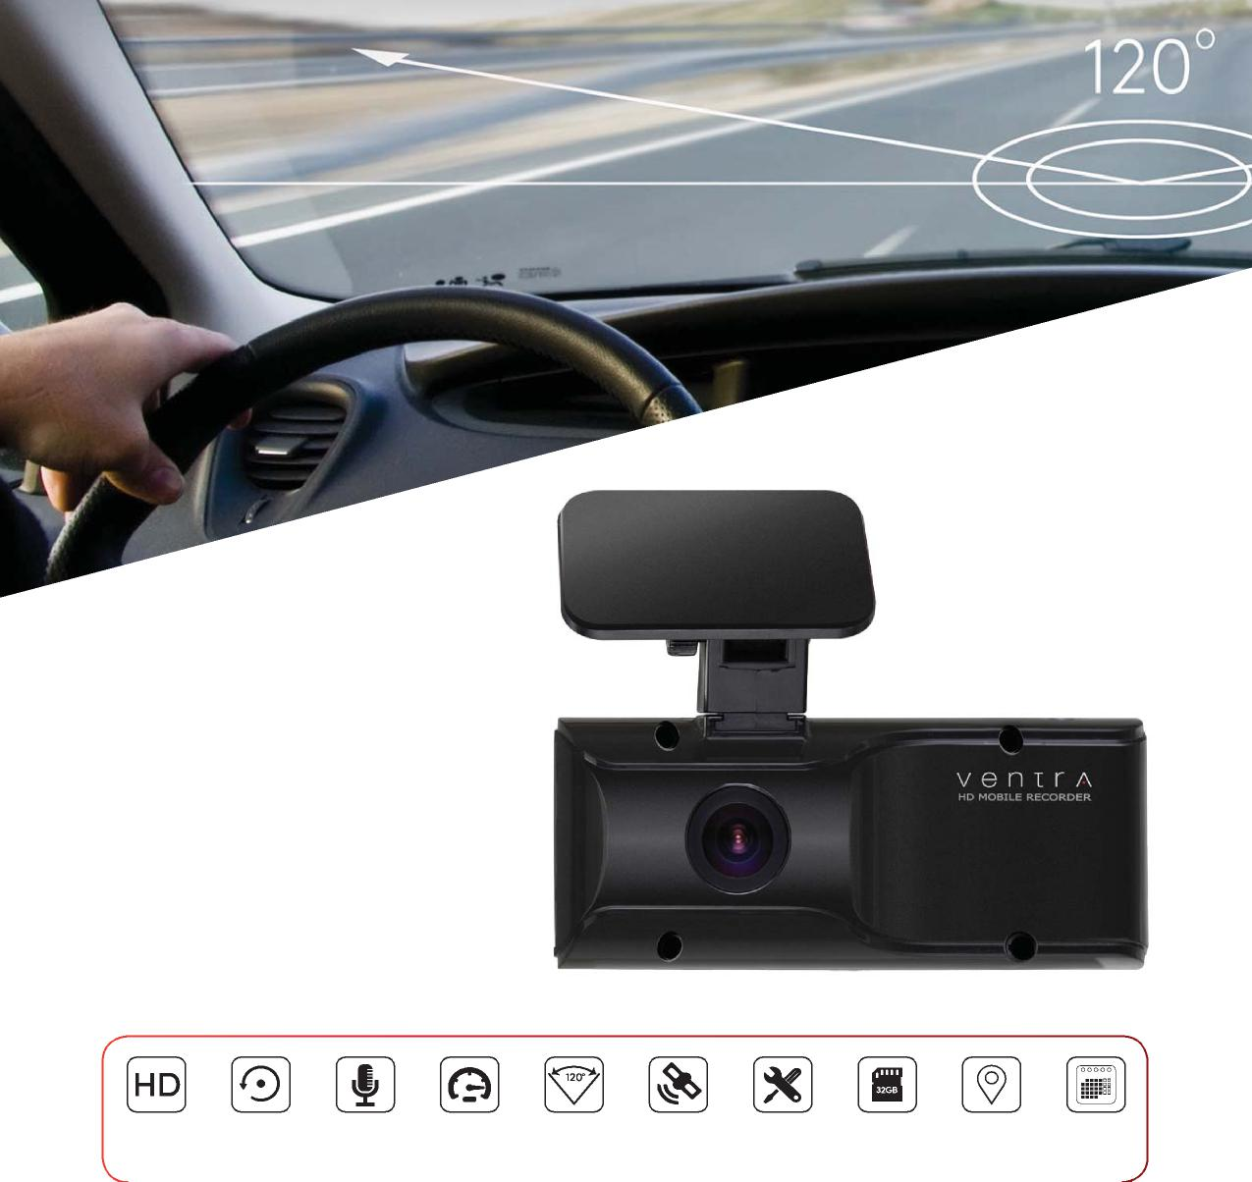
120º Viewing Angle
Actual Size
Technology Behind It
All-In-One Safety ,Security & Fleet Management Solution
120 wide angle view
Max Vehicle Speed
HD Video Auto Record Audio
Recording
Customisable Speed &
GPS Location Supports up to Location via Records Time
Settings 32GB SD Google MapsTM & Date
- High Definition video recording - 720P  - Built in GPS - Records speed and route  - Built in microphone  - Various event recording function  - Easy installation, Plug and Play  - Auto continuous loop recording | - Max vehicle speed limit trigger  - Customizable settings and configuration  - Print Event report with detailed info  - Video Out connection to external device or monitor  - Built in 3 - axis G sensor for impact, acceleration and stops  - User-friendly software with GoogleTM Map integration

Cockpit View

Easy to Setup | Operate | Manage
The CDR-500 is a Plug and Record, all-in-one vehicle recorder. With an integrated video camera and passive GPS, the CDR records high definition 720P video resolution, audio, speed, route history, date and time on a SD card that is easy to transfer and manage.
Designed for forward facing (road/traffic) or in-cabin recording (driver or passengers), the CDR-500 can be easily installed in various types of vehicles across different industries.
The system automatically records when the vehicle is on, so no interaction is needed from the driver. These recordings are continuously stored in a loop cycle and are marked as Normal or any of the Event triggers, which are indexed and saved for easy playback in our user-friendly software.
BeneFits of Ventra Vehicle Recorders
The costs of implementing Ventra vehicle recorders are nominal compared to the costs of vehicle related incidents.

Safety / Security
- Video footage in case of incident
- Increase security and safety
- Identify & correct driving patterns
- Increase driver awareness
- Monitor speed / driving behavior
- Enforce company guideline
- Exonerate non-fault situation
- Review / evaluate safety standard
- Mitigate liabilities
Operation
- Improve fuel efficiency
- Identify optimal routing
- Location history of vehicle
- Increase productivity
- Investigate incidents or violations in detail
- Reduce excessive wear and tear
Business
- Enhance customer service
- Increase performance of staff
- Video proof of delivery or service
- Reduce unrelated use of vehicle
- Protect company reputation
- Reduce risk
- Potentially lower insurance cost
- Improve company bottom line

Any Vehicle, Any Application, Any Industry

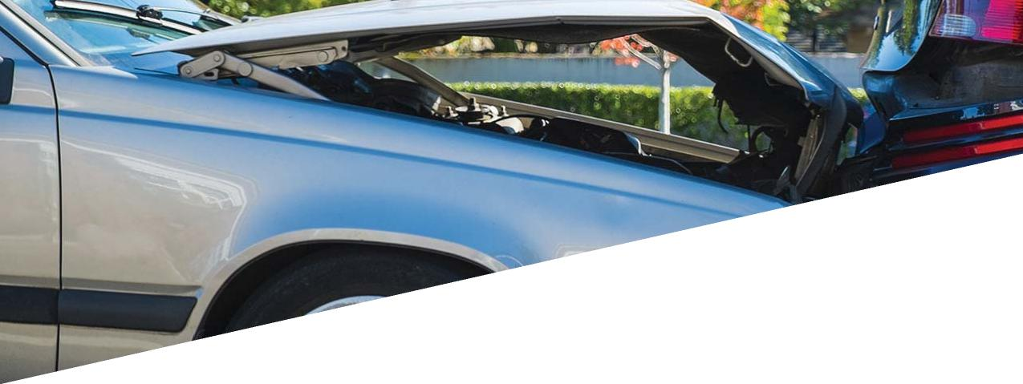
Utilized as a standalone system, or an Enhancement to existing Telematics solution
Coach / Shuttles
Taxi / Limo
Logistics / Distribution
First Response
Security / Law Enforcement
School Bus
Commercial Fleets
Personal Vehicles
Ventra is a premier technology company specializing in vehicle video recorders and fleet management solutions. As a leading provider, we have developed an advanced suite of recording solutions utilized in various types of vehicles and equipment across different applications.
Protect your employees, organization and family
Whether you manage a fleet of vehicles, supervise a mobile sales force or help safeguard your family, Ventra is the optimal vehicle video recorder to help record and identify unsafe driving behaviors, provide video footage in the event of an accident, and improve the security and safety of the drivers.
Cost Effective, No monthly fees
Ventra vehicle video recorder is a cost effective, turnkey solution without any monthly fees or software license fees. It’s a one-time investment that can yield returns in safety, efficiency and bottom line.

Why Should I Need It?

Analytics – Simple, yet Powerful reporting
EVERY 5
SECONDS Vehicle Crash
EVERY 7 SECONDS
Involving property damage
EVERY 10 SECONDS
Involving injury
EVERY 12 SECONDS
Fatality
Average on the job crash with injury
$74,000
Average on the job crash with fatality
$500,000
$87billion
Economic cost of crashes to employer
- Video recording for security and safety in the event of an incident
- Identify, Correct and Reduce Problems and Risks
- Increase driver awareness and promote safer driving
A typical driver travels on average 12,000 to 15,000 miles annually and has a 1 in 15 chance of being involved in a vehicle collision.

$16,500
Average cost of a crash to an employer

The leading causes of accidents;

- Distracted driving
- Excessive speed
- Driving under the influence
When a driver is on the road, they are not just dealing with the operation of the vehicle, but also faced with the constant dynamics of other drivers, conditions, speed, traffic and signal lights. Being a safe driver helps prevent being the cause of the accident. But what if the accident was caused by other attributes?
Given the frequency and cost of vehicle accidents, organization of all sizes should implement a safe driving
7
guideline with Ventra vehicle recorders playing an integral part of that. Through continuous video recording, Ventra system provides comprehensive insight to driving history, identify, and review behaviors and incidents in greater details.
Above all else, the system provides video documentation in the event of an incident to determine the cause, which may help exonerate a non-fault situation and mitigate legal and financial risk.

Search by time or event Driving Behaviour Speed, vehicle & driver info

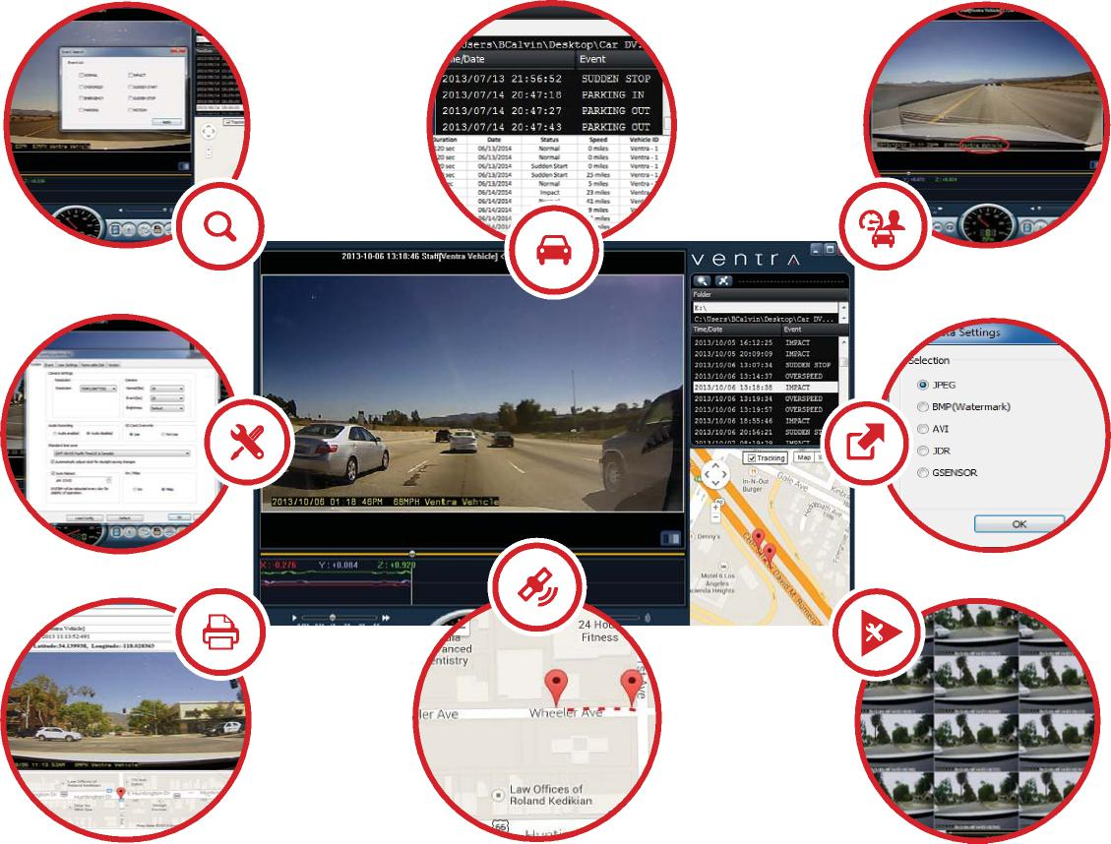
Customizable Settings
Export files

Print Event Report Route history via GoogleTM Maps Customizable playback option

Managing a fleet has never been easier
The user friendly software included with each system, allows the administrator to securily manage, configure and view any number of vehicles with an assignable vehicle or employee ID to each Ventra recorder. Integrated with advanced features such as file back up to JPEG or AVI, event report print capability, and max vehicle speed.
The Ventra Advantage |  | System Includes:
1. Easy to setup, Plug and Record | 6. Customizable settings | CDR-500 | CDR-500BT
2. HD Video technology | 7. Password protection | - CDR-500 Recorder | - CDR-500 Recorder
3. No monthly fees or contracts | 8. Compact design | - 8 GB SD card | - 32 GB SD card
4. Cost effective | 9. Easy to use software management tool | - Aux Pwr cable | - Permanent pwr cable
2  5. Minimal training required | 10. Outstanding support at every stage | - Mounting bracket | - Aux Pwr cable
 |  | - Software | - Mounting bracket
 |  | - User manual | - Software
 |  |  | - User manual

Info and sales - info@ventrainc.com Tech support – support@ventrainc.com Media relations: media@ventrainc.com
1578 W. San Bernardino Rd. # E Covina, CA. 91722. USA
Tel: (888) 418-3833 w w w . ventrai n c . com

