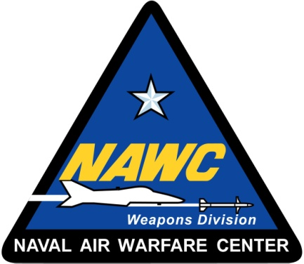
NAWCWD INDUSTRY DAY AGENDA
February 26, 2014

1:00 | Introduction | Derrick Hu, Deputy Director, Office of Small Business Programs, NAWCWD
1:05 | Opening Remarks | RDML Michael Moran, Commander, NAWCWD
1:20  2:00 | NAWCWD Overview  Technical Focus Areas | Mr. Scott O’Neil, Executive Director and Director of Research and Engineering, NAWCWD  Mr. Mallory Boyd, Deputy Director, Technical Operations, Research and Engineering, NAWCWD
2:45 | Break
3:00  4:00 | Panel Discussion  Feedback and Future Topics | RDML Michael Moran, Mr. Scott O’Neil, Mr. Mallory Boyd, Dr. Larry Merwin (Director of Research), Ms. Karen Haden (Director for Contracts)  RDML Michael Moran
4:15 | Networking
5:00 | End of Event

