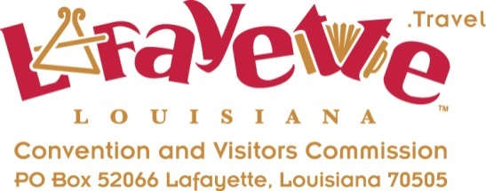

Neil Jones- Lafayette FAM Tour
Thursday, March 13, 2014 & Friday, March 14, 2014
4:45-5:00 Arrive in Lafayette

LAFAYETTE CONVENTION & VISITORS COMMISSION
1400 NW Evangeline Thruway, Lafayette LA 70501-2829
Tel (337) 232-3737, US (800) 346-1958 www.LafayetteTravel.com

Eugenie Mitchell- mobile (337) 849.9796, Eugenie@LafayetteTravel.com, Tourism
Ben Berthelot, President & CEO, Ben@LafayetteTravel.com
Kelly Strenge, Communications, KStrenge@LafayetteTravel.com

*** Meet Eugenie in the Visitor’s Center

Thursday Afternoon:
5:00-5:45 Downtown Lafayette- Drive thru the area, murals, past Alexandre Mouton and several museums, Stop at St. John’s Cathedral and drive on UL Campus by Cypress Lake & Paul & Lula Hillard Museum

5:45-6:15 Drive to the River Ranch area, Randol’s

6:30 Arrive at Hilton, Neil’s Choice- Room service at Hotel or Dinner nearby at Café Vermilionville, www.cafev.com or Blue Dog Café www.bluedogcafe.com or in the Oil Center- Variety of Options

Overnight Hilton Lafayette, 1521 W. Pinhook Rd, Lafayette LA 70503, Conf #310.9307.726
Tel 337-235-6111, fax 337-237-6313, Danielle.Duplantis@InterstateHotels.com, www.Lafayette.Hilton.com

Friday:
8:00-8:15 Depart Hilton- coffee & Pastry-Great Harvest Bread Co.
8:30-8:50 St. Martinville
8:50-9:30 Shadows on the Teche & Konriko Rice
9:30-10:15 Tabasco & Jungle Gardens
10:15-10:45 Jefferson Island & Rip Van Winkle Gardens
11:15-11:45 Acadian Village & Mama Redell
12:00-12:45 Bach Lunch Downtown- Music by Les Freres Michot & food from Creole Lunch House, Hub City Diner, and Poupart's Bakery.
1:00-1:20 Jean Lafitte Acadian Cultural Center
1:25-2:10 Vermilionville
2:15-2:45 Cajun Food Tours- Intro to Tour and 1 stop- Blue Dog Café
3:00-3:20 Lake Martin
3:30-3:40 Drive Downtown Breaux Bridge
3:40 Depart for Baton Rouge & Tin Roof Brewery

