Leadership Academy Modules for 9.28

**Become a Leadership Academy Graduate by completing just one module!**

**Leadership Academy Scholar Course**

*Core Leadership Academy Values:* Faith, Excellence, Creativity, Unity & Passion

**^^ Successful Completion Meets Leadership Academy Graduate Requirement**

**\*\* Scholar Track**

**@Meets Annual Retreat Requirement**

Moderator: Mr. Paolettigabriel.paoletti@camdencatholic.org

The Leadership Academy Scholar Course is the culminating experience in the scholar track and previous students have described the program as “life-changing”, “inspiring”, “enlightening” and “fulfilling” and incorporates each of the leadership academy values of Faith, Excellence, Creativity, Unity & Passion. Students become experts in themselves through learning a series of positive psychology skills which they apply in a culminating retreat.  Students examine their core beliefs, values and goals and how they affect what they notice in the world and what they miss. They become aware of how they think, and learn to challenge and change counterproductive habits of thinking. They become aware of their personal strengths and weaknesses and learn how to maximize their gifts. They learn to be grateful for what they have been blessed with in their  lives and maximize the opportunities they are provided.  They learn how to strengthen current relationships and how to reestablish past ones and create new ones. The course consists of 12 workshops, a 3-day overnight retreat and two follow-up sessions.

To sign up for either the fall or winter course please click here [LA Scholar Sign Up](https://docs.google.com/forms/d/1I1tpYW6Yr7xmyaWKm29Onb99MxcGCXtiR-ViLO_iocs/viewform). Students must register now if they plan to attend either course and attend the opening information session

Fall & Winter Course Dates (still being confirmed):

Wednesday October 29th Activity Period in Library 8:15 am - 8:45 am

Sunday November 2nd All Scholar Course Meeting 5pm-7pm

**Workshops 3pm-5pm in room 239 on the following dates**

* December 2nd, 3rd, 4th
* December 9th, 10th, 11th
* December 16th, 17th, 18th
* January 6th, 7th, 8th (Jan 12th if needed)

**Winter Retreat Jan 17th-19th**

Spring Course Dates:

TBA

**Must Sign Up By:** October 17th   **Module Code:** 14001Scholar@\*\*  [LA Scholar Sign Up](https://docs.google.com/forms/d/1I1tpYW6Yr7xmyaWKm29Onb99MxcGCXtiR-ViLO_iocs/viewform)

Cost: ~$85

**Women’s Leadership: Irish Synergy**

Macintosh HD:Users:gabesmac:Library:Containers:com.apple.mail:Data:Library:Mail Downloads:54AFFBAE-731F-424B-9856-712A82BF9D40:CCHS_girlpower_logo_words.pdf

*Core Leadership Academy Value:* Excellence & Unity

Moderator: Ms. Palladino [Christine.Palladino@camdencatholic.org](mailto:Christine.Palladino@camdencatholic.org) Ms. Gallagher [elizabeth.gallagher@camdencatholic.org](mailto:elizabeth.gallagher@camdencatholic.org)

Student Moderators:

Students will lead a Irish Synergy workshop for 6th, 7th and 8th grade young women to help them develop their potential as leaders. The students will learn communication skills and develop interactive activities to help teach these skills to the young women attending the event. They will focus on listening skills, non-verbal communication, and conversation skills. The students will also act as mentors to the young women helping to empower them and build their self-efficacy throughout the workshop. Students will also receive 5 service hours for running the Irish Synergy workshop.

Dates:

Workshop 1: October 1st 3-5pm in 239

Dress Rehearsal: October 5th 11:00 am- 2:00 pm

Irish Synergy Workshop October 19th 8:30 am – 2:30 pm

**Must Sign Up By:** October 1st **Module Code:** 14002Women - Women Leadership - Irish Synergy [Click Here to Sign Up Now](https://docs.google.com/forms/d/1UiUQlv4HeZrypC46CY88Xn8_T3PBwBZ99Jz6hnzU-oI/viewform)

Cost: FREE



**Survivor :Real World.**

*Core Leadership Academy Value:* Unity & Passion

**\*\* Scholar Track**

Moderator: Ms. Whipkey [mary.whipkey@camdencatholic.org](mailto:mary.whipkey@camdencatholic.org).

Based on Daniel Pink’s book *A Whole New Mind: Why Right-Brainers Will Rule the Future,* participants will examine and understand the importance of interpersonal skills necessary to survive outside the classroom, especially on a college campus and in the 21st century economy. Through various activities, students will examine story telling skills, etiquette skills, and empathy skills to understand their own brand. This skill set will enable them to network with others through building strong connections and presenting the best of themselves to others. Students will apply these skills through real-world networking opportunities.

Dates:

**Activity Period: October 21 (8:00-8:45)**

**Workshop 1: October 26 4-6PM – Leadership Room**

**Workshop 2: November 14- 3:30- 5:00 Cherry Hill Mall**

**Workshop3: TBD**

**Activity Period: December 16 (8:00-8:45)**

**Must Sign Up By:** October 14th **Module Code:** 14008Survivor\*\* [Click Here to Sign Up Now](https://docs.google.com/forms/d/1UiUQlv4HeZrypC46CY88Xn8_T3PBwBZ99Jz6hnzU-oI/viewform)

Cost: Free!

** How to Make Viral Videos!**

*Core Leadership Academy Value***:** Creativity

Student Moderator: Ally Maclean

Faculty Moderator: Mr. Paoletti[gabriel.paoletti@camdencatholic.org](mailto:gabriel.paoletti@camdencatholic.org)

YouTube videos are the next major venue for entertainment, advertising, even politics. In this workshop participants will read excerpts from Malcolm Gladwell’s book *The Tipping Point,* and explore what are the characteristics that cause a web video to go viral. They will then apply this knowledge to create their own viral YouTube video. They will learn how to create a storyboard, write for film, and use Camden Catholics TV studio equipment, green screen technology and Apples iMovie software to create their video. Students are encouraged to use these videos for current class projects.

Dates:

Activity Period class 10/10 8:00 – 8:45 am

Workshop 1 Wed 10/15 12:00 – 2:00 pm

Workshop 2 Mon 10/20 3:00- 5:00 pm

Workshop 3 Tues 10/28 3:00- 5:00 pm

Independent study: Creating and editing videos 10/28 – 12/9

Presentation of Videos 12/9-12 on Channel 1 during Activity Period

**Must Sign Up By:** October 5th **Module Code:** 14011ViralVideo [Click Here to Sign Up Now](https://docs.google.com/forms/d/1UiUQlv4HeZrypC46CY88Xn8_T3PBwBZ99Jz6hnzU-oI/viewform)

Cost: Free! (Students may choose to buy equipment if needed)

**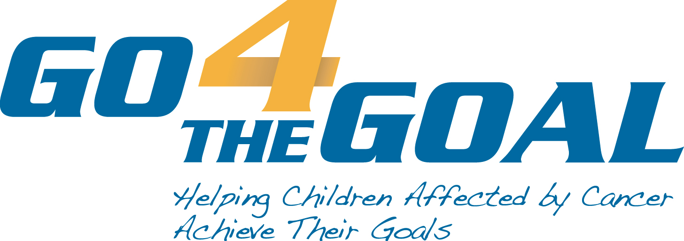**

**Go4TheGoal: Advocacy for Pediatric Cancer**

*Core Leadership Academy Value:* Faith & Passion

Student Moderator: Kayleigh Whitmore [kywhtmr@gmail.com](mailto:kywhtmr@gmail.com)

Faculty Moderator: Ms. Merenyi [noemi.merenyi@camdencatholic.org](mailto:noemi.merenyi@camdencatholic.org)

Students will learn about the OpenSource Leadership Strategies model for advocacy. They will learn how to identify a cause they are passionate about and evaluate methods to advocate for that cause. They will also learn about pediatric cancer, Go4TheGoal it’s history, its model for advocacy vs. other charities. They will examine first hand how Go4TheGoal caries its mission to improve the lives of children battling cancer by providing financial support, developing and implementing unique hospital programs, funding innovative research, and granting personal wishes. The students will then take part in helping Go4TheGoal to carry out various service projects throughout the year.

Dates:

Go For the Goal is a yearlong club with a number of various opportunities throughout the year. For students to receive credit for this module they must cumulate over 9 hours of service and course time dedicated to Go For the Goals mission. At the end of the year students will create a collage and 1-2 page reflection summarizing their experience working for Go For The Goal and what they learned about advocacy.

**Must Sign Up By:** October 1st **Module Code:** 14005G4G [Click Here to Sign Up Now](https://docs.google.com/forms/d/1UiUQlv4HeZrypC46CY88Xn8_T3PBwBZ99Jz6hnzU-oI/viewform)

Cost: Free!

To Find out about other modules being offered please go to the titled [Available Leadership Academy Modules](https://docs.google.com/document/d/1zscgdKnEiSjk4PRNHCHtoas7z5Vyy1VpG7iUOIVVKms/pub) posted in the Leadership Academy folder on Edline!