Why is it so hard to find a doctor?
Half of primary care physicians in our state are not accepting new patients. A prescription for the problem.
By Michael Fitzgerald
ALEX WILLIAMSON
KATHRYN QUIRK THOUGHT it would be easy to find a new doctor when she moved from Boston to Newton in 2009, just like it was when she arrived in Boston in 1996. Back then, she walked across the street to a doctor’s office and got an appointment.
It isn’t 1996 anymore. Quirk still hasn’t found a primary care doctor she feels comfortable with. Her quest sounds a lot like dating; in four years she’s had three doctors and has sometimes preferred to get care from physician’s assistants and nurse practitioners who work in those doctors’ offices. With three kids, a husband, and a job, Quirk doesn’t have endless time to look. She’s frustrated that it took her four months to find her first doctor in Newton. When she didn’t connect with that physician, she was able to switch to one she liked. But his practice stopped taking her insurance, and Quirk has needed a good chunk of this year to land a replacement doctor. She felt relief in September when she found one who was accepting new patients, but that was only the first hurdle. She won’t find out whether she likes this new doctor for a while; she couldn’t get an appointment until April 2014.
Quirk’s woes reflect a broader problem in the Boston area: It’s hard to get a doctor. Entire practices are booked. Even if she wanted to go back to her old doctor in Boston, he probably wouldn’t be able to take her. His practice is part of Massachusetts General Hospital, and primary care openings at MGH are like snowflakes in September.
Across Massachusetts, about half of primary care doctors aren’t taking new patients, according to the Massachusetts Medical Society’s 2013 Patient Access to Care Study. The rate for internal medicine specialists, or internists, who often also serve as primary care doctors, is 55 percent. If you’ve found a new doctor and want to schedule a routine visit, be prepared to wait. It takes an average of 39 days for new patients to get an appointment with a family physician and 50 days to see an internist. That’s better than last year, when the average wait was a whopping 45 days, but up from 29 days in 2010.
The wait could get longer. The Association of American Medical Colleges projects that nationwide 13,700 more doctors of all types were needed than were available in 2010, and that the gap will hit 130,600 by 2025, with about half of the shortfall in primary care. Are doctors becoming two-headed calves? No, but they are getting scarcer, for lots of reasons.
Nationwide, 13,700 more doctors of all types were needed than were available in 2010, and that gap will hit 130,600 by 2025

For one, we’re all living longer, on average, and we need more care as we age. Baby boomers, the oldest of whom are now in their mid-60s, will swell demand for doctors’ time over the next two decades. Doctors are baby boomers, too, meaning many of them are nearing retirement age; about a third of the nation’s doctors, including specialists, are older than 55. Meanwhile, when the state reformed health care in 2006, it expanded insurance coverage, increasing access to care without boosting the supply of doctors.
Nationwide, there simply aren’t enough residency training programs to go around — more than 1,700 newly minted MDs were frozen out of residency programs, primary care and otherwise, in 2013 alone. Add to those factors an acute lack of interest in primary care by young doctors. A study published in 2012 in The Journal of the American Medical Association found that only 1 in 5 third-year residents planned to go into general internal medicine.
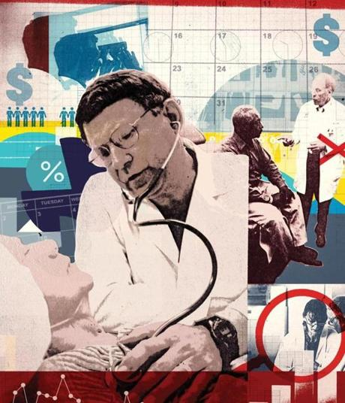
ALEX WILLIAMSON
Why? One big reason is money. While primary care doctors’ pay averages over $220,000 a year, good money to most of us, doctors who specialize average close to $400,000 a year.
Daniel Ginsburg, a health consultant who was the chief operating officer of the Massachusetts General Physicians Organization from 1994 to 2008, says it’s hard for up-and-coming physicians to resist the lucrative specialties, especially since medical students average more than $166,000 in debt. “I went to business school and not medical school, and if you look at where doctors are going, the decision-making process is disappointingly similar,” Ginsburg says.
Primary care is as demanding as (some say more demanding than) many traditionally higher paying specialties, including what’s called “the ROAD” specialties — radiology, ophthalmology, anesthesiology, and dermatology. Doctors in those professions, however, tend to work fewer nights and weekends than many other doctors. Medicine has also become more specialized in the last 50 years, and prestige and pay went to those who were most specialized. In the 1990s, “the internists felt like second-class citizens,” says Ginsburg, “and were paid that way.”
Ginsburg also says Boston hospitals often paid primary care doctors at about the national average, despite the higher-than-average cost of living in this area.
Quirk was lucky back in 1996 to walk into a Mass. General practice and get a primary care doctor. Ginsburg remembers a time in the early to mid 2000s when a friend asked him for help getting a male primary care doctor at MGH. “I couldn’t get him anybody,” he says.
Some things have changed since the 1990s to help address the pay disparities. Notably, some insurance payouts were restructured so that primary care physicians became the source for referrals to specialists. Hospitals and health care systems, nervous about being cut off by primary care doctors, started buying physician practices to ease access to referrals.
Though that has helped with pay disparities, in the 2013 Massachusetts Medical Society Physician Workforce Study, 45.6 percent of primary care doctors in the Bay State said their salaries were uncompetitive or very uncompetitive compared with MDs in other states (53.2 percent of specialists in Massachusetts said the same).
By requiring patients to visit a primary care doctor before seeing a specialist, the referral system has probably also slowed access. And the rise of the concierge doctor is having an impact on doctors’ availability. Concierge practices demand a retainer from patients, often more than $1,500 a year, limiting participation to patients who can afford the fees. In exchange, patients get quick access to their doctors.
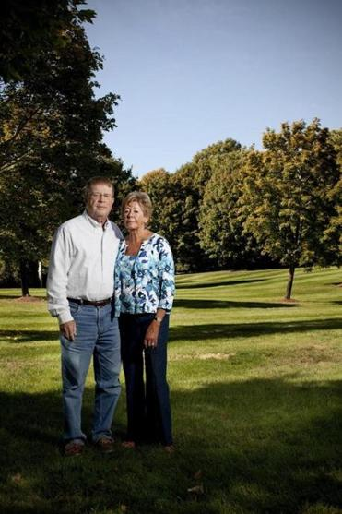
ALEX GAGNE
Bill and Joan Sawyer of Bedford switched to different doctors when their old one went to a concierge practice that carries a yearly fee. Now Bill’s new doctor is going concierge, too, forcing him to look for a physician again.
Bill and Joan Sawyer’s longtime doctor at a practice affiliated with Newton-Wellesley Hospital decided a few years ago to join a concierge practice, MDVIP, which has 19 doctors in Massachusetts. The Sawyers, who live in Bedford, would have had to pay $1,800 a year each to follow him. They decided to switch to different physicians in their doctor’s practice at Newton-Wellesley. That hasn’t worked out so well for Bill Sawyer — he got a letter telling him his replacement doctor was joining the same concierge practice. “Now I have to go looking for a new doctor again,” says Sawyer, a retired lawyer.
“What’s difficult here is to establish a relationship with a doctor; you need to do it over time,” Sawyer says. “If the physician is only going to be available to you for a year or two, what are you going to accomplish?”
***
THE AFFORDABLE CARE ACT (ACA) should not have a major impact on Massachusetts, since the state went through its own push to universal access in 2006. Only 4 percent of Massachusetts residents remain uninsured, and MassHealth and related programs mean far more people can go to doctors.
Sort of.
MassHealth and other government subsidized programs are not an open door to primary care doctors, as Stanley Kisob found out. Kisob, a resident of Framingham, lost his job in June and with it his Harvard Pilgrim insurance. He signed up for Commonwealth Care — another state-subsidized insurance program (to be phased out as ACA comes online) — and called his doctor to schedule his annual physical. “They wouldn’t do it because I didn’t have insurance they would take,” Kisob says.
He spent the summer looking for a doctor on his own and was turned down by several who didn’t take his insurance. In September he got a recommendation from Network Health, a nonprofit health insurer that serves low and moderate income Massachusetts residents, and finally got an appointment with a doctor in Natick.
Kisob has plenty of company. The latest Massachusetts Medical Society survey shows that only 70 percent of primary care physicians polled take MassHealth; 66 percent of internists do. Those numbers are up, though, by 6 percent and 12 percent respectively since 2012.
Even if all doctors start taking MassHealth, doctor shortages will probably increase in the near future. Joseph W. Gravel Jr., president of the Massachusetts Academy of Family Physicians and chief medical officer at Greater Lawrence Family Health Center, says that after the 2006 introduction of health care reform, the state needed to train more primary care doctors, since there were more people with insurance coverage. Instead, he estimates this year Massachusetts will train twice as many radiologists and four times as many anesthesiologists as family doctors.
Gravel, who directs a family residency program at the Lawrence health center that accepts 10 doctors a year, says that, ideally, 40 percent to 50 percent of all physicians would be primary care doctors, but in Massachusetts, the percentage “is probably around the low 20s.” Still, Gravel has hope that the tide will turn. “I’ve never been more optimistic than I am right now.” In part, he’s optimistic because of the Affordable Care Act. He thinks that adopting universal health care will expose the real cost of medical care to the country and help force new payment models. He expects those models to restructure health care spending toward primary care doctors. Gravel also hopes to see broader use of loan forgiveness programs for medical students who go into underserved fields like primary care.
Health care public policy debates are notable for their vicious creativity (“death panels,” anyone?). But substantive policy could happen now. Audrey Shelto, president of the Blue Cross Blue Shield of Massachusetts Foundation, thinks the ACA will force health care providers “to be much more creative about the workforce.”
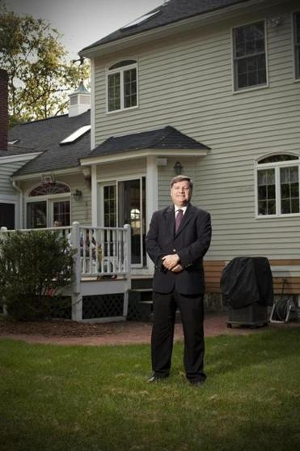
ALEX GAGNE
Joseph W. Gravel Jr., president of the Massachusetts Academy of Family Physicians, says that, ideally, 40 percent to 50 percent of all doctors would practice primary care, but the reality is closer to 20 percent.
There’s already a push toward team health care, which some call the “medical home” model, with a doctor, nurse practitioner and physicians’ assistants, pharmacists, and other personnel working together. Patients see the most relevant team member, so a diabetic might spend more time with an education specialist than with a doctor, improving care and saving the system money.
Team-based care models are a major innovation in primary care practice in the last decade, pushed by organizations like the Harvard Medical School Center for Primary Care and Mass. General’s Stoeckle Center for Primary Care Innovation. Medical home fits with another trend — the shift away from today’s fee-for-service business model, where doctors get paid for what they do. Instead, insurers and providers are increasingly turning to global payment, which prioritizes patient outcomes and controls cost through a yearly budget per patient. This approach could allow doctors a share in insurance savings. If answering a patient e-mail after hours means avoiding a trip to the emergency room or if a diabetic is able to take fewer medications, practices could see financial rewards.
“Current practices are driven by the tyranny of the urgent. Doctors are on hamster wheels, giving patients 15 minutes,” says Asaf Bitton, assistant medical director of Brigham and Women’s Advanced Primary Care Associates, South Huntington, a two-year-old medical home that includes clinical social workers, pharmacists, and nutritionists, along with doctors.
He calls South Huntington’s team-oriented approach “advanced primary care 3.0” and says it allows for doctors to serve more patients and for patients to get more care. South Huntington has the equivalent of three full-time doctors, and each carries an average of about 2,000 patients, a little higher than usual. Sounds like the hamster wheel all over again, except in a medical home, patients don’t see the doctor for everything that comes up. “There is a concern that team practice will interfere with the sacred bond between patient and doctor,’’ Bitton says, “but I feel it augments that bond.” He says he has more to offer his patients by working with a team. His practice trains eight internal medicine residents a year (Brigham and Women’s has 172 residents, not counting pediatrics, with 36 in primary care).
The ACA also creates more funds for primary care residency programs. The bulk of funding for residencies, three- to seven-year training programs focused on fields medical students enter once they receive their degrees, comes from Medicare, but the number of residencies supported has been frozen since 1997. “That’s where the bottleneck comes from,” says Atul Nakhasi, a medical student at Johns Hopkins University who wants to be a primary care doctor. Nakhasi chairs the American Medical Association’s Medical Student Section, the country’s largest organization of medical students.
Currently spending a year and a half earning a master’s in public policy at Harvard’s Kennedy School, Nakhasi wants to see the number of primary care doctors rise. He, too, thinks the ACA will lead to a restructuring of medical spending based on patient outcomes, which will shift financial incentives toward providing high-quality preventive care rather than a high quantity of medical tests and procedures. Nakhasi would like to see programs like the National Health Service Corps’ Loan Repayment Program greatly expanded, to reduce debt load for primary care doctors. And he wants to boost the number of residency programs. Meanwhile, one-quarter of outpatient visits take place in emergency rooms, the most expensive way to see a doctor. “That’s where people are going for their primary care visits!” Nakhasi says.
One such person could be Tom Pounds, a self-employed consultant who moved to Cambridge last year from California. While he and his wife finally found a pediatrician they like for their kids, Pounds, 53, has yet to see a doctor himself after looking for one on and off for about a year. Two or three practices recommended by friends turned out to be full. He’s been in good health, but confesses that if something happened, “I suppose I’d go to a CVS clinic or the emergency room.”
Pounds does have a doctor, but in name only. When he enrolled in the Tufts insurance plan in August, he had to pick a doctor. He did so at random and doesn’t expect to use that doctor. Minor-but-urgent needs can probably be handled at a clinic, he says, and in a real crisis he’d wind up in an emergency room regardless.
Walk-in retail clinics like those at CVS and Walgreens could become a significant source of care for people who need medical help but don’t need to see a doctor. That might also relieve pressure on the medical system. But Boston will still need more primary care doctors.
So it’s good news that, after about 15 years, there’s a new family medicine residency program gearing up in the Boston area. Carney Hospital in Dorchester, part of the Steward Health Care system, has started the Carney Family Medicine Residency. Carney’s program will support eight residents per class each year, and in its first year may also accept up to four second-year residents as transfers.
The new residency program, which begins training its first class next summer, aims to rethink how primary care residents work, including a team-based approach that will feature two medical assistants for every physician and a revamped curriculum built around short, more interactive education modules. Medical assistants and other support staff must be bilingual, speaking English and one of four other languages commonly spoken in Dorchester: Haitian Creole, Portuguese, Spanish, or Vietnamese.
The residency’s program director, Deborah R. Erlich, says, quite seriously, that Carney wants to build joy into the residency.
“Primary care has a high reputation for burning doctors out,” Erlich says, “and we want to turn that on its head.” She has started measuring joy levels for the hospital’s staff members and will keep tabs on them over the next year and beyond.
Talking on a recent Monday, she’s excited. “This is a big day for us,” she says. It’s the day the new program starts accepting applications. On day one, 400 arrive. Erlich is feeling the joy.
Whether one new residency program can bring more joy for people like Kathryn Quirk or Tom Pounds remains to be seen. It does represent a small step forward into a different kind of health care system. Enrollment in the ACA’s mandated health care exchanges began October 1. There are a lot more steps to take.
Michael Fitzgerald is a writer in Cambridge. Send comments to magazine@globe.com.
Due to a reporting error, an earlier version about the shortage of primary care physicians incorrectly referred to the O in the medical profession’s ROAD specialties. The O stands for ophthalmology.

