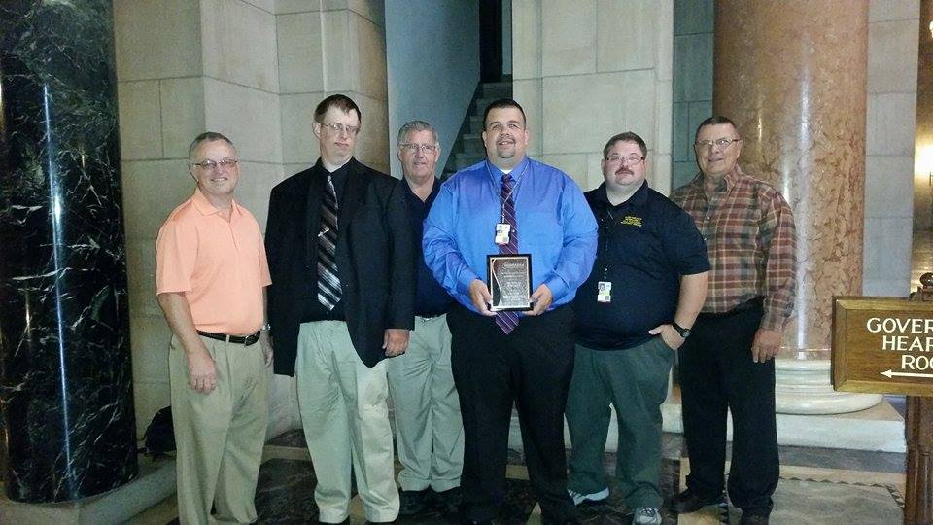
Nicholas Kemnitz, Wayne County Emergency Manager displays his award in the capitol rotunda. He is accompanied by (left to right) LeRoy Janssen, retired Deputy Wayne County Emergency Manager, Kevin Garvin, Cedar County Emergency Manager, John Bomar, Madison Fire Chief, Matthew May, Winnebago Emergency Manager and Randy Larson, Wayne County Commissioner.

