**Location:**  Pack 170, St. Paul’s Lutheran Church, 1244 Saint Paul’s Church Road, Pennsburg, PA 18074

**Date: April 5th, 2014**

**Time: Check-In** from 8:00 AM to 9:30 AM

**Race Begins** at 9:30 AM

**Contact:**

**For event organization: Gregg Kintner,** [**gregg820@comcast.net**](mailto:gregg820@comcast.net)**, 610-973-4385**

**For rules and regulations: Jeff Cannon,** [**cannon.jds@comcast.net**](cannon.jds@comcast.net)**, 610-213-2047**

**Each Continental District Pack may send up to five participants**

**Please email the names of your 5 racers to** **chris.smith@scouting.org** **by March 30th, 2014.**

**A concession stand will be available for snacks, drinks, and lunch items.**

***Please read this entire document before attempting to race at this District Event***

**Introduction:**

The information provided here is meant to be the rules and specification for the 2013 Continental District Pinewood Derby. We have collected this information from the *Cub Scout Grand Prix Pinewood Derby Guidebook.* Remember that the goals of the Pinewood Derby are to have fun, learn new skills, and expose the scout to quality time with a parent or other adult.

**Sportsmanship:**

It is recommended that all Scouts and adults read and discuss this section.

Racing requires participants to learn two main things: the craft skills necessary to make your car and sportsmanship. This has to do with how you act and behave while participating in the derby.

The first thing to remember about sportsmanship is that everyone's skills are a little different. Some people are better than others at certain skills. You may be good at one thing but not good at another. This doesn't mean you are a good person one time and not good another time. You can always be a good person, whether or not you have the skills for racing. Remember, you and your friends are individuals first and racers second. This idea is sometimes called *having respect for others.*

The second thing to remember is to follow the rules. Without rules, there would be no Pinewood Derby. You will never know if you are really good at doing something unless you follow the rules. This is sometimes called *being fair and being honest.*

The third thing to remember about good sportsmanship is that there are winners and losers in every competition. You know this when you choose to compete. There are times when you will win and be happy, and times when you will lose and be unhappy. Being a winner is easy but being a loser is sometimes hard. To be a good sportsman, you must be able to say, "I did my best" and be satisfied with the results. If you win you must not gloat.

**The Track: {MODIFY AS NEEDED FOR YOUR TRACK}**

The car you made and will race at the District Pinewood Derby will be on an aluminum track that is three lanes wide and approximately 29 feet long from the starting gate to the finish line. The starting gate is elevated approximately four feet higher than the finish line. The track goes downhill steeply for approximately six feet then rounds out level to the finish line. The lanes are determined by raised aluminum rails that run along the inside of the car wheels. These rails guide the cars down the track and prevent them from hitting each other. If you ignore some of the rules in the next section, your car may not clear the middle section of the lane and you will not be able to race. Within these rules, there are many things you can do to make the car go as fast as possible.

**PINEWOOD DERBY CAR SPECIFICATIONS**

The following rules and dimensions govern all Pinewood Derby Races as stated in the Official Grand Prix Pinewood Derby Kit and as shown in the figures below

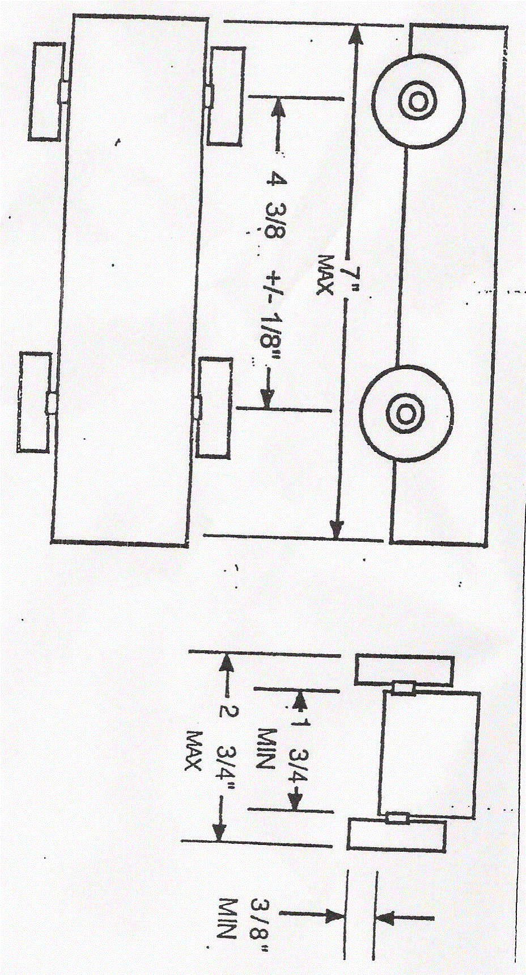

**Car Specifications:**

|  |  |  |
| --- | --- | --- |
| **1. Construction:** | Must be newly constructed for this year. | |
| **2. Chassis:** | Car body must be made of wood from the official BSA kit provided. Purchased pre-constructed & complete cars (including axles & wheels) are not permitted. Metal, plastic, and other wood accessories and details are permitted, such as a steering wheel and driver, spoilers or fins, etc., as long as these accessories do not cause the car to exceed the maximum length, width, height, or weight specifications defined below. There may not be any features to the car which would allow any part of the car to extend beyond the starting gate; therefore, giving a shorter distance to the finish line. | |
| **3 Running Gear:** | 1. Only official BSA wheels and axles may be used (no single/solid axles permitted) | |
|  | 1. Wheels may not be altered or re-shaped, narrowed, or beveled. Light sanding is permitted to reduce the plastic molding scar. | |
|  | 1. Axle span (wheel base) may not be altered from the kit or the dimensions below | |
|  | 1. No bearings, bushings, springs or washers may be added to the wheel/axle assembly | |
|  | 1. No suspension riggings allowed | |
|  | 1. The car must be freewheeling (no power source or starting mechanism) (i.e. no working rocket engines!) | |
| **4. Car Weight** | The car weight must not exceed 5.0 ounces (141.75 grams) | |
| **5. Dimensions:** | Overall Length (front to back) | 7 inches maximum |
|  | Overall Width (side to side outside wheels) | 2.75 inches maximum |
|  | Overall Height | 6 inches maximum |
|  | Wheelbase (axle to axle) | 4 3/8th +/- 1/8th inches |
|  | Track Width (hub to hub) | 1.75 inches minimum |
|  | Ground Clearance | 3/8th inch minimum |
|  |  |  |
| **6. Lubrication:** | Dry graphite only. No oil or grease permitted. | |
|  |  | |
| **7. General** | All parts and accessories must be securely fastened to the car and cannot interfere with the track or other cars.  **DO NOT APPLY NUMBERS** – They will be assigned on race day. | |
|  |  | |
| **8. Inspection** | Each car must pass inspection by the official inspection committee before it may compete. If, at registration, a car does not pass inspection, the owner will be informed of the reason for failure, and will be given time within the official registration period to make adjustments. After approval, cars will not be re-inspected unless the car is damaged in handling or in a race. | |

**Race Day Rules:**

1. All Scouts and adults must conduct themselves with a high level of sportsmanship. Everyone must also respect all other participants, spectators, and race volunteers. New Hanover Lutheran Church has graciously allowed the use of their facilities. Please take great care to respect the property of the church. Smoking is not permitted anywhere in the building, including the rest rooms. Please do not dispose of any cigarette butts on the ground outside.
2. A Scout must be in Class-A uniform to race his car. The Class-A uniform includes his blue or tan scout shirt, his appropriate neckerchief, and neckerchief slide. Shirts are to be tucked into pants or shorts. Please avoid sweat pants or athletic pants or shorts. Everyone should look their best, including leaders, who should wear their best Class-A uniform too.
3. If the Scout is not going to be able to attend during their assigned heat, another scout can be designated in advance to be a substitute. Race officials must be notified of any substitutes before races begin. The Scout, who built the car, must be present for the initial check-in and inspection of the car. Any exceptions to this must be approved by the event chairman in advance.
4. The Scout must have his car ready to race before arriving. Only minor adjustments to the weight may be made during the inspection process.
5. The Scout must check-in and have his car inspected between 8:00 AM and 9:30 AM. Scouts who have not checked in before 9:30 AM, will be ineligible to race. Racing will begin at 9:30 AM.
6. All inspections will be conducted by the District Inspection Judges at a special inspection area using scales and gauges provided for the event. The gauges may include a clearance block and a box into which the car will be required to fit.
7. The Inspection Judges are responsible for evaluating each car's adherence to the technical standards (above). Their decision may be appealed to the event chairman, who, after consultation with the inspection team, the scout, and his parent/guardian, shall render a final, decision.
8. When the car has passed inspection and received its race number, it will be placed into the "holding area". No further lubrication or adjustment(s) may be made.
9. Each Scout will be called to the on-deck area near the holding area to identify his car for the appropriate heat and lane. The Starting Team will then place the car on the track according to the assigned lane number. When all cars are placed and the boys are at the finish line, the Starter will start the race. Each Scout is responsible for returning his car to the holding area immediately following the race.
10. If, during a heat, the car leaves its assigned lane, the track, interferes with another car, loses an axle, etc. the heat will be rerun. If the same car leaves its assigned lane, the track, interferes with another car, loses an axle, etc. on the 2nd run, that car is disqualified and will receive no time for that heat. If, during the 2nd run, another car is interfered with, the heat is rerun a 3rd time, without that disqualified car. Race officials’ decisions in this matter are final.
11. Any repairs necessary during the course of racing can only be done by the Scout with help from their parent or other adult in front of a Race Official as long as the car is ready for the next assigned heat. The car must be inspected and weighed again by a race official before returning to the holding area.
12. All cars will run twice in each lane for a total of 6 races as assigned by the race management software.
13. The final race results will be determined by the average time of each car using all six heats.