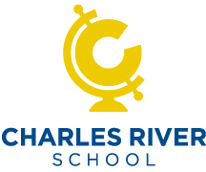

You’re Invited!

NSF Grant Project – Demonstration

When: December 5, 2014
9am – 11am

Where: Charles River School
6 Old Meadow Road
Dover, MA

What: Explore your World!
iGlobe and MIT have been awarded a grant from the National Science Foundation to educate students and the public on climate change. Join us at Charles River School to learn more about the project and how you can participate. We need your design ideas and feedback on prototypes.

Don’t forget to bring some student ambassadors!
(2-3 per school)

Experience the HyperDome… our portable planetarium theater

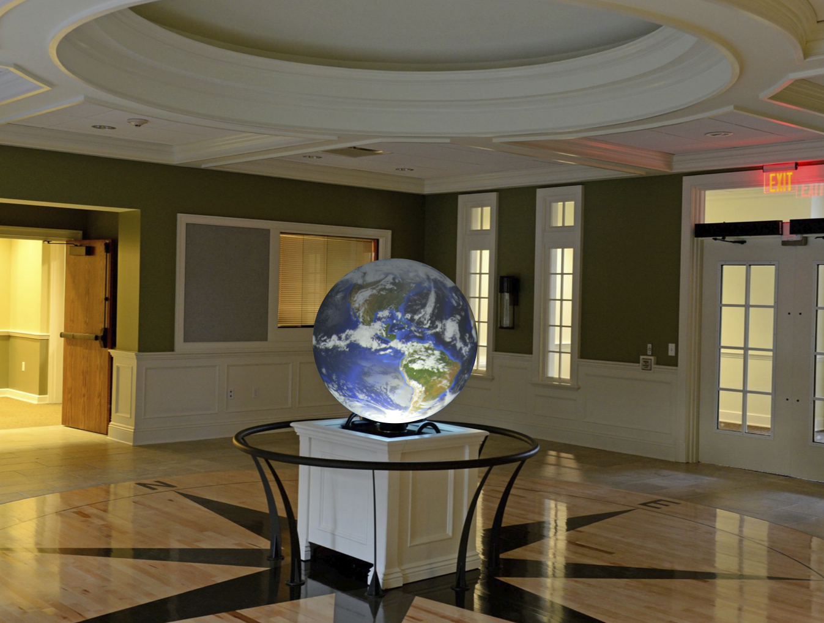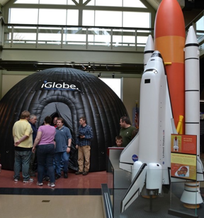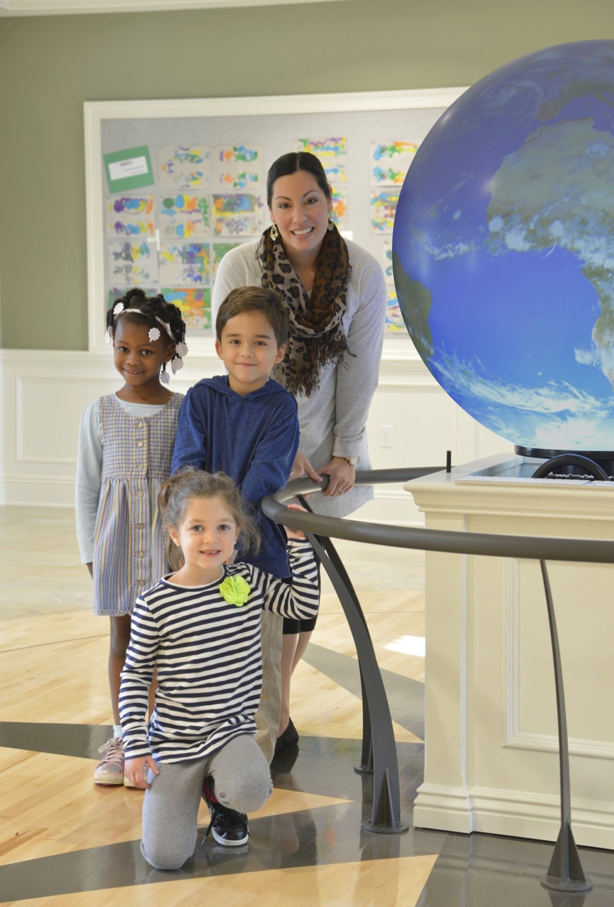

RSVP Required by November 25th – Contact Bill Horn, Bill@iGlobeInc.com for more information

Sponsored by… 