National Merit Scholarship News

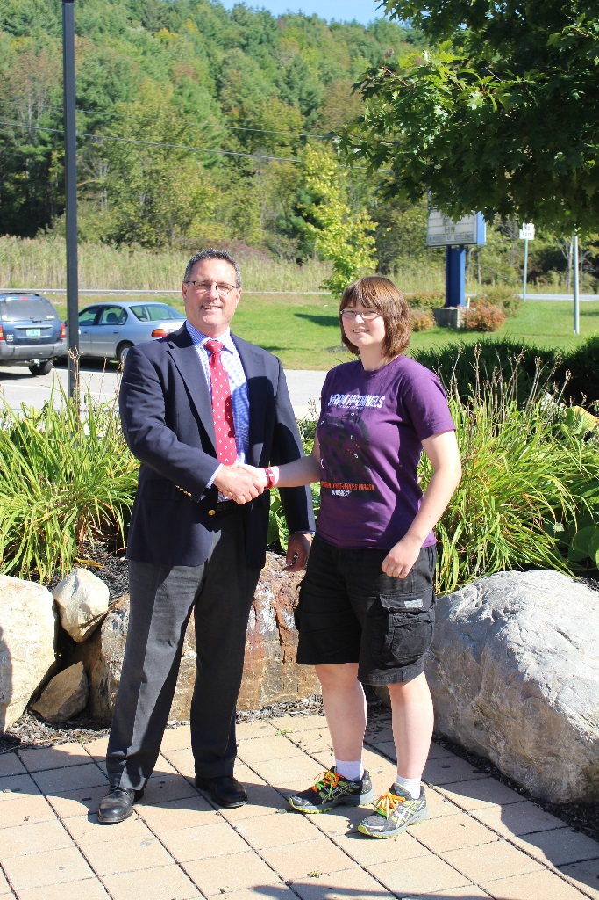
Otter Valley is pleased to announce that Nora Enright has been named a Semifinalist in the 2015 National Merit Scholarship Program. In early September, about 16,000 students, of the 1.4 million who entered the program, by taking the 2013 Preliminary SAT, are notified that they have qualified as Semi-finalists. We are proud that Nora will complete the additional requirements in order to be considered a Finalist in the spring of 2015! Congratulations, Nora!

